**Commercial Vehicle Enforcement**

**NORTWEST SECTOR:**

Details:

* 12/31 – Three Inspectors screened 78 commercial motor vehicles at the US Rte 7 Ferrisburgh detail. 11 inspections were conducted. 8 violations were detected (1 driver and 7 vehicle)

Crashes:

Notables:

* 12/30 – Cpl. stopped a tractor trailer combination on I 89 in Georgia for an equipment violation. An inspection was conducted and revealed a rearmost turn signal was inoperative on the trailer. The trailer was placed out of service.

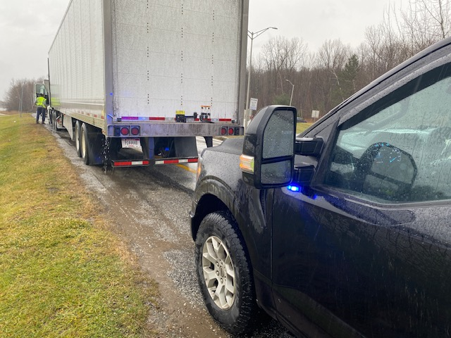

* 1/03 – Cpl. stopped a tractor trailer combination on I 89 in the Chittenden County safety corridor for a speed infraction. An inspection was conducted, and the driver was currently in violation of the 11-hour driving rule. The driver was placed out of service for the violation.

Passenger Vehicle: Nothing to report.

Safety Audit:

**NORTHEAST SECTOR:**

Details:

* 12/31 Coventry Village, 4 Inspectors screened 37 vehicles. 12 inspections were completed which resulted in 2 vehicle violations.
* 01/02 Derby Port of Entry, 4 inspectors conducted a directed patrol and conducted 12 inspections which resulted in 1 driver violation.

Crashes:

Notables:

* 12/30 Lyndonville, Inspector conducted an inspection on a Class A commercial driver’s license required combination and discovered the operator only had a Class D driver's license. The operator was placed out of service.
* 12/31 Coventry Village, Inspector conducted a level 2 inspection and located one of the glad hand hoses chafing against the deck causing damage to the hose.
* 12/31 Bradford detail, Inspector conducted an inspection on a vehicle transporting an empty roll-off container. Among other violations, the container was not properly secured to the vehicle and the driver’s CDL was disqualified. The driver and vehicle were declared out-of-service.

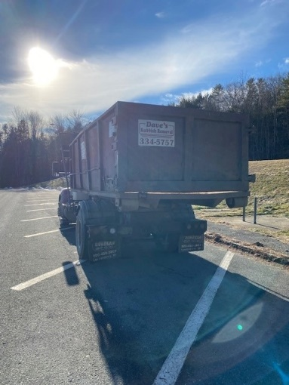

* 01/03 Morrisville, Inspector stopped a commercial motor vehicle for an equipment violation, a level 2 inspection was completed, and the operator was placed out of service for not wearing hearing aids which was required on their medical card as well as being in possession of 6 bottles of alcohol while being on duty. The operator was issued a VCVC for the alcohol violation.

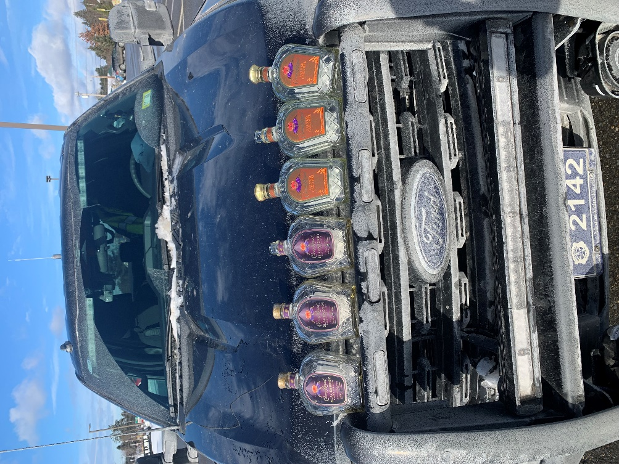

New Entrant:

Compliance Review:

Passenger Vehicles: Nothing to report

**SOUTH SECTOR:**

Details:

* 12/31, Bradford SB; 5 inspectors screened 67 vehicles and completed 16 inspections (2 Hazmat) resulting in 2 driver and 7 vehicle violations.

Crashes: Nothing to report

Notables:

* 1/3, Rte279 Weigh Station Bennington, Inspector conducted a Level 3 inspection on a 4-axle dump truck. The truck was hauling salt and had a weight exceeding 69,000 pounds. The truck did not have a Vermont excess weight permit. A VCVC was issued for the violation.

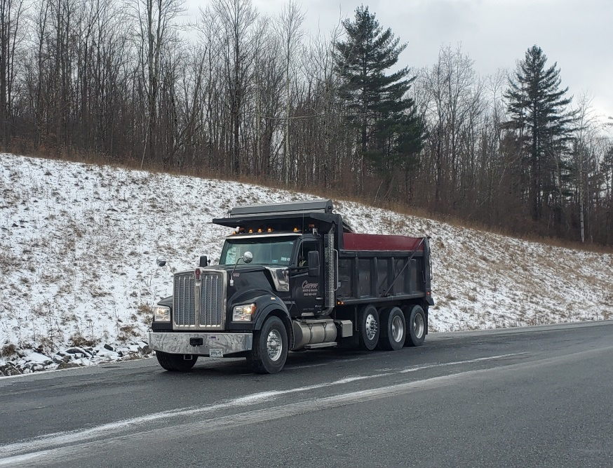

* 1/3, Rte. 279 Weigh Station Bennington, Inspector conducted a Level 2 inspection on a small box truck. It was discovered the carrier rented a 14,500lb truck to engage in interstate commerce. The carrier did not have a current US DOT number, and the driver had no medical certificate.

Passenger Vehicle: Nothing to report

**Traffic Enforcement Unit:**

During the week of 12/30-1/3 the Traffic Enforcement Unit conducted 79 inspections which resulted in 3 driver and 9 vehicles being placed out of service. 

Crashes: Nothing to report

Notables:

* 12/31--Cpl stopped a tractor trailer on Route 22a for inoperable lights on the trailer. The carrier was found to be suspended in Vermont and the truck tractor was placed out of service for a flat tire.

* 12/31, Inspector stopped a truck towing a firewood processor on Route 22A in Fair Haven. The carrier failed to register for a USDOT number prior to beginning interstate operations. The truck was not registered. The carrier was issued a Vermont Civil Violation Complaint for no registration.

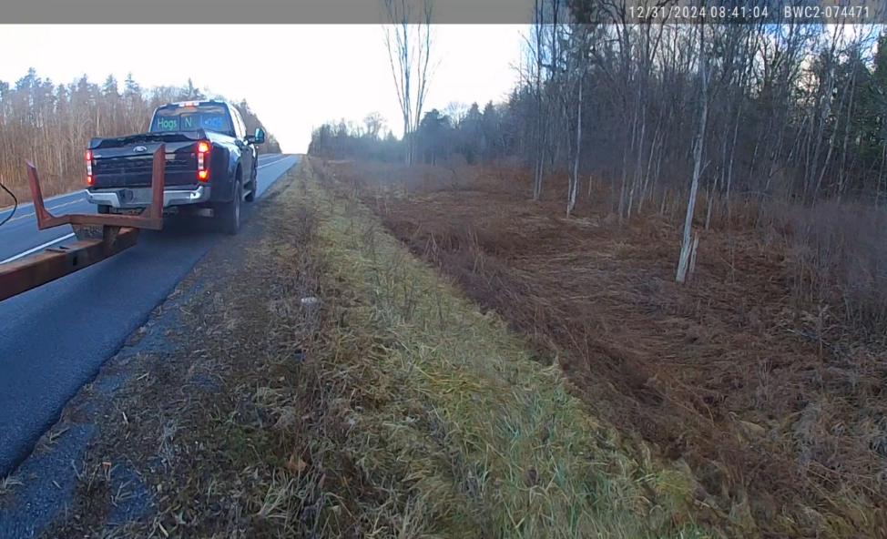

* On 12/30 Lieutenant stopped on Route 100 in Killington for trash hauler who had lost their load on Route 100 in the S turns. Traffic was stopped as he assisted the hauler remove the large amount of trash from the roadway. The same trash hauler was previously issued a ticket for failing to have a waste hauler permit and was instructed to tarp the load.

* 12/31, Inspector stopped a truck and trailer on Route 22A in Fair Haven for a marking violation. The truck had no trailer brake controller as required and was placed out of service for inoperable brakes.

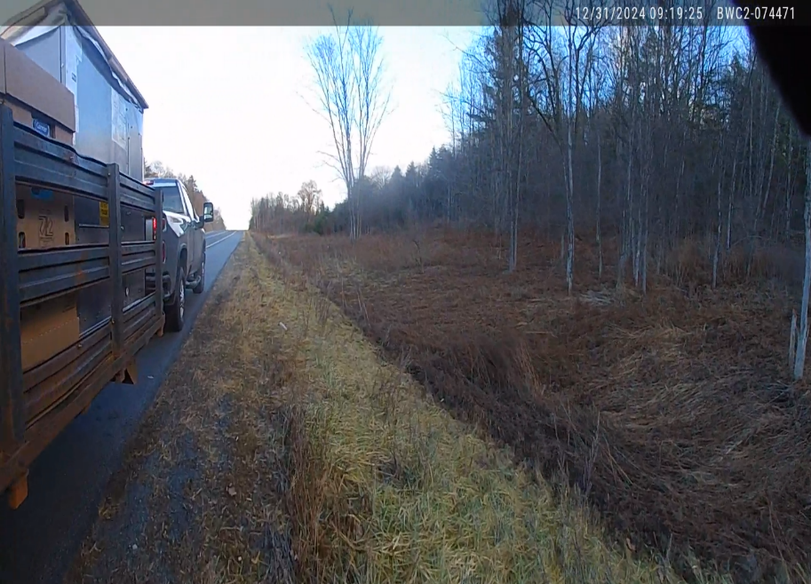

* 1/2, at the IRA detail, Inspector placed an interstate truck out of service for no operable brake lamps and an inoperable turn signal. The carrier also failed to register for a USDOT number prior to beginning interstate operations. The driver had no medical card.
* 1/3--Cpl stopped a tractor trailer on Route 22a in Orwell for an inoperable tail lamp. The carrier was found to have no operating authority and both steer axle tires had belt material exposed in the tread area. The carrier and truck tractor were placed out of service.

* 1/3, Inspector stopped a truck that failed to stop at the Bennington truck inspection site. The driver had a suspended license and no medical card. The driver was issued a Vermont Civil Violation Complaint for no license.

* 1/3--Cpl stopped the driver of a tractor trailer for speeding on Route 22a in Orwell. The truck tractor was placed out of service for a vehicle component that was dragging on the highway. The trailer was placed out of service for no operable brake lamps.

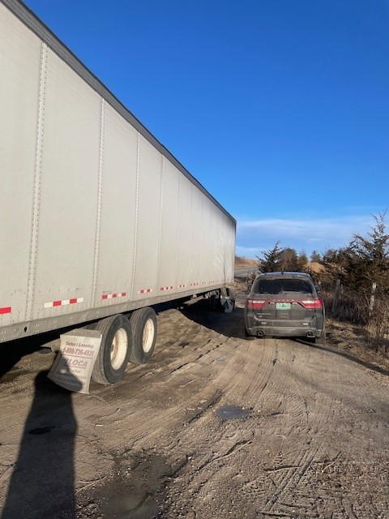

* 12/30- Insp stopped a commercial motor vehicle on I-89 in Williamstown for a missing license plate on the trailer. An inspection was conducted, and the carrier was operating in interstate commerce without a USDOT#. The truck and trailer were both unregistered. The driver had no med card and no commercial driver’s license. The combination required a Class A commercial driver’s license. The owner/operator was issued a ticket for no commercial driver’s license and placed Out of Service.

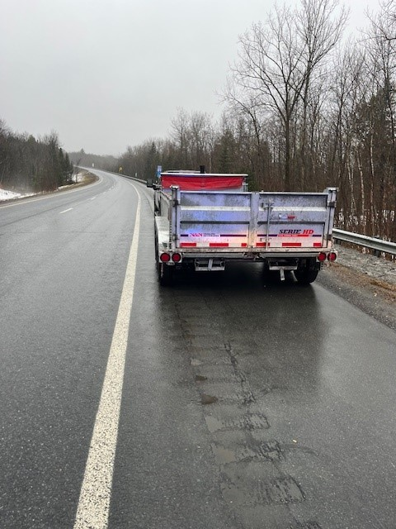

* 12/31-Insp stopped a commercial motor vehicle for a lighting violation on I-89 in Randolph. An inspection was conducted, and the trailer was placed out of service for a breakaway brake violation. The driver was issued a warning.

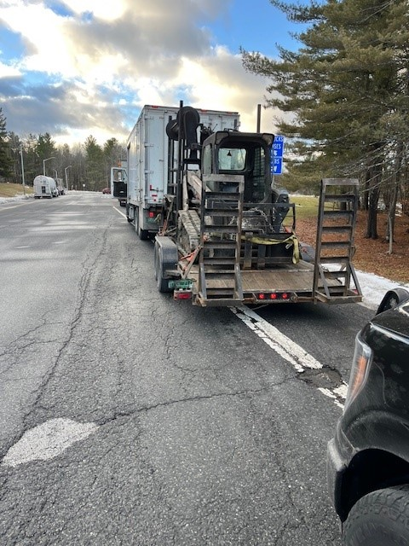

* 12/31-Insp stopped a commercial motor vehicle on I-89 in Berlin for a lighting violation. An inspection was conducted, and the driver was placed out of service for an expired medical card on a commercial driver’s license required vehicle. The driver was issued a warning.

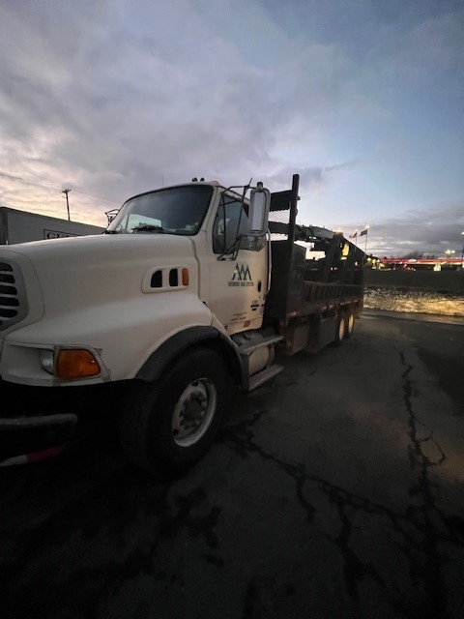

* 01/02-Insp assisted Berlin PD and Berlin VSP with several box truck slide offs on Rte. 63 and Rte. 64. The truck on Rte. 64 rolled over on snow covered roads.
* 01/03-Insp stopped a truck and trailer for a marking violation on I-89 in Randolph. An inspection was conducted, and the carrier was found to be operating in interstate commerce with an in-active USDOT number. The truck was placed out of service and the owner/operator was issued a warning.

* 1/3--Cpl stopped a truck and trailer in interstate commerce for a marking violation. The trailer was placed out of service for a flat tire.

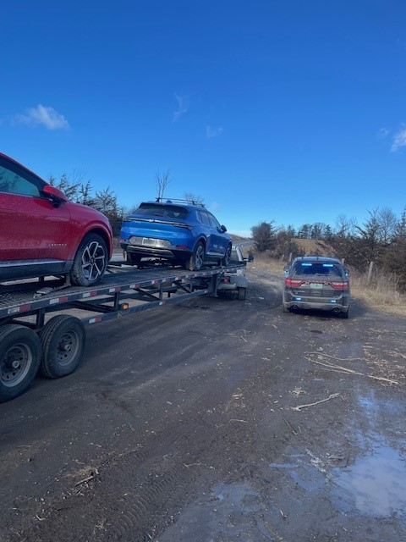

* 1/4 (Saturday), Inspector and Captain completed 5 motor coach inspections at Killington Mountain Resort. 1 driver violation and 1 vehicle violation were found.

**HQ Sergeant:**

New Entrant: