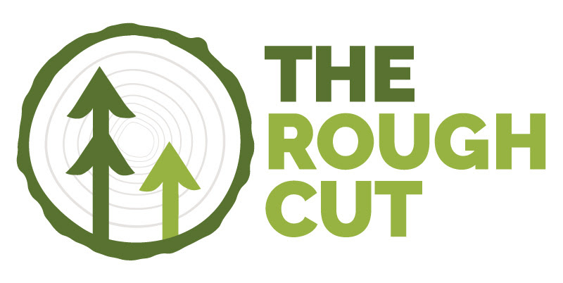

July 2025

by Christine McGowan
Vermont Sustainable Jobs Fund

I’m thrilled to open this edition of The Rough Cut with some exciting news: we’ve officially announced the 2025 cohort of the Forest Business Accelerator—and it’s an inspiring group of entrepreneurs.
This year’s eight selected startups are tackling some of the forest economy’s most pressing challenges—from underutilized wood species and sawmill waste to carbon emissions and rural economic development. Their innovations span AI-powered conservation tools, bio-based materials, 3D printing with wood pulp, and next-generation renewable fuels. It’s a powerful reminder that the future of forestry is not only rooted in tradition but also driven by bold, forward-thinking ideas.
The Forest Business Accelerator, hosted by the Vermont Sustainable Jobs Fund in partnership with Vermont State University and funded by the Northern Border Regional Commission, provides these early-stage companies with mentorship, business development training, and peer learning opportunities. One standout will receive a $15,000 award this fall to help scale their impact.
You can meet the full 2025 cohort and learn more about their work atforestaccelerator.com.
In this issue, you’ll also find:
• Highlights from the 2025 Vermont Forest Industry Summit, including Alan Organschi’s inspiring keynote on mass timber and our forest economy;
• A feature on Scratch Builders, a Vermont company pushing the boundaries of sustainable construction;
• And a roundup of resources and events to support your work in the forest economy.

And finally, the Vermont Forest Future Strategic Roadmap Implementation Steering Committee is in full swing developing working groups for each of the five pillars. I’m pulling together a working group for Pillar 3: Research, Innovation and Technology. If you are interested in participating in the working group or just staying connected to this work, shoot me an email!

As always, stay safe out there,
-Christine
LinkedIn

Dispatch from the Forest
Industry News Worth Knowing


  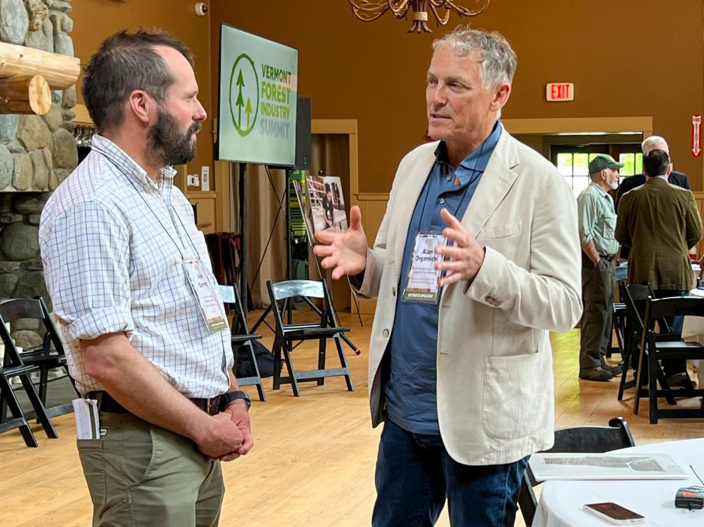
Innovation Takes Center Stage at the 2025 Vermont Forest Industry Summit

Bolton Valley Resort played host to the 2025 Vermont Forest Industry Summit on June 19, bringing together forest economy leaders from Vermont, New Hampshire, and Maine under the theme “Innovation in the Forest Economy.” The event showcased cutting-edge ideas, products, and partnerships shaping the future of the forest economy in the region.

Attendees earned professional credits while engaging in a full day of learning and networking. The Summit opened with a keynote by Alan Organschi, a Yale professor and architect renowned for his work with mass timber and sustainable building materials.

A dynamic plenary discussion tackled the challenges and opportunities posed by global trade disruptions, featuring voices from government, industry, and academia. Breakout sessions explored topics ranging from maple industry innovation and locally produced glulam to bio-based building materials and emerging markets for low-grade wood.

The day wrapped up with a fireside chat featuring forester and author Ethan Tapper, whose work bridges forestry and public engagement.
Video recordings of the day's sessions will be posted to the website shortly, but they are now available as a playlist on the VSJF YouTube Channel here.

Other Noteworthy News:

USFS Announces 2025 Wood Innovation Grants (USFS)

Tree-Based Tech: The Future of Maine’s Forest Products Industry(Northern Woodlands)

Mass Timber Could Drive Forest Expansion and Cut Emissions (Yale School for the Environment)

Private Forests that Provide Public Benefit are Under Threat(Northern Forest Center)

Will Act 250 changes help local wood products industry? (WCAX)

The Overstory
Our industry has a story to tell, so settle in and enjoy some good news!

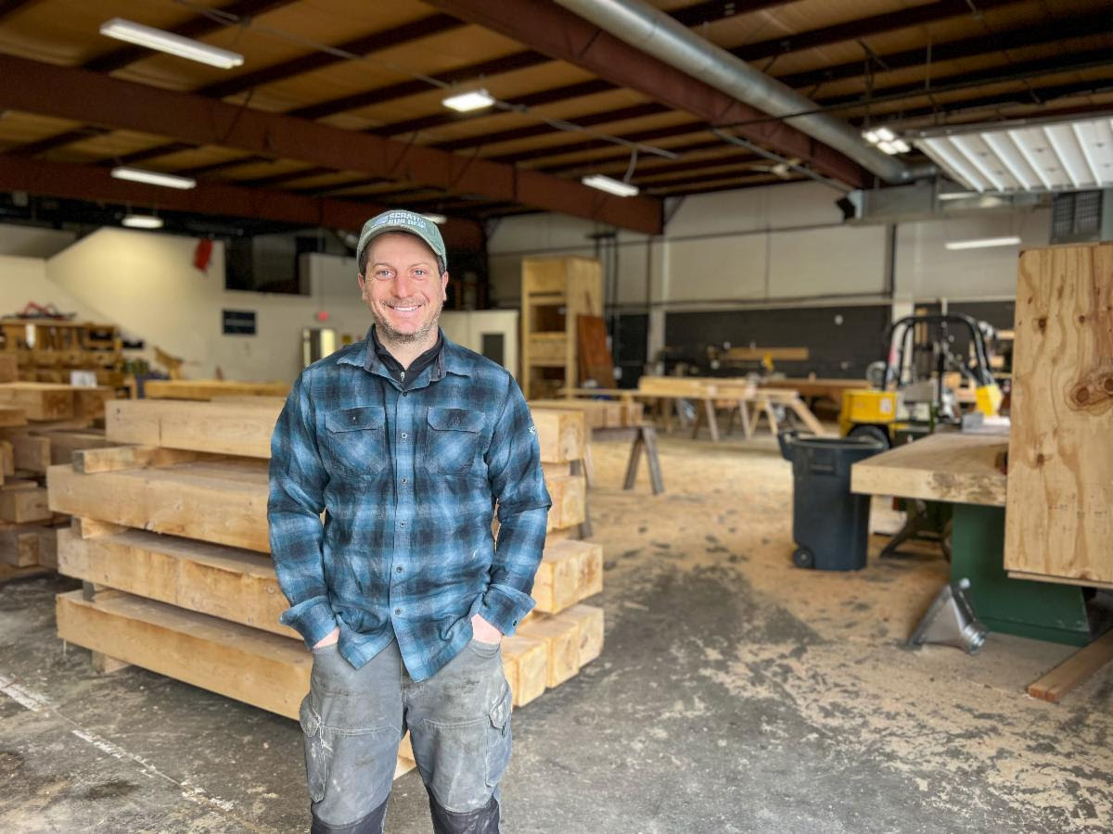

Scratch Builders goes out on a limb

Evan Taubes, owner of Scratch Builders in Williston, Vt., is among a few builders working to advance the mass timber industry in Vermont. “If no one is presenting it as an option to clients, then the choice will continue to be timber framing or steel,” said Taubes. “We’re sticking our neck out a little when we see an opportunity that would be a good fit for mass timber because it aligns really well with our values.”

Read the full story here!

  Vermont Forest Economy Business Resources
  Department of Forests, Parks and Recreation
  Agency of Commerce and Community Development
  VHCB Farm and Forest Viability Program
  UVM Extension Forest Business Program
  VSJF Business Management Coaching
  Vermont Manufacturing Extension Center
  Vermont Small Business Development Center (vtSBDC)
  Upcoming Events
  Now open for Loggers: SLoCAMP Grants Available. Click for more info
  July 26: Tree to Cutting Board Workshop, 9:30 AM – 2:00 PM, Peacham, VT
  Contact VWA for more info
  August 5–7: Northern Hardwood Conference, All day, Syracuse, NY
  Click here for more info
  August 17–19: SMART 2025: Emerging Engineered Wood for Buildings, All day, Yale University, New Haven, CT Click for more info
  Sept. 9 - Oct. 14: Fine-Tune Your Story: Marketing Workshop Series, Click here to apply



About the Vermont Forest Industry Summit, the Forest Business Accelerator and VSJF
Vermont’s forest economy contributes more than $2.1 billion in direct economic output and provides more than 14,000 jobs in forestry, logging, processing, specialty woodworking, construction, wood heating and maple production. The Vermont Forest Industry Summit creates space for strong relationships and collaboration throughout the industry and promotes the development of new and existing markets for Vermont wood products.

Committed to nurturing the sustainable development of Vermont’s economy, VSJF provides business assistance, network development, strategic planning, and value chain facilitation in agriculture and food system, forest products, waste management, renewable energy, and environmental technology sectors. Learn more at www.vsjf.org.

VSJF is the proud host of the 2025 Forest Business Accelerator, a 4-month program for entrepreneurs seeking to commercialize new or improved products or services in the forest and wood products industry. www.forestaccelerator.com.

