Commercial Vehicle Enforcement

- 07/15—07/16 Inspectors attended radiological security training at Dartmouth College.

NORTHEAST SECTOR:

Details:
- 07/15 Newbury, 3 Inspectors completed 11 inspections which resulted in 17 vehicle violations (3 out of service) and 9 driver violations (3 out of service).
- 07/17 I-91 Bradford Sb Rest Area, 5 Inspectors screened 76 vehicles. 17 inspections were completed which resulted in 35 vehicle violations (5 out of service) and 4 driver violations (1 out of service).

Crashes:
- Nothing to report.
Notable:
- 07/14 Coventry, Inspector conducted an inspection and portable weigh on a commercial motor vehicle that did not have a permit to be in excess of the legal road limit. The company was issued a ticket for being 9,400lbs over the legal road limit of 55, 000lbs.
- 07/14 Coventry, Inspector conducted an inspection of a commercial motor vehicle and found the driver required hearing aids per his medical card and he did not have one while operating the commercial vehicle. The driver was placed out of service.
- 07/14 Coventry, Inspector conducted an inspection on a commercial truck/trailer combination with a GVWR of 36,500 lbs. A total of 13 violations were discovered to include the driver was under 21 without a valid commercial driver's license engaged in interstate commerce as well as no medical certification.
- 07/14 Coventry, Inspector conducted an inspection on a commercial truck/trailer combination with a GVWR of 41,500 lbs. It was discovered that the trailers breakaway cable not attached to the towing vehicle, operating a class A commercial driver’s license required vehicle with a class D driver’s license, and no medical certification
- 07/15 Newbury, Inspector observed a commercial motor vehicle that was unable to maintain its lane. The vehicle was stopped, and an inspection was completed. The operator advised that he was tired. The operator was placed out of service until he was no longer fatigued.
- 07/15 Wells River, Inspector conducted an inspection on a commercial motor vehicle and found the operator required corrective lenses as per his medical card but that he did not have any while operating the commercial motor vehicle. The driver was placed out of service.
- 07/15 Wells River, Inspector conducted an inspection on commercial vehicle and discovered an inoperative turn signal on the rearmost vehicle as well as a flat tire on the trailer.
- 07/15 Wells River, Inspector conducted an inspection as well as a portable weigh on a commercial motor vehicle and discovered 9 violations. Some of these violations include the combination being 25,000lbs over the registered weight as well as an 18,000 lb. bulldozer secured with only one chain.
- 07/17 Ryegate, Inspector conducted a traffic stop on a passenger vehicle traveling 115 mph on I-91. The driver was subsequently transported and processed for driving under the influence, excessive speed, and negligent operation.
- 07/17 Bradford, Inspector conducted an inspection on an interstate commercial motor vehicle with no USDOT numbers. It was discovered the automobile being transported had a defective tie-down securing it. The driver replaced the tie-down before continuing his route.
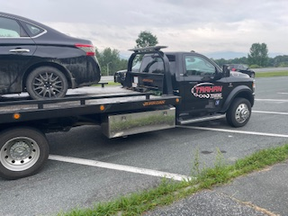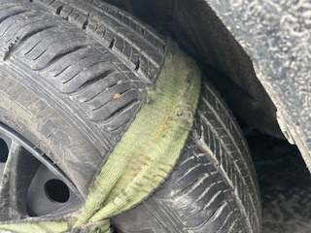
- 07/17 Bradford, Inspector conducted a hazardous materials inspection and found the shipping papers did not accurately describe the hazardous material being transported. The truck was placed out of service.
- 07/17 Bradford, Inspector conducted an inspection on a commercial motor vehicle and discovered axle 3’s inner tire measure at 18/120 psi. The vehicle was placed out of service until repaired.
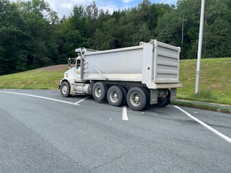
- 07/18 Troy, Inspector conducted a traffic stop on a commercial motor vehicle who failed to display their registration. An inspection was completed, and 5 vehicle violations were discovered to include the trailer’s breakaway was not attached to the power unit. The driver was educated on how to properly connect the breakaway, and they continued their route.
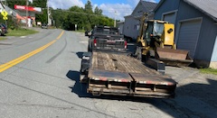
- 07/18 Newport City, Inspector conducted a traffic stop on a commercial motor vehicle for a permit check and portable weight. The vehicle was discovered to be 4,200 lbs. over their permitted weight of 69,000 lbs. Also, the driver failed to be in possession and wear corrective lenses as indicated on their license. The driver was placed out of service.
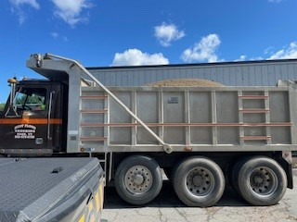

New Entrant:
- Nothing to report.

Compliance Review:
- Nothing to report.

Passenger Vehicles:
- Nothing to report.

NORTHWEST SECTOR:

Details:
- 7/15 – 2 Inspectors screened 40 commercial motor vehicles at the VT Rte 104 Cambridge detail. 8 Inspections were conducted and 23 violations detected. (2 driver and 21 vehicle). 2 vehicles and 1 driver were placed out of service.
- 7/17 – 2 Inspectors screened 85 commercial motor vehicles at I 89 Highgate POE detail. 9 Inspections were conducted and 17 violations detected. (2 driver and 15 vehicle). 1 vehicle was placed out of service.

Crashes:
- Nothing to report.

Notables:
- 7/14 – Inspector stopped a tractor trailer combination on I 89 in Colchester for an equipment violation. A subsequent inspection was conducted detecting a tire was severely deflated on the trailer. The trailer was placed out of service until repaired.
- 7/14 – Inspector stopped a straight truck on I 89 in Colchester for an equipment violation. A subsequent inspection revealed a tire was severely deflated on the truck. The truck was placed out of service for repair.
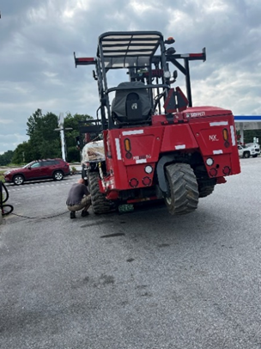
- 7/15 – Inspector inspected a tractor trailer combination at the VT Rte. 104 Cambridge detail. The inspection revealed the trailer was not registered. The trailer was grounded and the carrier was required to register the vehicle to continue their trip.
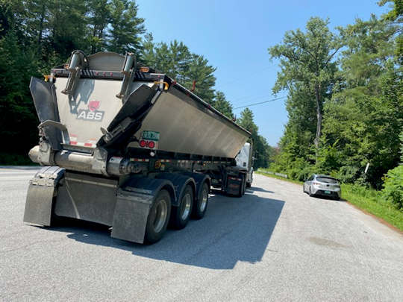
- 7/15 – Inspector stopped a truck hauling a trailer on VT Rte. 15 in Cambridge for an equipment violation. A subsequent inspection revealed the driver did not possess a CDL and one was required for the combination. Additionally, a rear turn signal on the trailer was inoperative and the emergency breakaway device was defective. Both the driver and trailer were placed out of service. A ticket was issued to the driver.
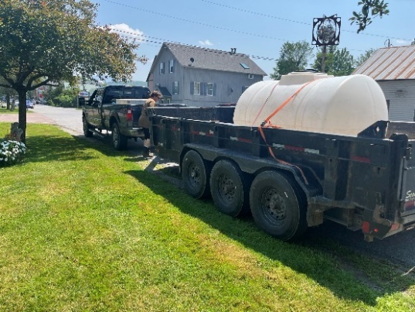
- 7/17 – Inspector inspected a tractor trailer combination at the I 89 Highgate point of entry. The inspection revealed a brake hose was cut on the truck tractor and leaking air. The truck tractor was placed out of service for an air leak at other than a proper connection.
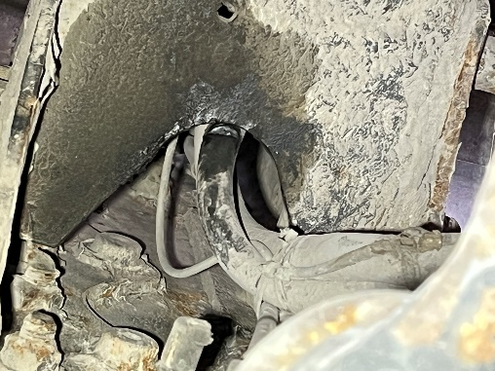
- 7/17 – Inspector inspected an oversized load at the I 89 Highgate point of entry detail. The inspection revealed the carriers single trip permit was invalid. The carrier was forced permitted to continue their trip through Vermont.
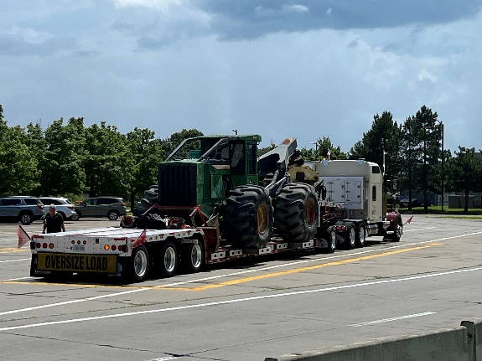
- 7/18 – Inspector stopped a box truck on I 89 in Colchester after the Smart Roadside system detected a flat tire. An inspection was conducted and the truck was placed out of service for a severely deflated tire.
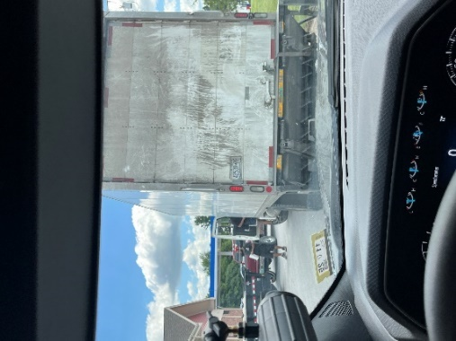
- 7/19 – Inspector attended a car seat event in Barre City. Car seats were installed for the public and technicians met their re-certification objectives during evaluations.

New Entrant:
- Nothing to report.

Passenger Vehicle:
- Nothing to report.

SOUTH SECTOR:

Details:
- 7/15, I91 Guilford; 5 Inspectors screened 239 commercial vehicles and completed 17 inspections resulting in 4 driver and 13 vehicle violations; 2 drivers and 2 vehicles were placed out of service. Additionally, one oversized permit was checked for compliance.

Crashes:
- Nothing to report.

Notables:
- 7/14, Inspectors conducted a Cargo Securement training session for a large group of AOT members from the D8 region.
- 7/15, Guilford, Inspector inspected a 2-axle interstate vehicle and found a missing hub bearing cap on a trailer axle allowing an open view into the hub. The trailer was placed out of service until repaired.
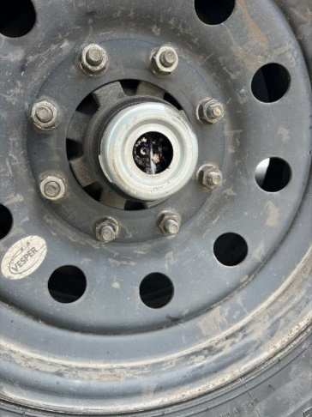
- 7/15, Inspector conducted a traffic stop on a box truck on I91 in Guilford that had bypassed an open CMV checkpoint. It was discovered the operator had a currently suspended license and was placed out of service.
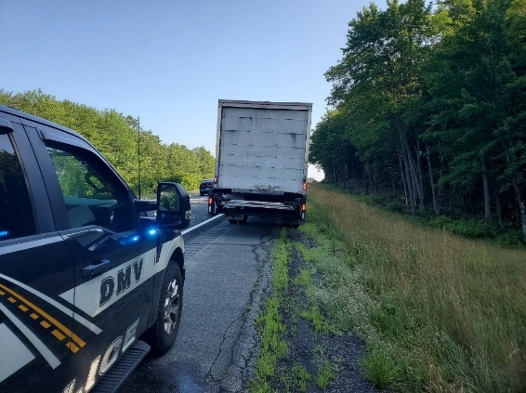
- 7/15, Guilford, Inspector conducted a Level 1 inspection on a box truck. During the inspection it was found that the driver’s medical certificate had expired last year. The driver notified the owner of the company who learned that all his driver’s medical certificates had expired and there was nobody available to drive the truck. The driver was placed out of service and the truck was left at the rest area until a driver from a tow company could pick it up.
- 7/15, Guilford, Inspector conducted a Level 2 inspection on a pickup towing a trailer hauling a shed. During the inspection it was found that the emergency breakaway was connected to the safety chains and not to the towing vehicle. During the same inspection Inspector Hammond found that none of the rear lights on the trailer were functioning. The combination was placed out of service.
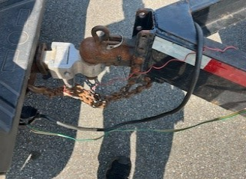
- 7/17, Mt. Holly, Inspector completed a portable weigh of a cement truck loaded with 11 yards of cement for delivery. The maximum gross weight allowed by State permit was 69,000 lbs, however, the vehicle weighed 79,300 lbs. A VCVC, in the amount of $617.00 was issued to the carrier for the violation.
- 7/17, Mt. Holly, Inspector completed a portable weigh of a cement truck loaded with 11 yards of cement for delivery. The cement truck had a 69K permit and the portable weight showed that the truck weighed 80,900 pounds. A VCVC, in the amount of $668.00 was issued to the carrier for the violation.

Passenger Vehicle:
- Nothing to Report.

TRAFFIC ENFORCEMENT:

- During the week of 7.14--7.18 the Traffic Enforcement Unit conducted 88 inspections which resulted in 10 drivers and 13 vehicles being placed out of service.

Crashes:
- Nothing to report.

Notables:
- 7/14--Inspector stopped the driver of a tractor trailer for speeding on Route 22a in Orwell. The driver presented his ELD showing a co-driver. When asked about the co-driver, the driver refused to answer or acknowledge that he had or has a co-driver. All he would say is that I need to contact the company as he won’t talk about it. He was told that I just needed acknowledgment that there was a co-driver but he continued to refuse. The driver was not currently in an 11 or 14 hour rule violation but he was given a false log violation as he reported sleeper berth and off duty time in the previous 6 days when the commercial motor vehicle was shown to moving across the country. The driver was given ample opportunity to acknowledge the existence of a co-driver but he refused. Therefore, his record of duty status could not be validated for the previous 6 days.
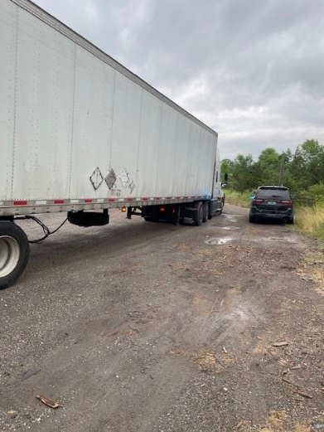
- 7/14--Inspector stopped the driver of a tractor trailer for speeding on Route 22a in Orwell. The truck tractor was placed out of service for a flat tire.
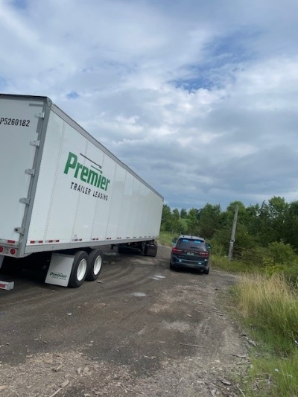
- 7/14, Inspector stopped an interstate vehicle on Route 103 in Clarendon. The driver was placed out of service for being under 21 years of age and having no medical card.
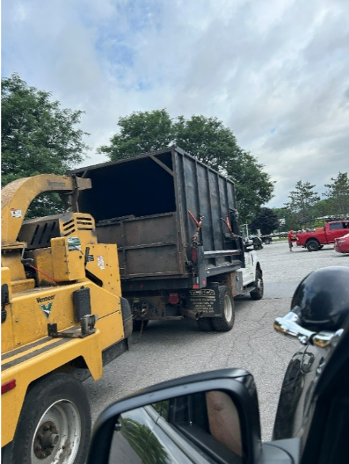
- 7/14--Inspector stopped a tractor trailer for an equipment violation in Shoreham. The trailer was placed out of service for a flat tire. The driver was placed out of service as his commercial driver’s license was not valid in his licensing State.
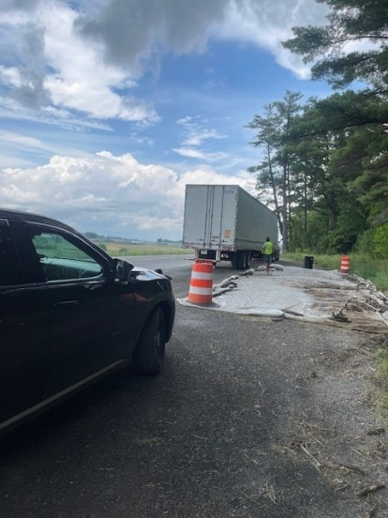
- 7/15--Inspector stopped the driver of a tractor trailer for speeding on Route 22a in Orwell. The truck tractor was placed out of service for a flat tire and for another wheel with billowing smoke due to the inner wheel seal leaking.
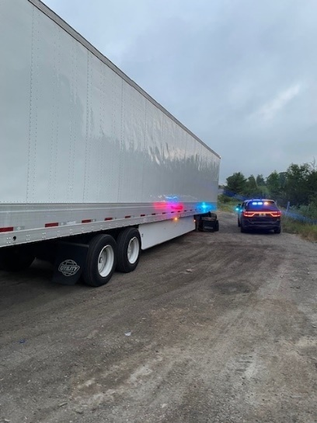
- 7/15--Inspector stopped a truck as there was a cargo strap dragging on the highway behind it. The truck was placed out of service for the violation and the carrier was found to be suspended in VT.
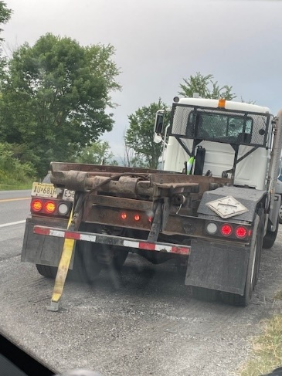
- 7/15, Inspector stopped a vehicle on I-91 in Guilford. The carrier failed to register for a USDOT number prior to interstate operations. The driver was placed out of service as he had no record of duty status after driving from Florida to Pennsylvania, then Vermont. The trailer was placed out of service for an improperly attached breakaway cable.
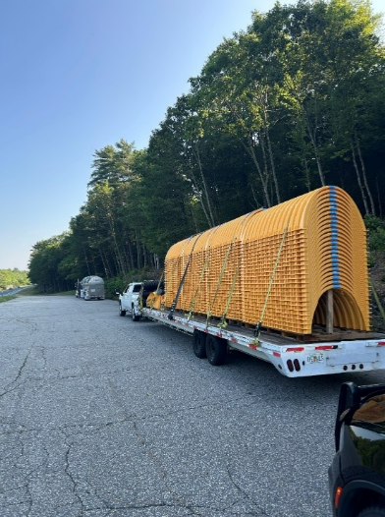
- 7/15, Inspector stopped a vehicle that failed to stop at the Guilford Inspection Site. The trailer was placed out of service for an improperly attached load and no emergency breakaway cable.
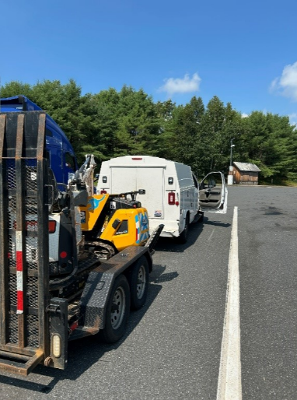
- 7/16, Fair Have Scale House, Inspector placed a driver out of service for being in interstate commerce and only being 18 years old.
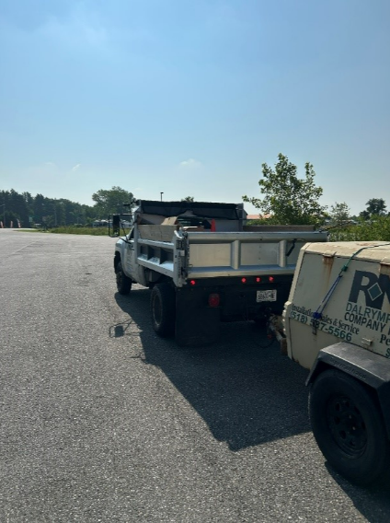
- 7/16, Fair Haven Scale House, Inspector placed a truck out of service for an inactive USDOT number.
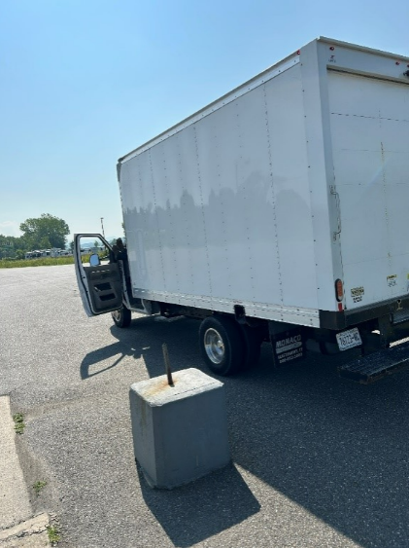
- 7/16--Inspector placed a driver out of service for not having a valid medical certificate at the Fair Haven Scale House.
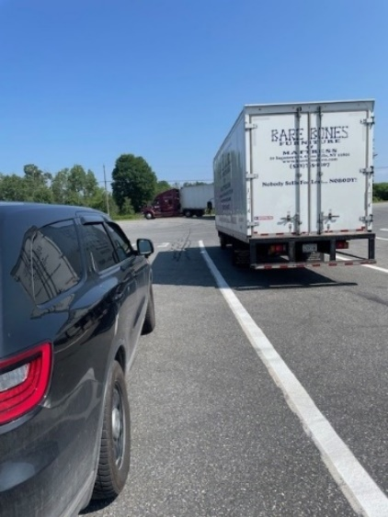
- 7/16--Inspector placed a trailer out of service at the Fair Haven Scale House for having an air hose leaking air from a hole in it.
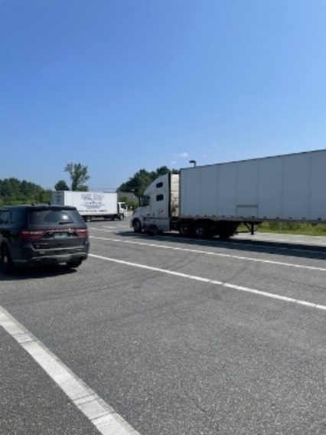
- 7/17, Inspector stopped a truck hauling a tractor on Route 4 in Woodstock. The driver was placed out of service for not having the required commercial drivers license Class A nor a valid medical card.
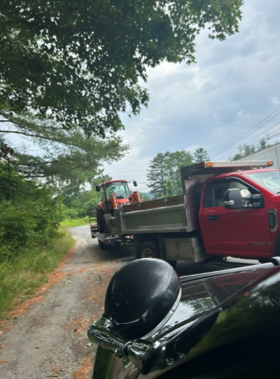
- 7/17, Inspector stopped a box truck on Route 4 in Woodstock. The driver was placed out of service for no valid medical card.
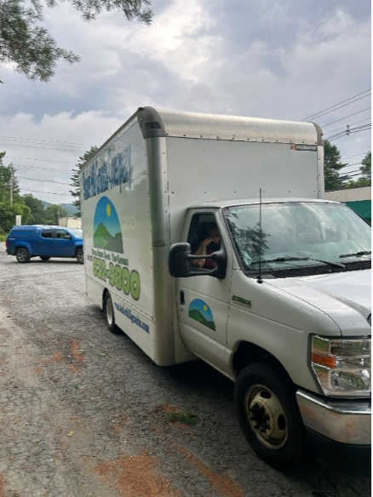
- 7/17, Inspector stopped a dump truck hauling a paving machine in Woodstock. The NH based driver was under 21 years old and had an intrastate only commercial driver’s license. He was placed out of service.
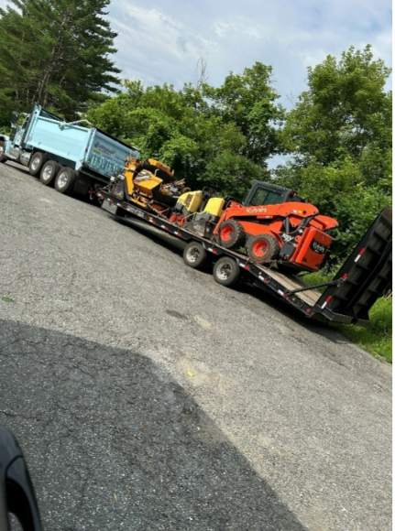
- 7/17, Inspector stopped an interstate vehicle on Route 4 in Woodstock. The carrier failed to register for a USDOT number prior to interstate operations.
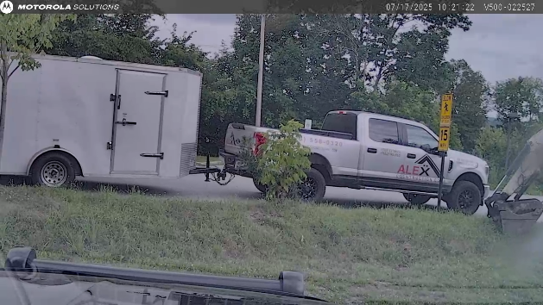
- 7/17--Inspector stopped the driver of a box truck for speeding on Route 22a in Orwell. The driver was placed out of service for not wearing/having corrective lenses as required.
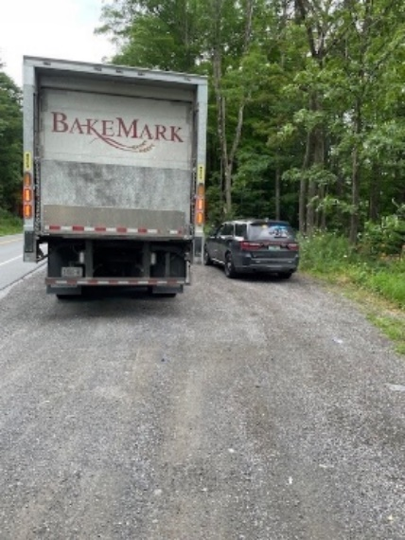
- 7/17--Inspector stopped a truck and trailer on Route 22a in Orwell as there was a cargo securement strap dragging on the highway behind the trailer. The trailer was placed out of service for this violation as well as the rear passenger side turn signal being inoperable.
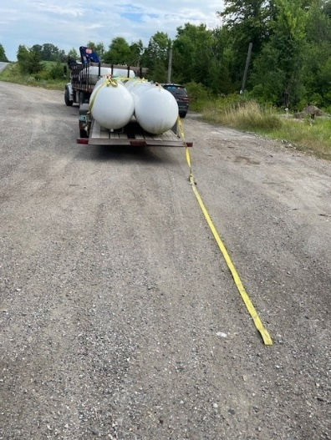
- 7/18, Inspector stopped a truck and trailer on Route 7A in Manchester. The driver did not have a Class A commercial driver’s license as required. The trailer had no working lights nor was the breakaway cable attached. The driver and trailer were placed out of service.
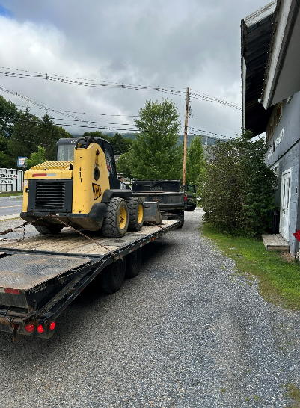
- 7/18, Inspector stopped a bucket truck on Route 30 in Manchester. The truck required a Class B commercial driver’s license, which the driver did not have. He was placed out of service.
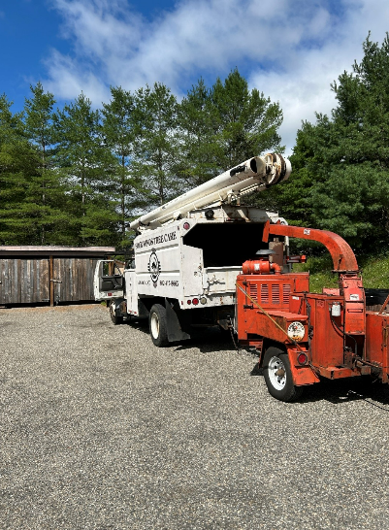
- 7/14- Inspector stopped a tractor/trailer for a load securement violation on I-89 in Berlin. An inspection was conducted and the trailer was placed out of service for not having the required tie-downs for cargo with no headboard. The driver was issued a warning.
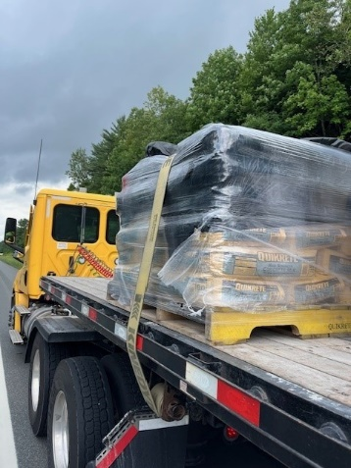
- 7/14-Inspector stopped a commercial motor vehicle on I-89 in Williamstown for a load securement marking violation. An inspection was conducted and the truck was placed out of service for no flag as required. The load extended six feet behind the truck. The driver was issued a warning.
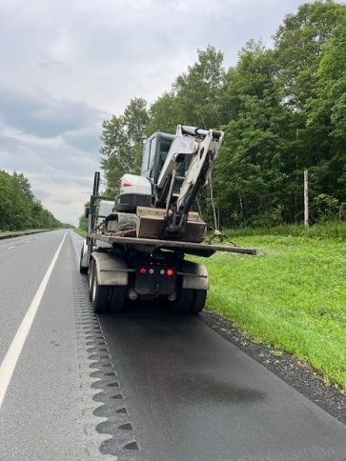
- 7/14- Inspector stopped a commercial motor vehicle on I-89 in Berlin for a load securement marking violation. An inspection was conducted and the truck was placed out of service for no flags as required. The load extended five feet back and was eight feet in width. The driver was issued a warning.
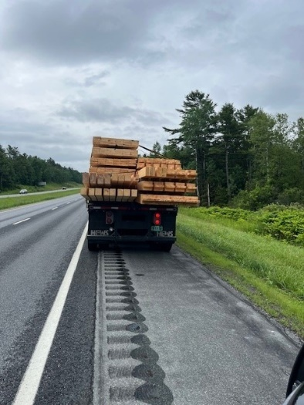

HQ Sergeant:

New Entrant:
- Nothing to report.

