Commercial Vehicle Enforcement

NORTHEAST SECTOR:

Details:
- 07/29 I-91 Coventry Nb Rest Area, 3 Inspectors screened 112 vehicles. 13 inspections were completed which resulted in 19 vehicle violations (3 out of service) and 9 driver violations (2 out of service).
- 07/31 I-93 Waterford Welcome Center, 5 Inspectors screened 182 vehicles. 22 inspections were completed which resulted in 62 vehicle violations (6 out of service) and 11 driver violations (4 out of service).

Crashes:

Notables:
- 07/28 I89, Sgt placed a commercial motor vehicle out of service for having a flat tire.
- 07/29 I91 Coventry, Sgt stopped a commercial motor vehicle which failed to stop at the safety checkpoint. The carrier was found to not have a USDOT registration number, the driver did not possess a class A CDL, nor did they have a medical card. The vehicle combination was placed out of service for inoperable required lights and for a defective emergency breakaway cable. The driver was issued a VCVC for not stopping at the safety checkpoint.
- 07/30 Newport, Sgt placed the driver of a commercial motor vehicle out of service for having an improper self-certification on their medical card.
- 07/30 Newport, Sgt assisted the Newport Police Department with a traffic stop involving a commercial motor vehicle and an improperly licensed driver. The vehicle was also found to be overweight. The driver was placed out of service and the carrier was issued a VCVC for the overweight violation.
- 07/31 I93 Waterford Sgt stopped a commercial motor vehicle for failing to stop at the safety checkpoint. The entire inspection was completed via a translator, and the driver was found to not be able to read traffic signs, which is the reason he did not stop at the checkpoint. Multiple hours of service violations were present as well.
- 07/28 Fairlee, Inspector conducted an inspection on an interstate commercial motor vehicle which failed to display markings. An inspection was completed, and it was discovered the driver did not have a medical certificate. The driver was placed out of service.
- 07/28 Fairlee, Inspector conducted a directed patrol in a work zone to enforce speed. 2 traffic stops were conducted, issuing 1 warning and 1 ticket for speed.
- 07/28 Bradford, Inspector conducted a traffic stop on a truck and trailer combination with mowing equipment which failed to properly display their registration and had a NH inspection. It was discovered that both the truck and trailer displayed unreadable VT expired temporary registration, the trailer registration displayed was not assigned to the vehicle, no current inspections, and the driver was suspended in the State of VT. Multiple tickets were issued, the registration plate was seized, and the vehicles were grounded.
- 07/28 Bradford, Inspector conducted an inspection on an interstate commercial motor vehicle which failed to display markings. During the inspection it was discovered the driver failed to have a medical certificate. The driver was placed out of service.
- 07/28 Waterford, Inspector conducted an inspection on a commercial motor vehicle towing a trailer. During the inspection 11 violations were discovered, to include the trailers breakaway cable not attached to the towing vehicle, both directionals on the trailer were inoperative, a damaged bearing cap exposing the inner hub, operating a commercial motor vehicle without a medical certificate as well as operating a vehicle which required a class A commercial driver’s license with a class D driver’s license. The trailer and operator were both placed out of service.
- 07/28 Waterford, Inspector conducted an inspection on a commercial motor vehicle hauling asphalt. During the inspection 8 violations were discovered to include Drugs/Marijuana inside of the commercial motor vehicle. The operator was placed out of service for 24 hours and the marijuana was seized as a result.
- 07/28 Danville, Inspector conducted an inspection on a commercial motor vehicle hauling steel. The operator was placed out of service as he could not satisfy the English language proficiency regulations.
- 07/29 Coventry detail, Inspector responded to a commercial motor vehicle that was attempting to turn around on VT Rte. 114 in Morgan and got stuck in the ditch with the trailer blocking the roadway. An inspection was conducted, and violations were issued to the driver.
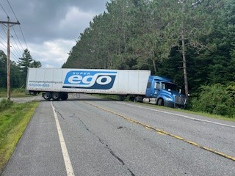
- 07/29 Coventry detail, Inspector conducted an inspection on a commercial motor vehicle and discovered the carrier was under suspension in the State of VT. The vehicle was grounded.
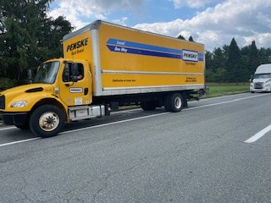
- 07/30 Sheffield, Inspector conducted a traffic stop on a commercial motor vehicle for speed. An inspection was completed, and it was discovered the vehicle had an inoperable parking brake and 1 of 4 brakes were contaminated by oil from a leaking seal. The vehicle was placed out of service and the driver was issued a warning for the speeding violation.
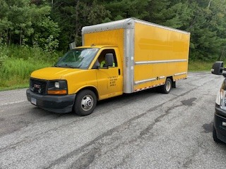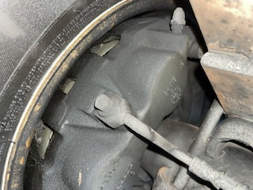
- 07/30 Barton, Inspector conducted a traffic stop on a commercial motor vehicle for an unknow item lodged within their dual set. An inspection was completed, and it was discovered one of his securement devices on the trailer became lodged between the dual set of axles 6. The vehicle was placed out of service until the device was removed.
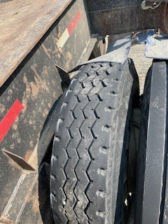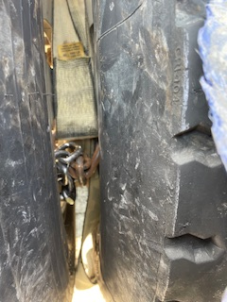
- 07/30 Stowe, Inspector conducted a commercial motor vehicle inspection. During the inspection 6 violations were discovered, to include the trailers breakaway cable not attached to the towing vehicle as well as the operator only having a class D driver’s license when a class A commercial driver’s license was required. The trailer as well as the driver were placed out of service.
- 07/30 Stowe, Inspector conducted a commercial motor vehicle inspection on commercial motor vehicle hauling a 10,250 lb. skid steer. During the inspection 8 violations were discovered, to include improper load securement of heavy vehicles (the skid-steer was only secured with one chain), Operating a class A commercial motor vehicle combination with a class D driver’s license, the trailers breakaway cable not attached to the towing vehicle. The operator as well as the trailer were placed about of service for the above violations.
- 07/30 Stowe, Inspector conducted a commercial motor vehicle inspection on a commercial motor vehicle hauling an excavator. During the inspection 13 violations were discovered, to include operating a class A required combination with only a class D driver’s license, an active fuel leak from the vehicles tank, a bearing filler cap missing on the trailer and operating a commercial motor vehicle without a valid medical certificate.
- 07/31 Waterford, Inspector conducted a traffic stop on a commercial motor vehicle for failing to obey traffic control devices. An inspection was conducted, and 3 violations were discovered, to include operating a commercial motor vehicle with de-activated/inactivated US DOT numbers when required. The vehicle was placed out of service.
- 07/31 Waterford, Inspector conducted a traffic stop on a commercial motor vehicle for failing to obey traffic control devices. An inspection was conducted, and a total of 14 violations were discovered, to include operating a commercial motor vehicle engaged in Intrastate commerce without a valid medical certificate, operating a commercial motor vehicle with de-activated/inactive US DOT numbers as well as both turn signals on the trailer were inoperative at the time of the inspection. The operator and the vehicle were both placed out of service.
- 07/31 Waterford, Inspector conducted a commercial motor vehicle inspection on a tractor trailer hauling grain. 4 violations were discovered to include the tractors’ emergency glad hose/tubing to have damage exceeding into the reinforcement ply. The trailer was placed out of service.
- 07/31 Waterford, Inspector conducted a commercial motor vehicle inspection on a tractor trailer hauling heavy equipment. 4 violations were discovered to include the tractors service glad hose/tubing to have damage exceeding the reinforcement ply as well as the tractor failing the air loss rate test. The vehicle was placed out of service for the violation.
- 07/31 Waterford, Inspector conducted a traffic stop on a commercial motor vehicle in interstate commerce for an inoperable brake lamp and no markings. An inspection was completed, and it was discovered the rearmost left turn signal was inoperable, the breakaway was not attached to the power unit, and the operator did not possess a class A commercial driver’s license while operating a class A combination. The vehicle and driver were placed out of service.
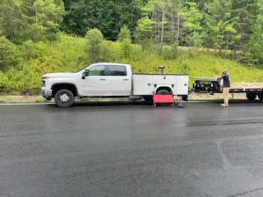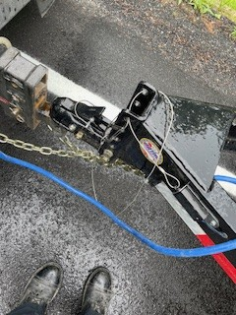
- 07/31 Waterford, Inspector conducted a non-bulk hazardous materials inspection on a commercial motor vehicle. One of the lead acid batteries was found to be missing the protections from the torminal arcing.
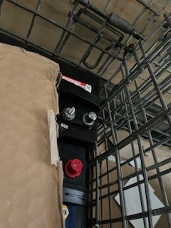

New Entrant:

Compliance Review:

Passenger Vehicles: Nothing to report.

NORTHWEST SECTOR:

Details:
- 7/29 – 3 Inspectors screened 259 commercial motor vehicles at the I 89 Colchester N weigh station detail. 16 Inspections were conducted and 43 violations detected. (3 driver and 40 vehicle). 1 driver and 10 vehicles were placed out of service.
- 7/31 – 3 Inspectors screened 125 commercial motor vehicles at the I 89 Georgia SB rest area detail. 18 Inspections were conducted and 12 violations detected. (2 driver and 10 vehicle).

Crashes:

Notables:
- 7/28 – Sgt. stopped a tractor trailer combination operating on I 89 in Williston for an equipment violation. The inspection revealed a tire was severely deflated on the trailer. The trailer was placed out of service.
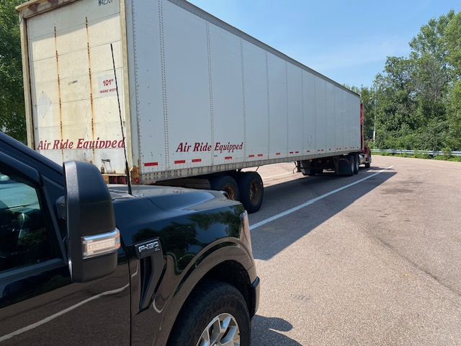

- 7/28 – Insp. attended Use of Force Instructor training.

- 7/28 – Insp. inspected a tractor trailer combination at the Fair Haven scale house. The inspection revealed a glad hand hose was damaged and the inner fabric ply was frayed. The combination was placed out of service for repair.
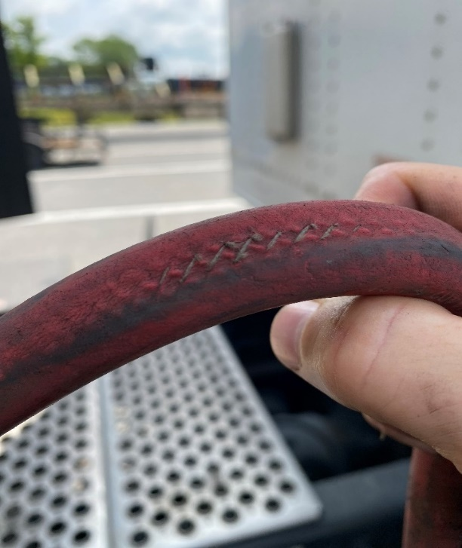

- 7/29 – Sgt. inspected a tractor trailer combination at the I 89 Colchester weigh station detail. The inspection revealed a tire was flat on the truck tractor. The truck tractor was placed out of service.

- 7/29 – Insp. inspected a truck at the I 89 Colchester weigh station detail. The inspection revealed a tire was flat on the vehicle and the truck was placed out of service.

- 7/29 – Insp. inspected a tractor trailer combination at the I 89 Colchester weigh station detail. The inspection revealed a tire was severely deflated on the truck tractor. The vehicle was placed out of service.
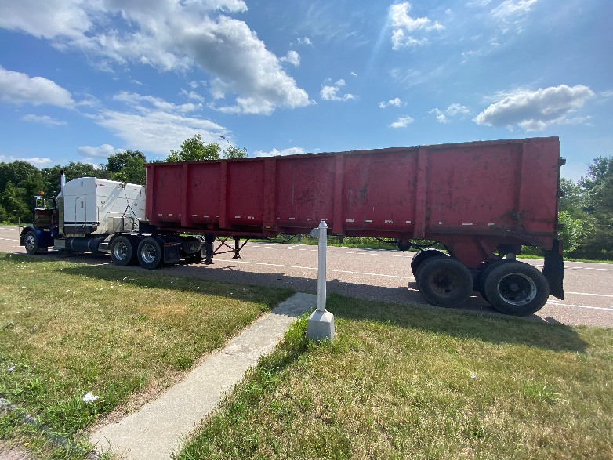

- 7/29 – Sgt. inspected a tractor trailer combination at the I 89 Colchester weigh station detail. The inspection revealed a tire was flat on the truck tractor. The truck tractor was placed out of service.

- 7/29 – Sgt. inspected a tractor trailer combination at the I 89 Colchester weigh station detail. The inspection revealed the power plug to the trailer was disengaged laying on the deck and the trailer had no operable lights. The trailer was placed out of service for the violation and the driver remedied the defect.

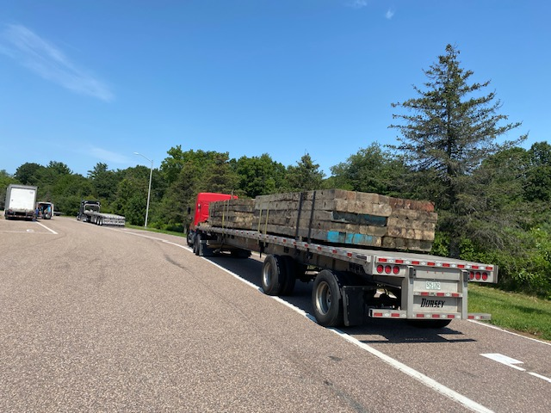

- 7/29 – Insp. inspected a truck at the I 89 Colchester weigh station detail. The inspection revealed a tire was severely deflated and the truck was placed out of service.
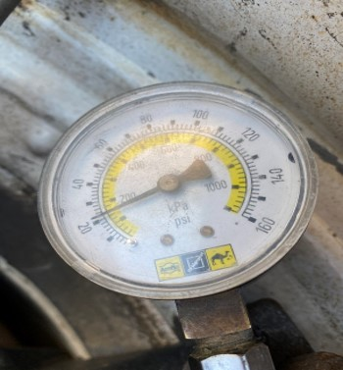

- 7/30 – Insp. inspected a box truck at the Fair Haven scale house. The inspection revealed the driver did not have a valid medical card. The driver was placed out of service for the violation.
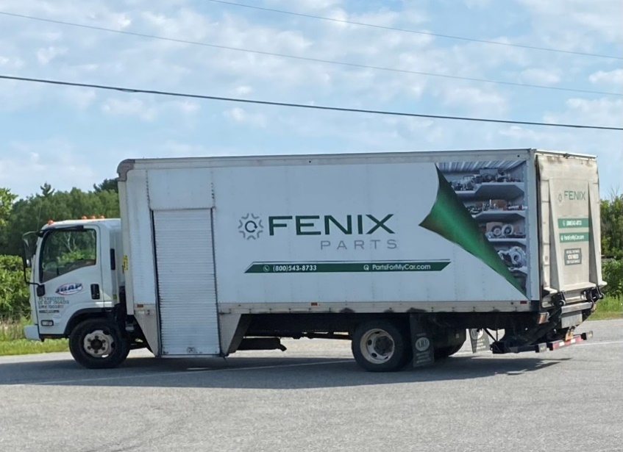

New Entrant:

SOUTH SECTOR:
Details:
- 7/28, I91N Springfield; 6 Inspectors screened 212 commercial vehicles and completed 23 inspections resulting in one driver and 25 vehicle violations; one driver and 5 vehicles were placed out of service. Additionally, 4 CVSA decals were issued for Level 1 inspections with no safety violations.
Crashes: Nothing to report.

Notables:
- 7/25, Inspector conducted an inspection on a truck and trailer combination. The truck was placed out of service for a tire that was flat and falling off the wheel.
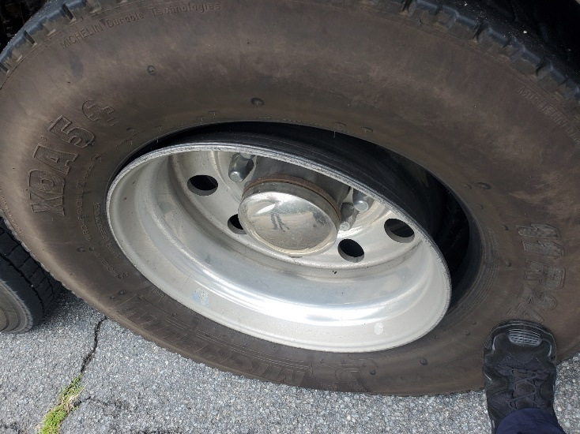
- 7/25, Inspector conducted an inspection on a truck and trailer combination. The trailer was placed out of service for the load not being properly secured per the federal regulations. The violation was repaired on scene by the driver.
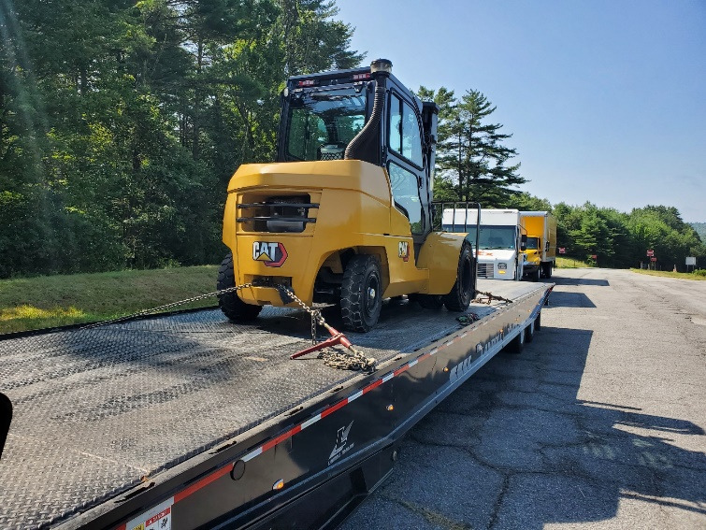

Passenger Vehicle: Nothing to report.

Traffic Enforcement:

During the week of 7.28--8.1 the Traffic Enforcement Unit conducted 85 inspections which resulted in 11 drivers and 13 vehicles being placed out of service.

Crashes: Nothing to report.

Notables:
- 7/28-Sgt. stopped the driver of a box truck for speeding on Route 22a in Orwell. The truck was placed out of service as the driver side wiper was detached, and wipers were required due to the weather conditions.
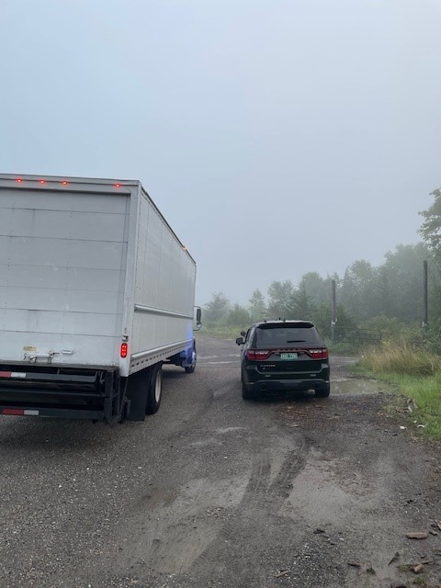
- 7/28, Fair Haven Scale House, Inspector placed a driver out of service for not having a commercial driver’s license. The Box truck weighed 29,980, thus requiring a Class B.
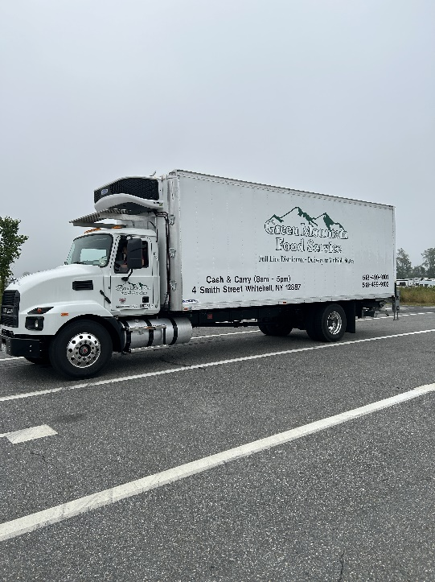
- 7/28, Fair Haven Scale House, Inspector inspected a NY based carrier. The truck weighed 87,100 with no overweight permit and had no IFTA. The truck was grounded.
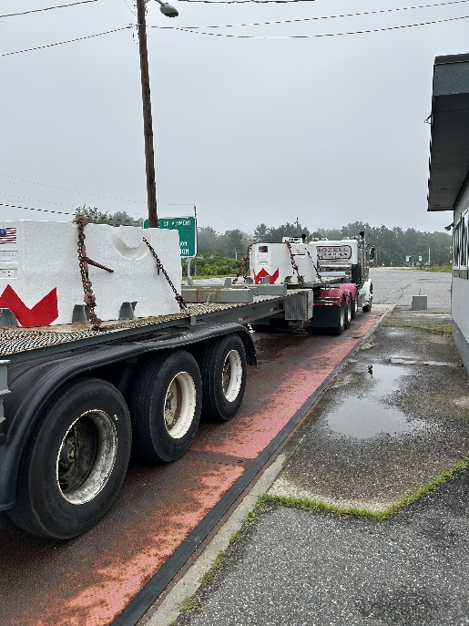
- 7/28, Fair Haven Scale House, Inspector grounded an oversize load for not having a permit. The cargo was 10’ wide.

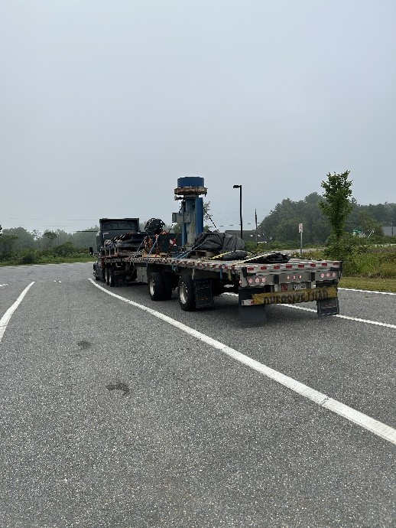
- 7/28, Inspector stopped a vehicle that failed to stop at the Fair Haven Scale House. The vehicle was escorted back to the weigh station. The driver was placed out of service for no medical card. The truck was placed out of service for an inoperable parking brake and an inactive USDOT registration. The trailer was placed out of service for no operable brakes, an inoperable rear turn signal and no breakaway cable. The truck was towed from the weigh station back to NY and the carrier was issued a Vermont Civil Violation Complaint.

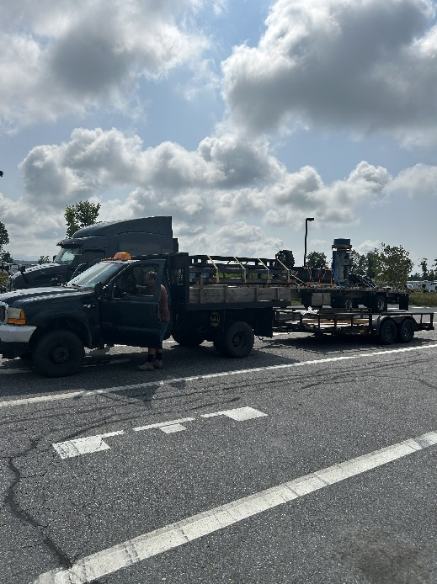
- 7/28, Inspector stopped an oversize load on Route 4 in Mendon. The hydraulic grapple of the skidder was not secured, placing the trailer out of service.

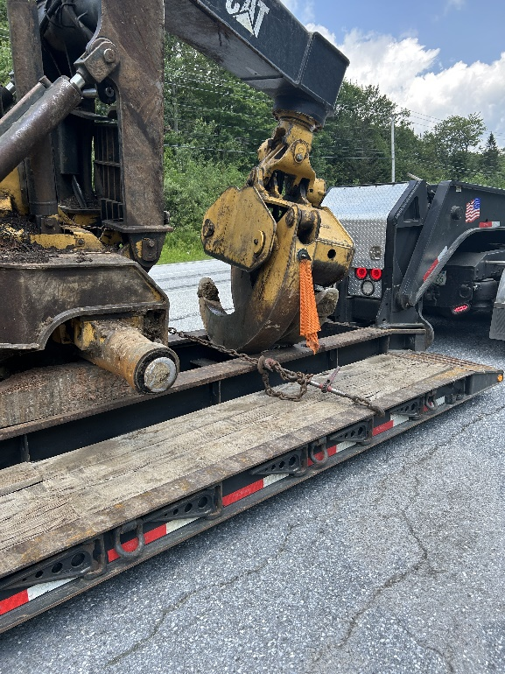
- 7/29--Sgt. inspected a tractor trailer at Colchester Weigh Station. The trailer was placed out of service for having no edge protection on the load as required and for a loose chain on the flatbed trailer.
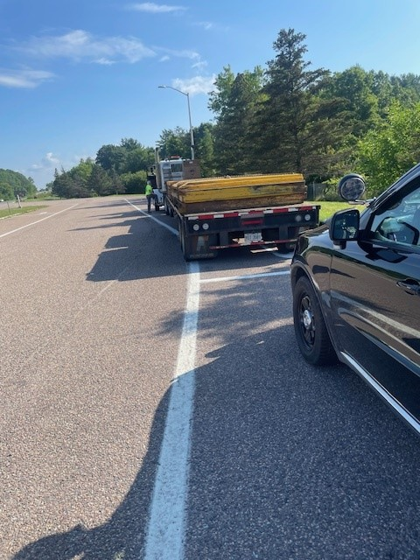
- 7/29--Sgt. inspected a tractor trailer at Colchester Weigh Station. The truck tractor was placed out of service as a glad hand hose had a hole in it.
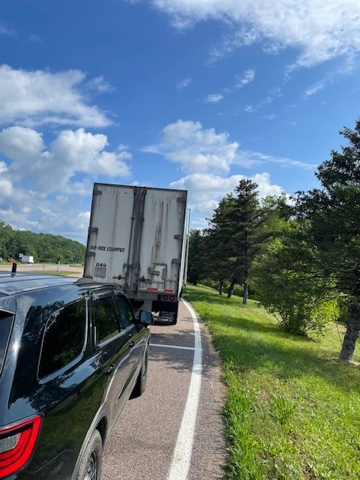
- 7/29—Sgt. inspected a tractor trailer at Colchester Weigh Station. The trailer was placed out of service for an inoperable rear turn signal.
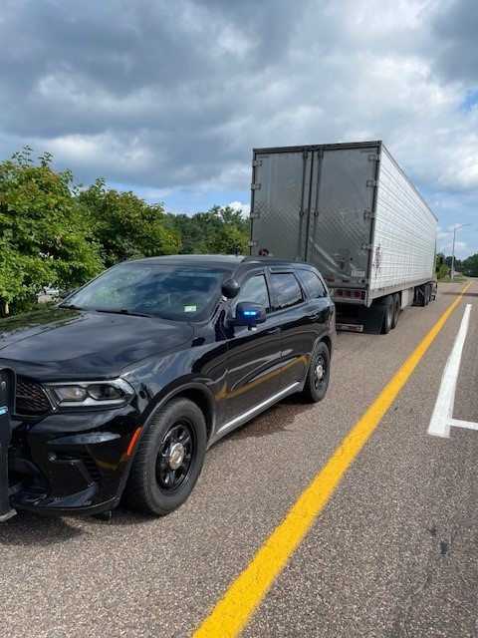
- 7/29--Sgt. inspected a truck and trailer at Colchester Weigh Station. The driver was placed out of service as the combination required a commercial driver’s license, and the driver had a Class D.
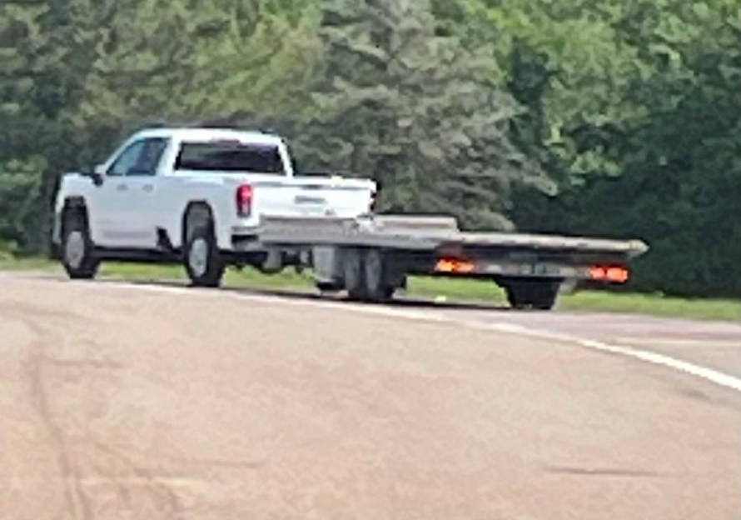
- 7/29--Sgt. inspected a tractor trailer at Colchester Weigh Station. The trailer was placed out of service for a hub cap missing allowing an open view into the hub assembly.
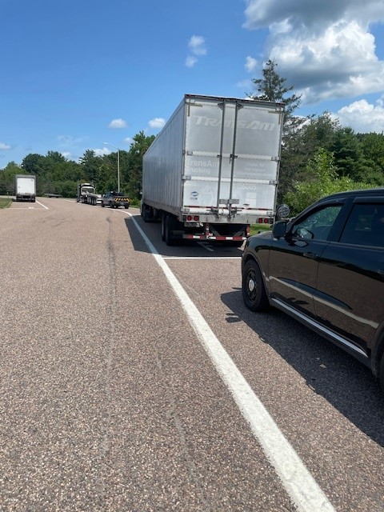
- 7/30--Sgt. stopped the driver of a tractor trailer for speeding on Route 22a in Orwell. The driver was placed out of service for not wearing corrective lenses while driving as required.
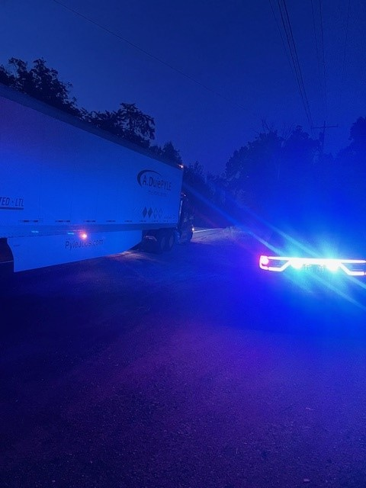
- 7/30--Sgt. stopped a truck tractor for no markings on Route 22a in Orwell. The commercial vehicle was grounded for having no International Fuel Tax Agreement. The driver was placed out of service for having a corrective lenses restriction on his commercial driver’s license and not wearing them or having them with him.
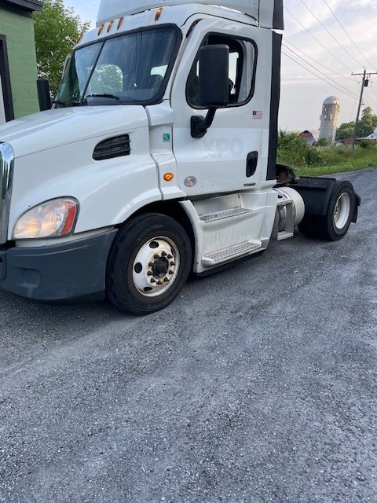
- 7/30-Sgt. stopped the driver of a tractor trailer for failing to pull into the open Fair Haven Scale House. The driver was placed out of service as his commercial driver’s license had a restriction requiring him to wear corrective lenses while driving and he was not.
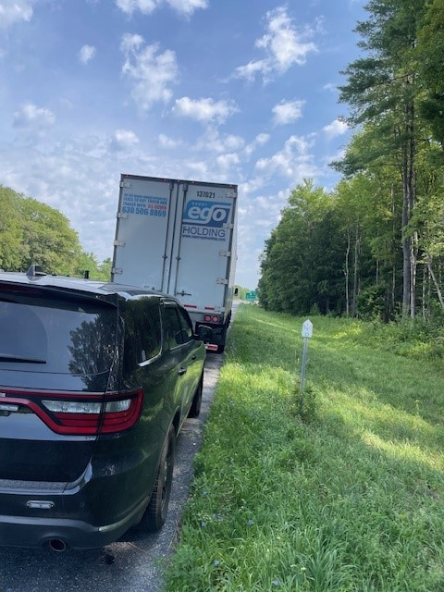

- 7/31--Sgt. stopped the driver of a tractor trailer for speeding on Route 22a in Orwell. The driver was placed out of service for having an intrastate only restriction on his commercial driver’s license. He was also 19 years of age.
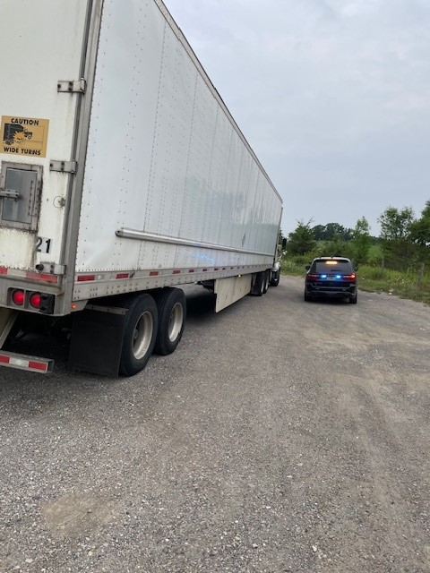
- 7/31--Sgt. stopped the driver of a tractor trailer for speeding on Route 22a in Orwell. The carrier was found to be suspended in Vermont and was grounded until the suspension could be lifted. The trailer was placed out of service for a flat tire.
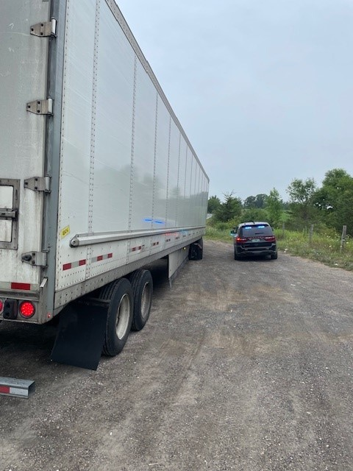
- 8/1-Sgt.stopped the driver of a tractor trailer for speeding on Route 22a in Orwell. The trailer was placed out of service for an air leak not at a proper connection and for none of the air suspension bags staying filled with air.
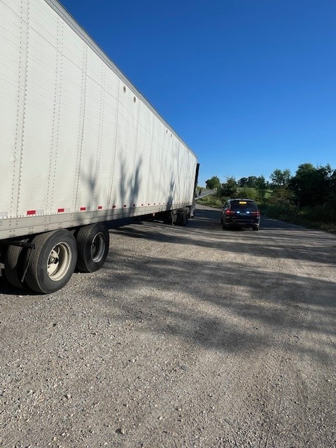
- 7/29-Insp stopped a truck/trailer for a marking violation on I-89 in Randolph. An inspection was conducted, and the trailer was placed out of service for a defective breakaway brake violation. The owner/operator issued several warnings.
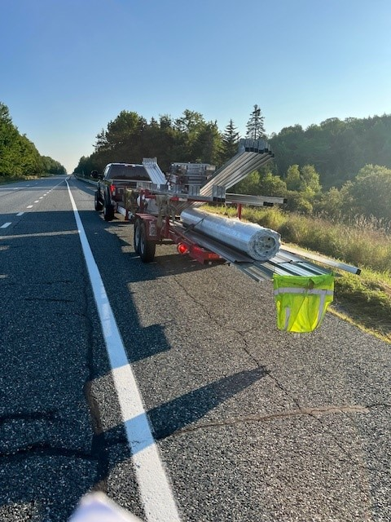
- 7/30- Insp stopped a truck/trailer for an expired inspection sticker on I-89 in Berlin. An inspection was conducted, and the vehicle combination required a Class A commercial driver’s license. The driver was placed out of service for no Class A commercial driver’s license/no med card. This is the second time the driver was inspected and had no commercial driver’s license. The carrier was issued a ticket.
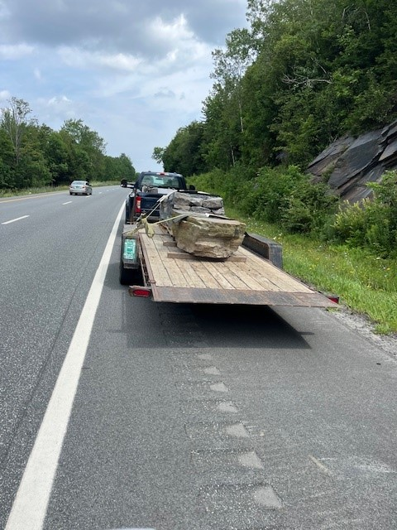
- 7/30- Insp stopped a truck/trailer for a marking violation on I-89 in Berlin. An inspection was conducted, and the driver was placed out of service for no med card. The trailer was placed out of service for a defective breakaway brake system. The driver was issued a warning.
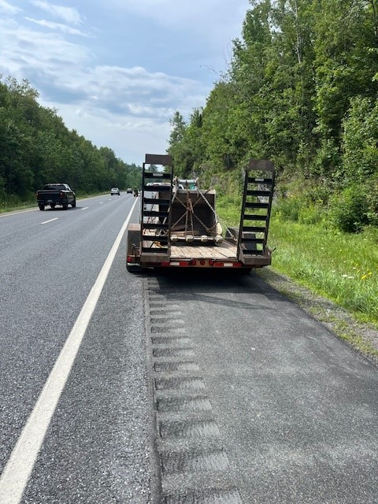
- 7/31- Insp stopped a truck for failing to stop at the Waterford Detail on I-93. An inspection was conducted, and the driver was placed out of service for no med card. The driver was issued a warning.
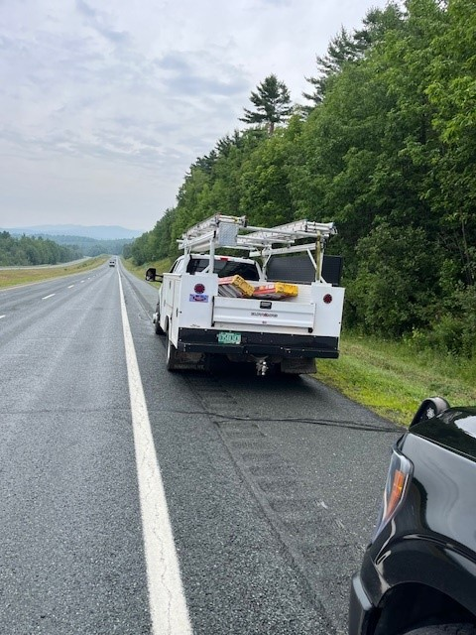
- 7/31- Insp stopped a truck/trailer for a marking violation on I-93 in Waterford. An inspection was conducted, and the driver was found to be in possession of alcoholic beverages. The owner/operator was placed out of service and issued several warnings.
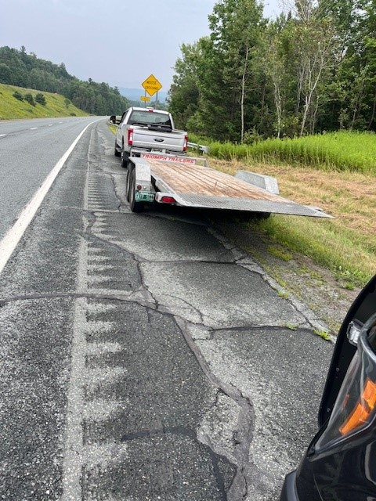

HQ Sergeant:

- 7/27: Sgt. inspected a motorcoach at the Highgate port of entry on I89.
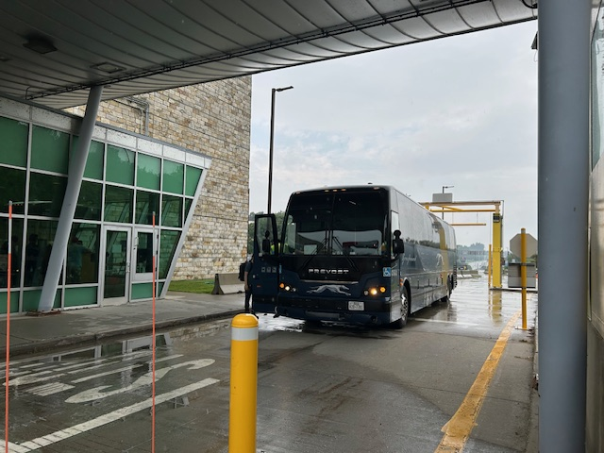
- 7/29: Sgt. attended the VT Judicial Bureau waiver penalty panel meeting.

New Entrant:

