Commercial Vehicle Enforcement

NORTHEAST SECTOR:

Details:
- 07/22 Us Rte. 2 in Concord, 4 Inspectors completed 18 inspections which resulted in 13 vehicle violations and 12 driver violations (1 out of service).

Crashes:

Notables:
- 07/21 Fairlee, Inspector conducted an inspection on a commercial motor vehicle in interstate commerce which failed to display markings. During the inspection, 10 violations were discovered, 5 of which were out of service violations which included: Breakaway not attached to the power unit, 4/8 brakes being defective, binders and chains unsecured dunnage, all hubs on trailer with broken filler caps allowing an open view to the hub assembly, and a disqualified license. The driver and vehicle were placed out of service.
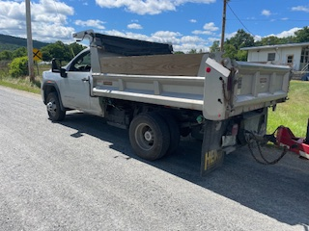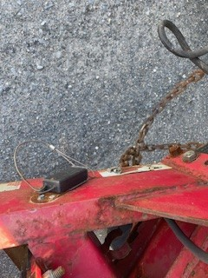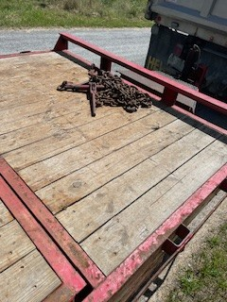
- 07/22 Concord, Inspector conducted an inspection on a commercial motor vehicle and discovered the driver was currently in violation of driving more than 11 hours and being more than 14 hours on duty due to misuse of personal conveyance. The driver was placed out of service.
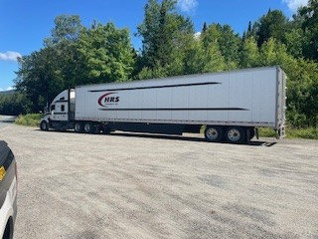
- 07/23 Highgate, Sgt stopped a commercial motor vehicle for a lighting violation, a portable weigh was completed, and the combination was found to be 6,000lbs over its allowable gross weight. The trailer was placed out of service for inoperable brake lamps.
- 07/23 Swanton, Sgt stopped a truck / trailer combination for a registration violation. The truck and trailer were found to not be registered, the owner / operator was issued a VCVC.
- 07/23 Coventry, Sgt stopped a commercial motor vehicle which was hauling a piece of farm equipment. The load required a permit due to its width and the carrier did not obtain one prior to transporting the load. The combination was grounded, and the carrier was permitted roadside.
- 07/23 Lyndon, Inspector observed a commercial motor vehicle transporting an excavator weighing more than 10,000 lbs., Inspector observed the excavator's boom was not secured. An inspection was conducted, and several violations were discovered to include the excavators’ boom not secured, the trailers breakaway cable not attached to the towing vehicle, and the operator did not have the proper CDL class to operate this combination. Both the operator and the trailer were placed out of service.
- 07/24 Danville, Inspector conducted a traffic stop on a commercial motor vehicle for traveling 70 mph in a posted 50 mph zone. An inspection was completed, and the operator received a ticket for the speeding violation.
- 07/25 Derby, Inspector conducted a traffic stop on a commercial motor vehicle in which the driver failed to wear his seatbelt. An inspection was completed, and 17 violations were discovered, 3 of which were out of service violations which included: more than 20% of the brakes being defective, a flat tire, and a rearmost turn signal was inoperable. The vehicle was placed out of service and received a ticket.
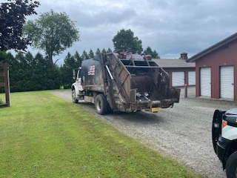
- 07/25 Barton, Inspector conducted a portable weigh on a dump truck. The dump truck was found to be 10,900 lbs. over its allowable weight.
- 07/25 Barton, Inspector observed a dump truck hauling sand. Both an inspection as well as a portable weigh were conducted on the vehicle. A total of 13 violations were discovered as well as multiple out of service violations to include: both turn signals at the rear of the vehicle were inoperative and the weight carried on both steer tires exceeded the rated load limit as well as the steer axle supporting 6,900 lbs. in excess of its allowable weight. The vehicle was placed out of service.

New Entrant:

Compliance Review:

Passenger Vehicles: Nothing to report.

NORTHWEST SECTOR:

Details:
- 7/22 – 3 Inspectors screened 75 commercial motor vehicles at the US Rte 7 Ferrisburgh detail.
15 Inspections were conducted and 23 violations detected. (1 driver and 22 vehicle). 3 vehicles were placed out of service.
- 7/23 – 3 Inspectors, 1 VSP Trooper, and 1 FMCSA Inv. screened 265 commercial motor vehicles at the I 89 Colchester NB weigh station detail. 17 Inspections were conducted and 46 violations detected.
(5 driver and 41 vehicle). 7 vehicles and 2 drivers were placed out of service.

Crashes:

Notables:
- 7/22 – Sgt. inspected a truck hauling a trailer at the US Rte. 7 Ferrisburgh detail. The inspection revealed the emergency break away device was defective and not hooked to the towing vehicle. The trailer was placed out of service.
- 7/22 – Insp. inspected a tractor trailer combination at the US Rte. 7 Ferrisburgh detail. The inspection revealed the rear most stop lamps were inoperative on the trailer. The trailer was placed out of service for repair.
- 7/22 – Insp. inspected a tractor trailer combination hauling cars at the US Rte. 7 Ferrisburgh detail. The inspection revealed multiple wheel straps had fallen off the tires. The trailer was placed out of service until the vehicles were properly secured.

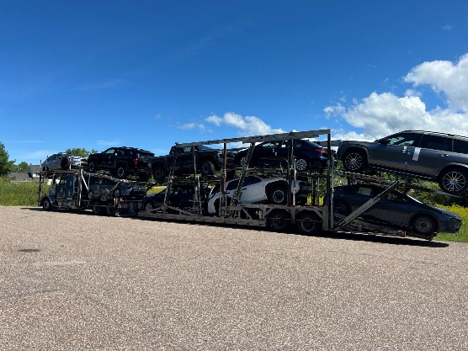
- 7/23 – Insp. inspected a truck at the I 89 Colchester NB weigh station detail. The inspection revealed a tire was severely deflated on the vehicle. The vehicle was placed out of service for repair.

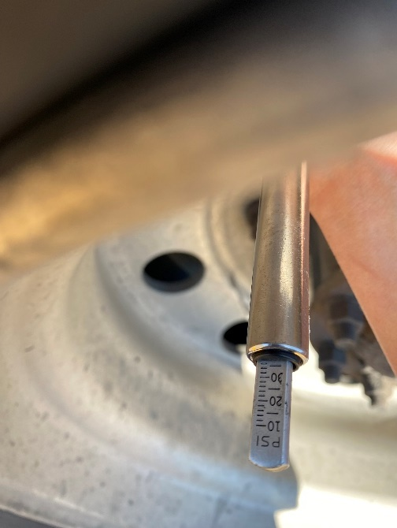

- 7/23 – Sgt. inspected a truck hauling a trailer at the I 89 Colchester NB weigh station detail. The inspection revealed the emergency breakaway device was defective and not hooked to the power unit. The trailer was placed out of service for repair.
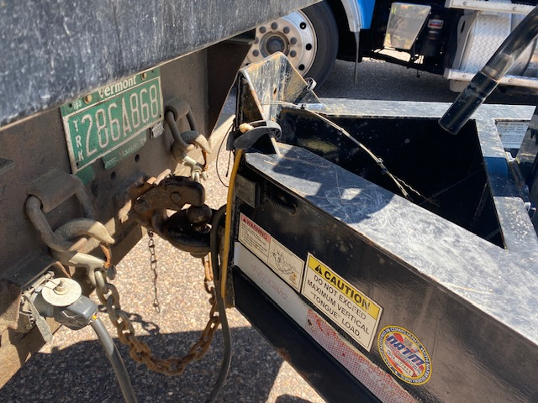

- 7/23 – Insp. inspected a tractor trailer combination at the I 89 Colchester NB weigh station detail. The inspection revealed a glad hand hose was chafed and the inner fabric ply was frayed. The combination was placed out of service for repair.
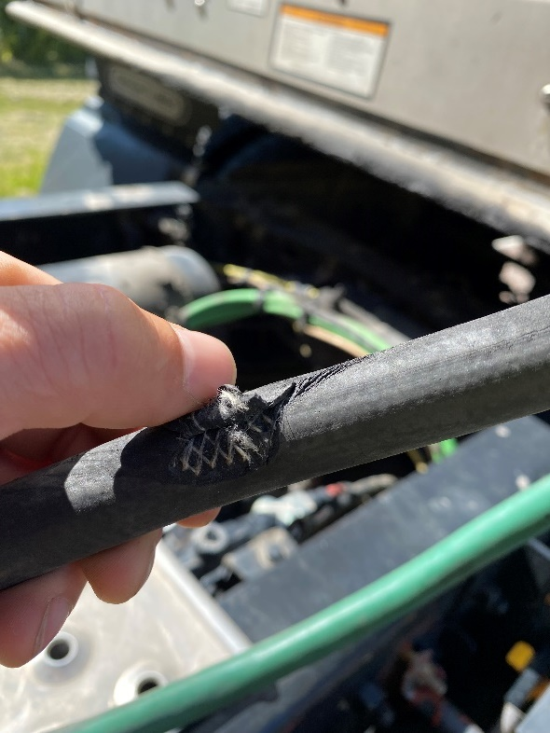

- 7/23 – Insp. inspected a box truck at the I 89 Colchester NB weigh station detail. The inspection revealed a tire was severely deflated on the truck. The truck was placed out of service.
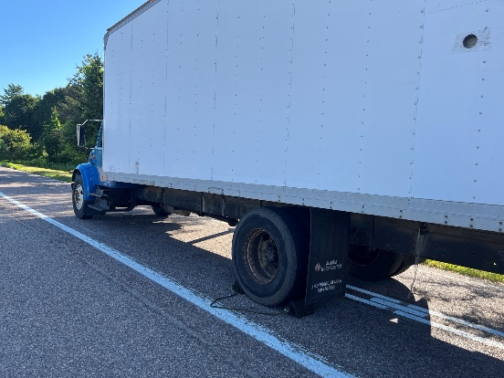
- 7/23 – Insp. inspected a truck hauling a flatbed trailer at the I 89 Colchester NB weigh station detail. The inspection revealed a heavy machine was not secured properly on the trailer as multiple chains were loose. The trailer was placed out of service until the load securement violation was repaired.
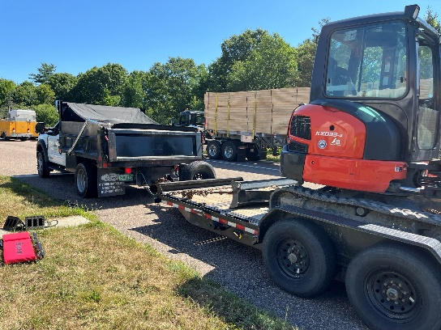
- 7/24 – Insp. stopped a passenger car on I 89 in Chittenden County for misuse of plates. Further inquiry revealed the Volkswagen sedan was not registered. An antique VT registration plate was seized, the vehicle was towed, and the operator was ticketed.
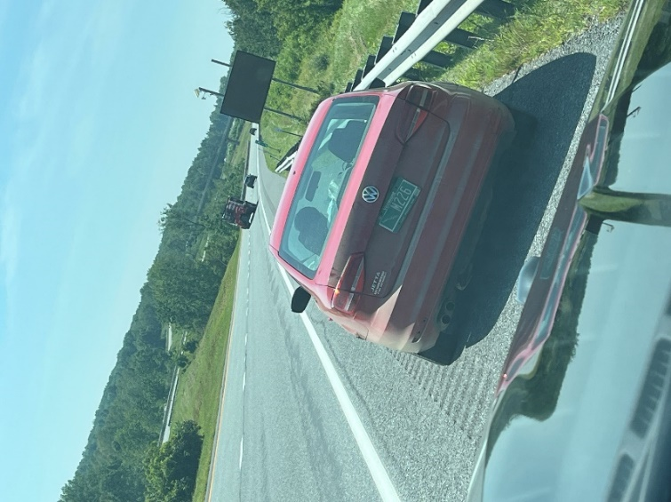
- 7/25 – Insp. participated in an evening DUI checkpoint in Grand Isle County. She was joined by members of the VT State Police and Grand Isle Sheriffs. Over 600 vehicles were screened resulting in one arrest and one DRE evaluation.
- 7/25 – Insp. responded to Barre Town to assist with a DRE evaluation.

New Entrant: Nothing to report

SOUTH SECTOR:
Details:
- 7/22, I91N Hartford; 6 Inspectors screened 233 commercial vehicles and completed 17 inspections resulting in 12 vehicle violations; one vehicle was placed out of service. Additionally, 2 oversized and 4 overweight permits were checked for compliance. One CVSA decal was issued for a Level 1 inspection with no safety violations. One ticket, in the amount of $5,048, was issued for an overweight violation.

- 7/23, I91S Putney Scale; 5 Inspectors screened 173 commercial vehicles and completed 16 inspections resulting in 2 driver and 2 vehicle violations. Additionally, one oversize permit was checked for compliance and one CVSA decal issued for a Level 1 inspection with no safety violations. One ticket, in the amount of $323, was issued for an overweight violation.
Crashes:

Notables:
- 7/22, Hartford, Sgt. placed a 4-axle combination out of service for an improperly connected emergency breakaway cable; the cable was connected to the receiver hitch-pin retainer pin.
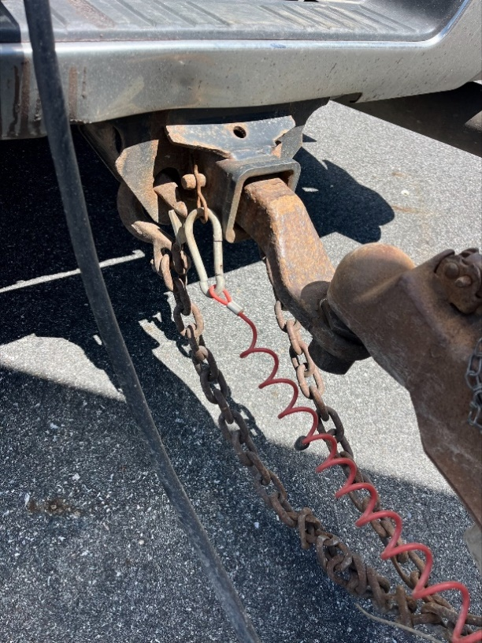
- 7/22, Inspectors attended the NSTI camp at the Hartford AOT garage. Inspector put on K9 demonstrations with K9 Anne while Inspectors and spoke with the groups and displayed the cruisers and equipment.
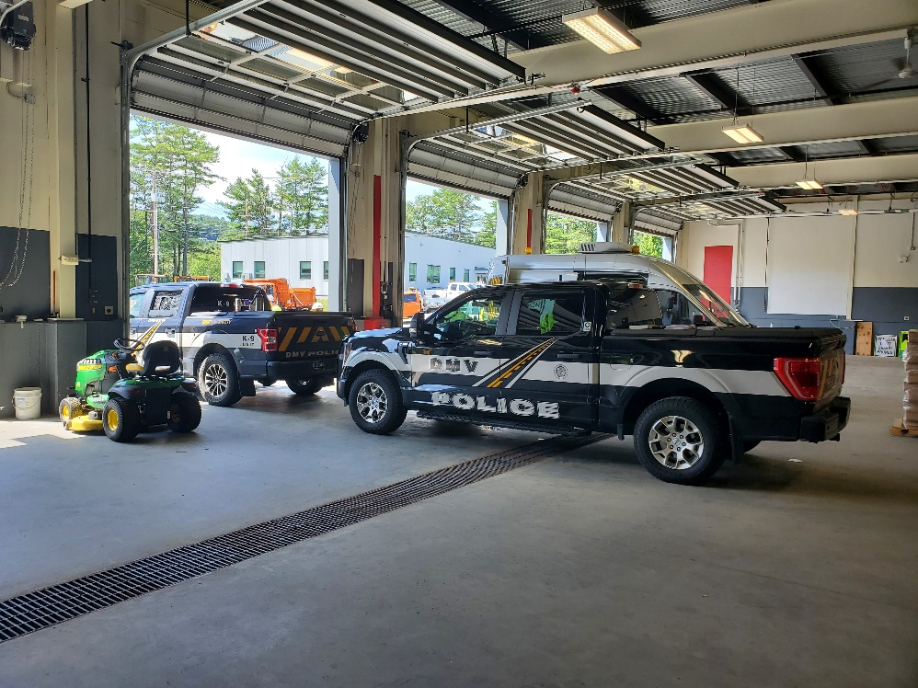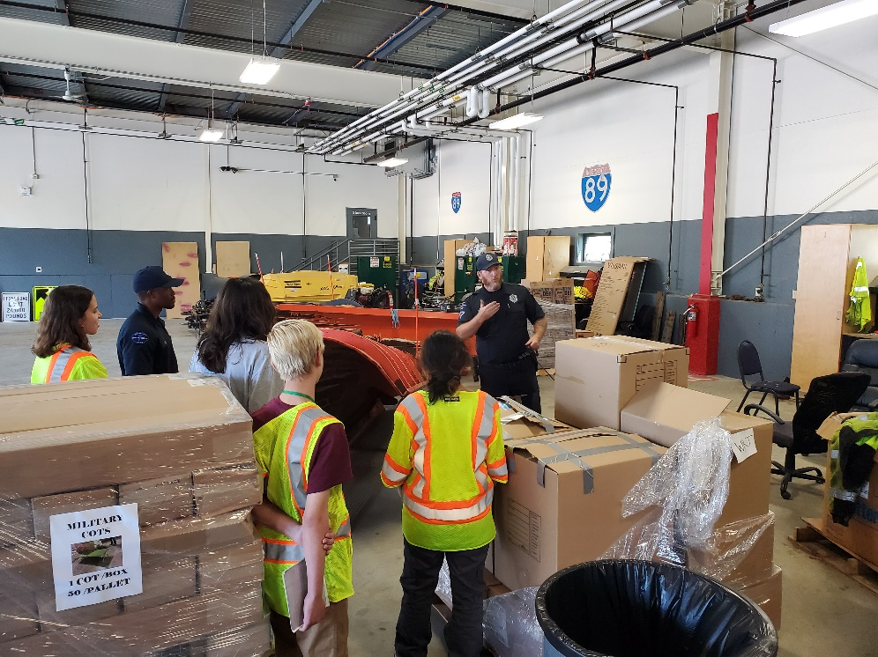
- 7/23, Putney Scale, Sgt. issued a ticket, in the amount of $323.00, for an overweight violation to a carrier transporting unprocessed milk; the maximum allowed (permitted) gross weight was 99,000 lbs., however, the weight of the vehicle and load measured 106,320 lbs.

Passenger Vehicle: Nothing to report.

Traffic Enforcement:

During the week of 7.21-7.25 the Traffic Enforcement Unit conducted 59 inspections which resulted in 13 drivers and 7 vehicles being placed out of service.

Crashes: Nothing to report.

Notables:
- Inspector facilitated final install of flashing beacons at the Colchester North Weigh Station. Inspectors will no longer need to deploy portable signs during rush hour traffic, greatly enhancing officer safety. Flashing beacons are bringing Vermont Weigh Stations in line with standards across the country. Several more locations are planned for this summer and fall.
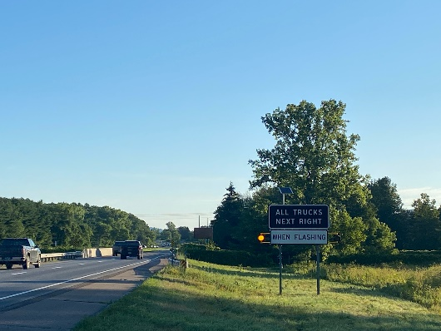
- 7/21--Sgt. stopped the driver of a tractor trailer for speeding on Route 22a in Orwell. The driver was found to be suspended in his licensing State of NJ and was placed out of service. The axle 1 driver side tire contacted the air hose into the brake chamber when the wheel was turned to the left and the axle 2 passenger side tire had a tarp riding on it. The truck tractor was placed out of service for these violations.
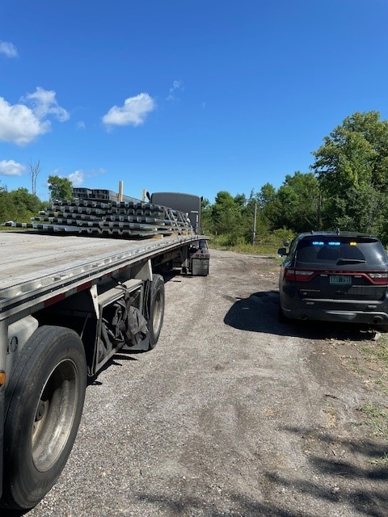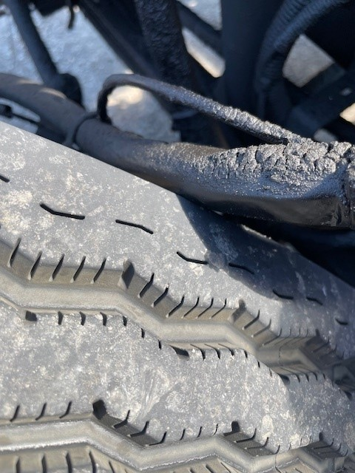
- 7/21, White River SB, Inspector placed a driver out of service for no medical card. The truck was placed out of service for an inactive USDOT number.

- 7/21, White River SB, Inspector placed a driver out of service for no medical card.
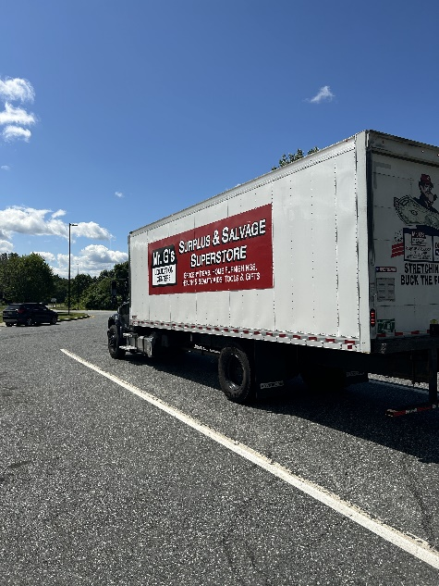
- 7/21--Sgt. stopped the driver of a box truck for speeding on Route 22a in Orwell. The driver was placed out of service for driving over 14 hours without 10 hours off duty. The driver had no sleeper berth.
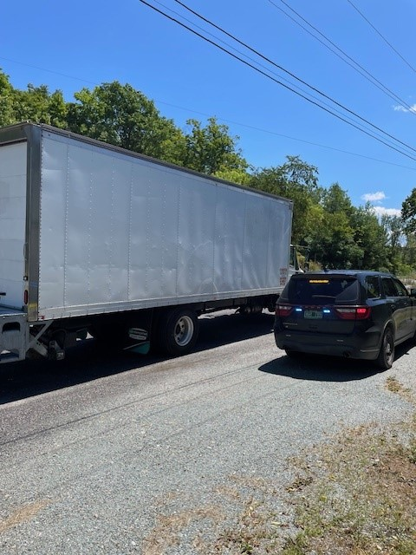

- 7/22--Sgt. attempted to stop the driver of a tractor trailer for speeding on Route 22a in Orwell for approximately 10 miles. The driver failed to stop for lights and siren while acknowledging that he saw me behind him. The truck tractor was placed out of service for a fuel leak, dripping on the highway.
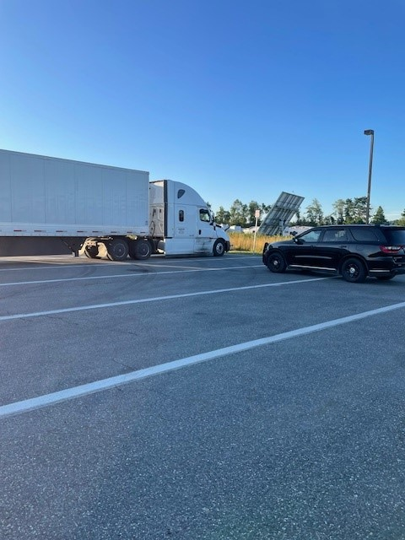
- 7/22, Fair Haven Scale House, Inspector placed a driver out of service for no medical card. The truck was placed out of service for an inoperable parking brake.

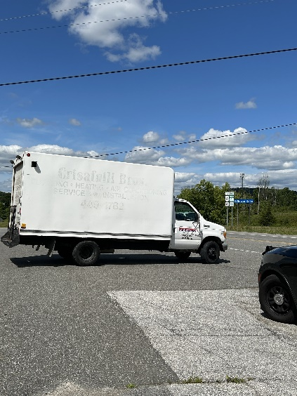
- 7/22, Fair Haven Scale House, Inspector inspected a NY based garbage truck and found the truck to have no IFTA as required. The carrier sent the truck back to NY.
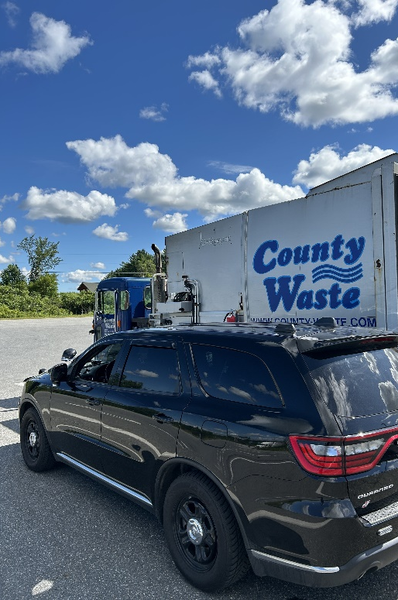

- 7/22, Inspector stopped an interstate truck on Route 3 in Proctor. The carrier failed to register for a USDOT number prior to interstate operations. The driver had no medical card and was placed out of service.
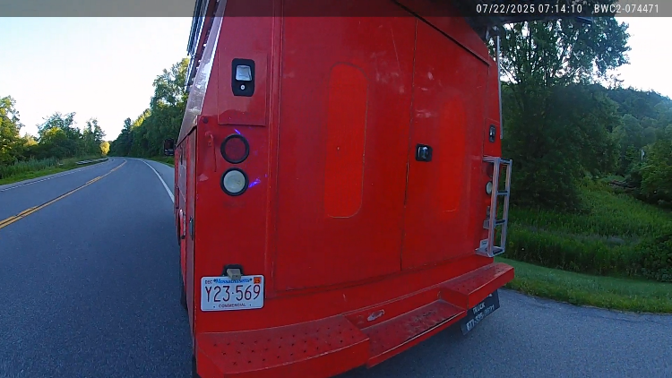

- 7/23, Inspector stopped an oversize load on Route 4 in Mendon. The carrier failed to receive a permit prior to moving the oversize load. The 60,000-pound excavator did not have securement over the boom nor enough overall securement and was placed out of service. The carrier was issued a Vermont Civil Violation Complaint and grounded until permitted.
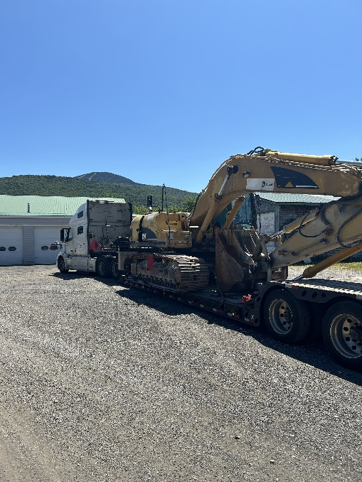
- 7/24, Inspector stopped an oversize load on I-89 in Randolph. The truck was grounded under proper oversize load flagging was displayed.
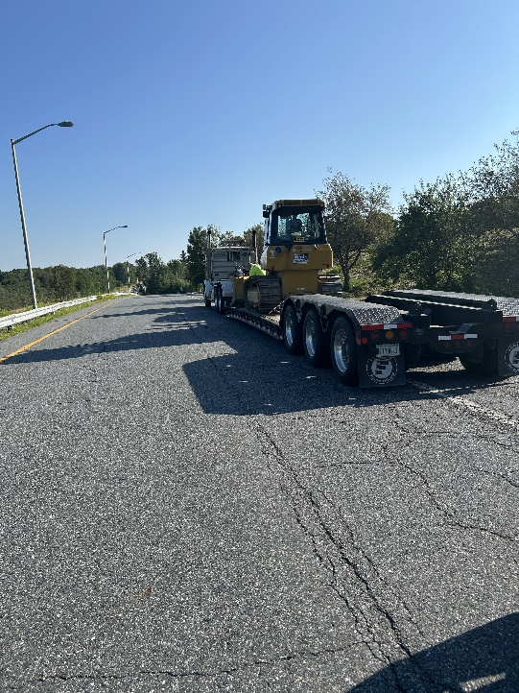
- 7/24, Inspector stopped an interstate vehicle on I-89 in Randolph. The driver was placed out of service for no medical card. The trailer was placed out of service for inoperable brakes and no breakaway cable.
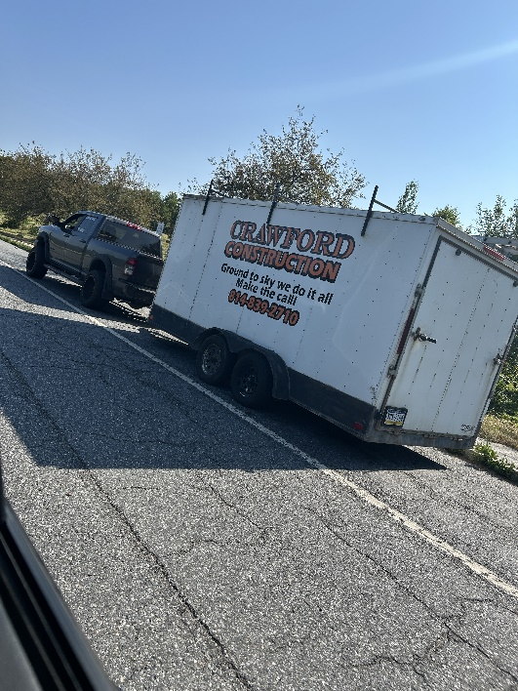

- 7/24, Inspector stopped a passenger car on a local road in Mendon for traveling 67 mph on a 35-mph road. The driver was issued a Vermont Civil Violation Complaint in the amount of $489 and 8 points.
- 7/21- Insp stopped a truck and trailer on I-89 in Randolph for a marking violation. An inspection was conducted, and the driver was placed out of service for no medical card. The trailer was placed out of service for no breakaway system. The owner/operator was issued a warning.
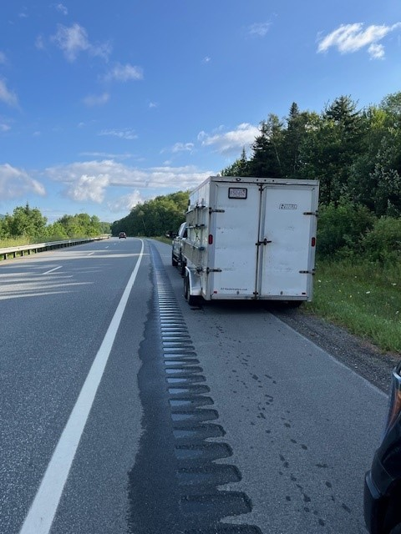
- 7/22- Insp stopped a truck and trailer on I-91 in Hartford for failing to stop at the Hartford NB detail. An inspection was conducted, and the driver was placed out of service for no medical card. The driver was issued a warning.
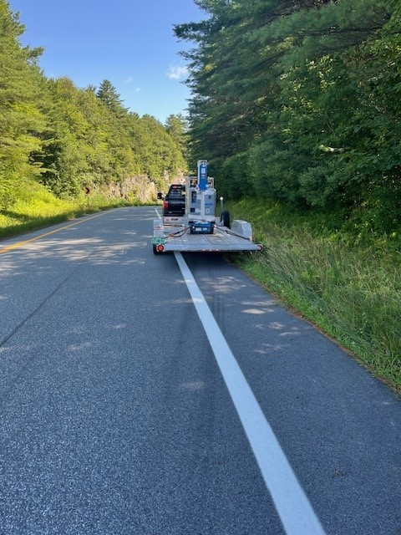
- 7/22- Insp stopped a truck and trailer for failing to stop at the I-91 detail in Hartford. An inspection was conducted, and the driver was placed out of service for no med card/no previous 7 days logs and inability to speak English. The trailer was placed out of service for a missing breakaway system. The driver had driver 22 hours non-stop from Georgia. The carrier was issued a ticket for permitting an unqualified driver to operate a commercial motor vehicle.
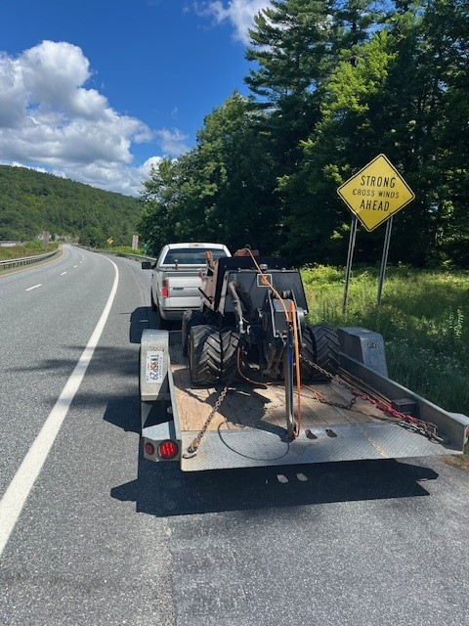
- 7/23- Insp stopped a tractor-trailer for a marking violation on I-89 in Brookfield. An inspection was conducted, and the driver was placed out of service for no previous 7 days logs. The driver was issued a warning.
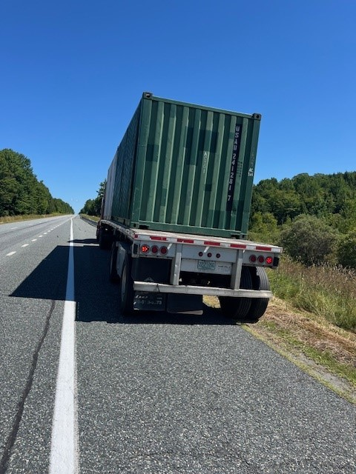
- 7/25- Insp stopped a truck/trailer on VT Rte. 63 in Berlin for speeding and a marking violation. An inspection was conducted, and the driver was placed out of service for being under 21 years old in inter-state commerce and no medical card. The carrier was found to have an Intrastate only USDOT# and was placed out of service for operating beyond the scope of their operating authority. The trailer was placed out of service for a defective breakaway system. The carrier was issued a Vermont Civil Violation Complaint for permitting an unqualified driver to operate.
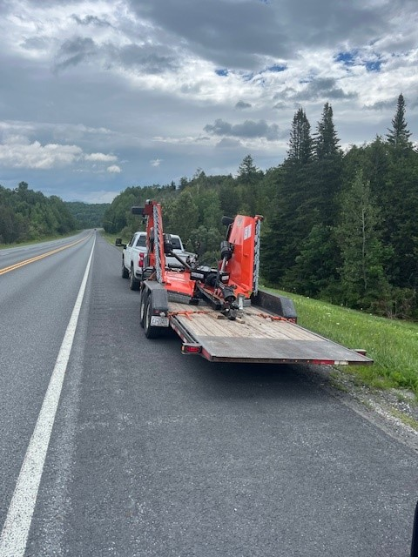
- Insp stopped two passenger cars on I-89 in Williamstown for Speeding around commercial motor vehicles. The drivers were both issued tickets for speeds of 96 and 97 MPH.

HQ Sergeant:

New Entrant:

