Commercial Vehicle Enforcement

NORTHEAST SECTOR:

Details:
- 09/17, Inspectors from the Northeast sector attended the Northwest detail.

Crashes:

Notables:
- 09/16 Coventry, Inspector conducted an inspection on a commercial motor vehicle and discovered the emergency glad hose, and a service brake hose had chafing into the reinforcement ply causing it to be frayed the vehicle was placed out of service.
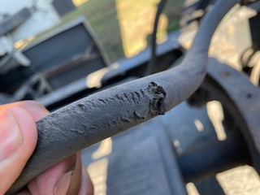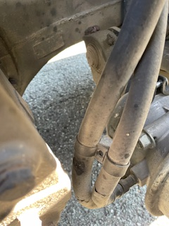
- 09/16 Greensboro, Inspector conducted a traffic stop on a box truck which failed to display their rear registration plate. A portable weight was also conducted concluding the vehicle was 6,301 lbs. over their registered weight and requiring a class B commercial driver’s license (CDL). The driver did not have a CDL and was found to be in possession of marijuana and consumed marijuana within the last 24 hours. An inspection was completed, and the driver was placed out of service and received a ticket.
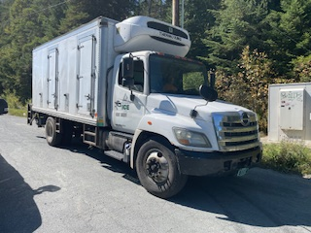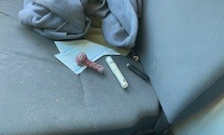
- 09/16 Saint Johnsbury, Inspector conducted a traffic stop on a dump truck due to its load being uncovered causing dust and debris to blow freely onto the roadway and other motorists causing traffic to slow down.
- 09/17 Colchester detail, Inspector conducted an inspection on a commercial motor vehicle identified to have a flat tire, which was located, and the vehicle was placed out of service until repaired.
- 09/17 Colchester detail, Cpl conducted an inspection on a commercial motor vehicle and located the sway bar bushings on the left and right sides axles 1 and 2 were worn and the sway bar could be moved by hand.
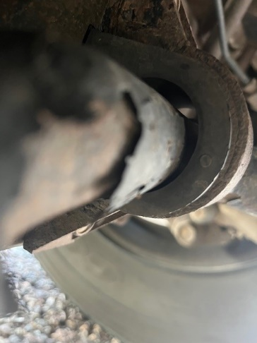
- 09/17 Colchester detail, Cpl conducted an inspection on a commercial motor vehicle operating under an over-dimensions permit but did not have a rear sign mounted, there were two flat tires, and the truck did not have a tractor protection valve that was operational.
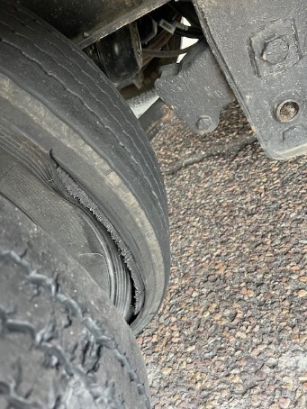
- 09/17 Coventry, Inspector conducted an inspection on a commercial motor vehicle and found a total of 8 violations to include, the trailers breakaway cable not attached to the towing vehicle, the operator of the commercial vehicle did not have a medical or a commercial driver’s license. The operator and vehicle were placed out of service.
- 09/17 Coventry, Inspector conducted an inspection on a commercial motor vehicle and discovered the operator to not have a valid medical certificate. The operator was placed out of service.
- 09/17 Derby, Inspector conducted a commercial motor vehicle and found a total of 7 violations to include the trailers breakaway cable not attached to the towing vehicle as well as the operator to not have a commercial motor vehicle driver’s license or a valid medical certificate. The operator and vehicle were placed out of service.
- 09/17 Barton, Inspector conducted an inspection on a commercial motor vehicle and found 7 violations to include the trailers breakaway cable not attached to the towing vehicle as well as one of the trailers turn signals to be inoperative. The trailer was placed out of service.
- 09/18 Waterford, Inspector conducted an inspection on a commercial motor vehicle and found the stop lamps to be inoperative. The vehicle was escorted back to its carrier and placed out of service.
- 09/18 Eden, Inspector conducted an inspection and portable weigh on a commercial motor vehicle and discover the driver was operating a class A combination with no commercial driver’s license, the vehicle had a loose chain and a 2 inch synthetic strap with a ½ inch tear causing machinery to be unsecured, the breakaway was not attached to the power unit, the parking brake was inoperable, and the vehicle was found to be 14,801 lbs. over its registered weight. The vehicle and driver were placed out of service and the driver was issued a ticket.
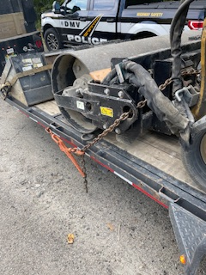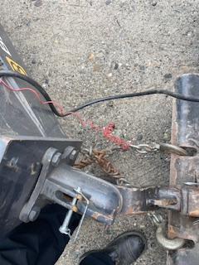
- 09/19 Island Pond, Inspector conducted an inspection on a commercial motor vehicle and found 6 violations to include the trailers breakaway cable not attached. Inspector Cotnoir instructed the operator how to properly attach this cable.

New Entrant:

Compliance Review:

Passenger Vehicles: Nothing to report.

NORTHWEST SECTOR:

Details:
- 9/16 - US Rte. 7 Leicester; 3 Inspectors screened 94 commercial vehicles and completed 11 inspections detecting 3 driver and 22 vehicle violations; 1 driver and 5 vehicles were placed out of service. 3 tickets were issued. Detail was closed early due to state police crash activation for a minor crash.

Crashes: Nothing to report.

Notables:
- 9/16 Leicester detail; Insp. stopped a work truck hauling an excavator that failed to stop at an open detail. The inspection revealed the driver did not possess a class A and one was required. The driver was placed out of service. The truck and trailer were placed out of service for load securement, an inoperative breakaway device, and an unsecured pintle hitch.
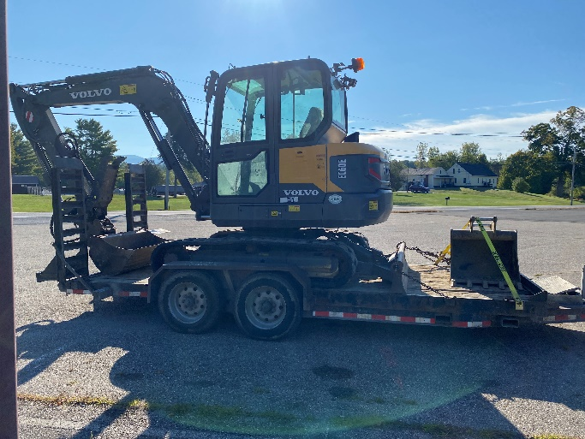
- 9/16 Leicester detail; Sgt. inspected a truck, and the inspection revealed a tire was severely deflated on the vehicle. The vehicle was placed out of service.
- 9/16 Leicester detail; Sgt. inspected a tractor trailer combination, and the inspection revealed the truck tractor did not have an operative low air pressure warning signal or light. The truck tractor was placed out of service for repair.
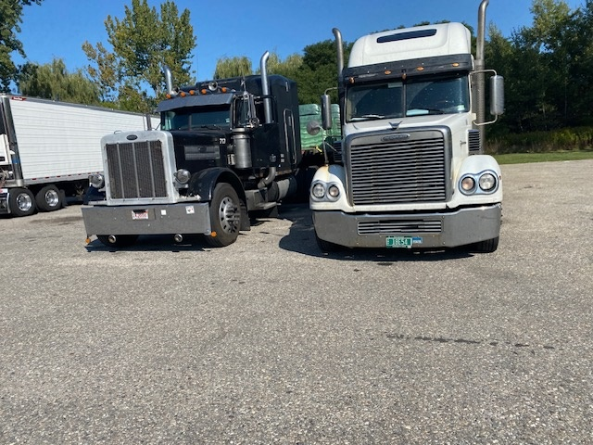
- 9/16 – Leicester Detail; Sgt. stopped a northbound tractor trailer unit for an observed load securement violation. The trailer was loaded with pallets of wood pellets and the first tier on the flatbed trailer was only secured with 1 strap when 2 are required. The trailer was placed out of service until the driver remedied the out of service violation.
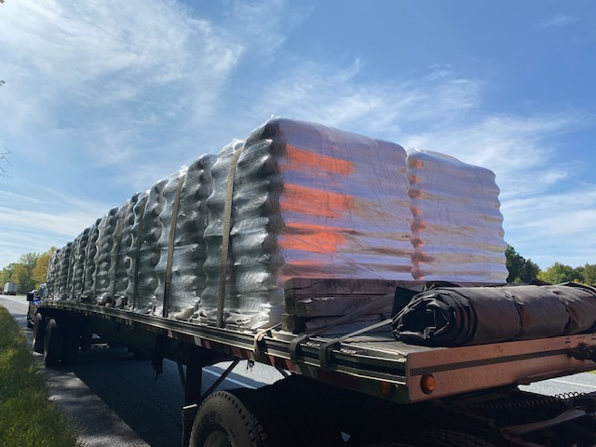
- 9/17 – I 89 Colchester N weigh station detail; Insp. inspected a tractor trailer combination. The inspection detected a flat tire and a leaking wheel seal contaminating the friction surface of the brake system. The truck tractor was placed out of service for repair.
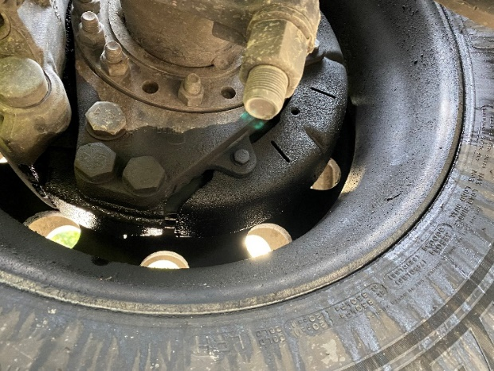
- 9/17 – I 89 Colchester N weigh station detail; Insp. inspected a tractor trailer combination. The inspection revealed a tire was flat on the trailer. The trailer was placed out of service.
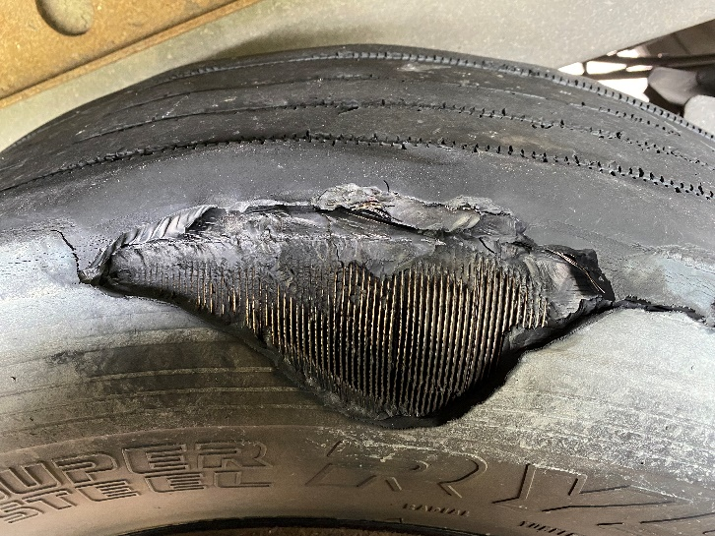

- 9/17 – I 89 Colchester N weigh station detail; Insp. inspected and weighed a tractor trailer combination hauling logs. The portable weigh revealed the combination was more than 8,000 pounds more than their 99000-pound permit. A ticket was issued to the carrier.
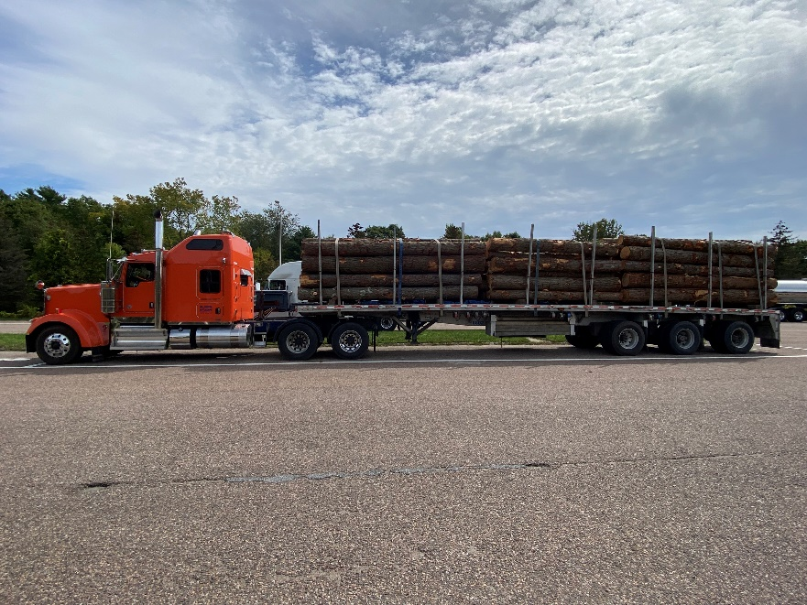
- 9/17 – I 89 Colchester N weigh station detail; Insp. inspected a tractor trailer combination. The inspection revealed a tire was flat on the trailer. The trailer was placed out of service.

New Entrant: Nothing to report.

SOUTH SECTOR:
Details:
- 9/17, Putney Scale House, 190 vehicles were screened with 15 inspections being conducted. The inspections resulted in 5 vehicle violations and 1 vehicle placed out of service.
- 9/18, Guilford Truck Check Area, 103 vehicles were screened with 10 inspections being conducted. The inspection resulted in 2 vehicle violations being discovered.

Notables:
- 9/15, The firearms instructor group conducted a training day at the Royalton range with members of the CVE Unit.
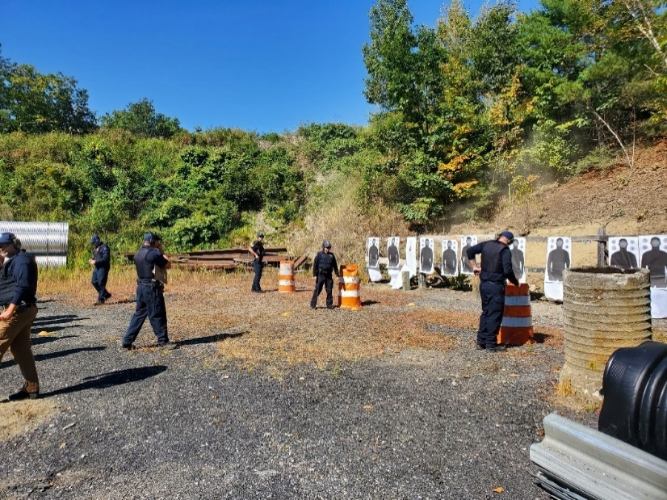
- 9/15, Inspector conducted a Level 2 Inspection on a truck and trailer combination. Upon further inspection, the combination was placed out of service because there was a broken inoperable breakaway cable.
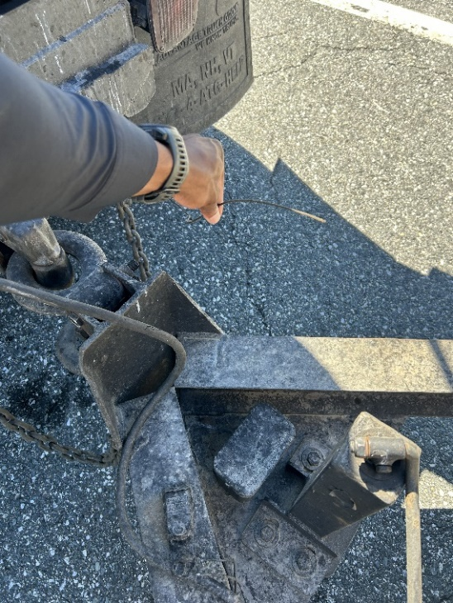
- 9/16, Inspector conducted a Level 2 Inspection on a tractor trailer unit. Upon further inspection of the vehicle's documents, it was learned that the vehicle combination did not have a Vermont Over Dimension Permit. The tractor trailer unit was force permitted.
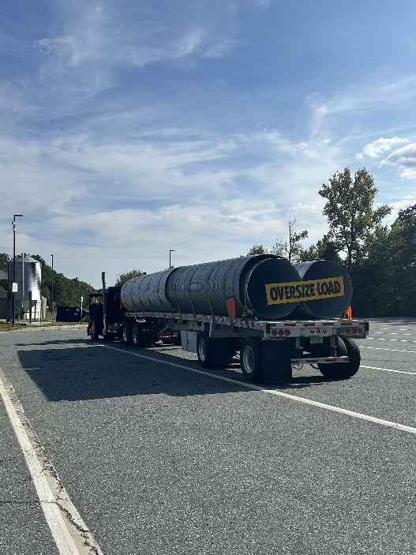
- 9/17, Inspector conducted a Level 2 inspection on a TT Unit. While conducting the inspection it was found that the inner dual on axle 3 passenger side was flat. The tractor was placed OOS until the tire was repaired.
- 9/18, Inspector along with members of US DOT displayed gratitude for National Truck Driver Appreciation Week to the drivers as they passed through the Guilford Truck Check Area.
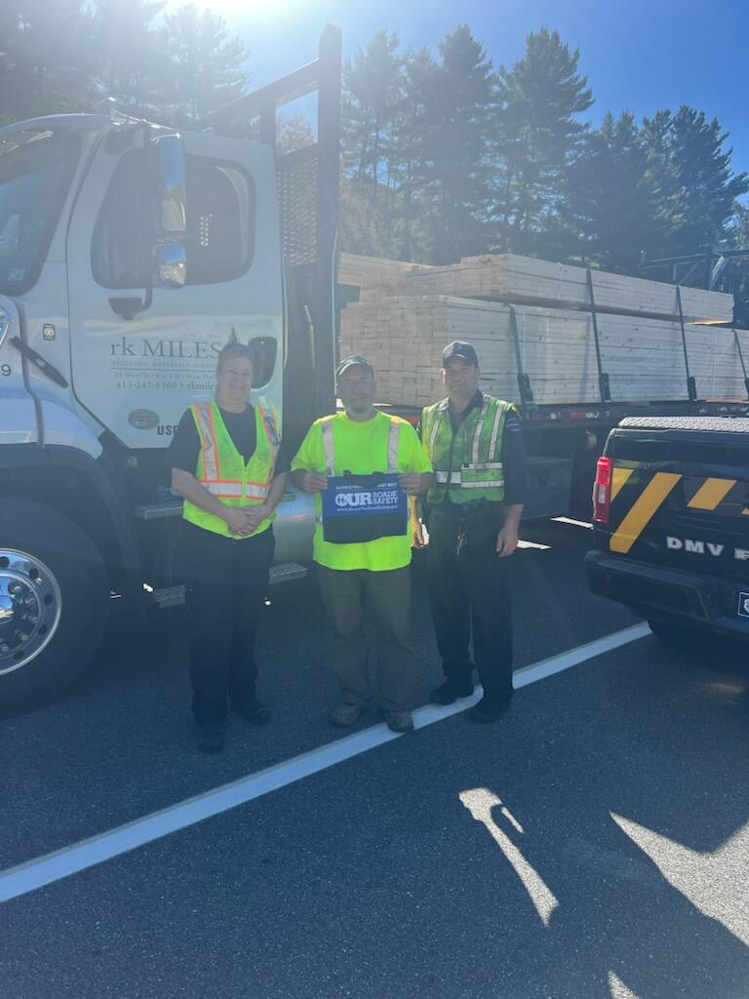
- 9/18, Inspector was conducting a work/construction zone traffic enforcement detail on I91 S in Fairlee Vermont. Inspector Cole initiated a traffic stop on a passenger motor vehicle that was traveling at 81MPH in a posted 55MPH work zone. Upon further investigation, the operator was screened for DUI then arrested for suspicion of DUI. The operator's vehicle was grounded because it was not insured, registered, and the operator had a suspended Vermont driver’s license.
Passenger Vehicle: Nothing to report.

Traffic Enforcement:

- During the week of the Traffic Enforcement Unit conducted 55 inspections which resulted in 10 drivers and 9 vehicles being placed out of service.

Crashes:

Notables:
- 9/14, Inspector opened the Fair Haven Scale House on Sunday Morning. A total of 12 trucks were screened over 5 hours, resulting in 7 inspections. 1 Driver was placed out of service for no medical card and sent back to NY.
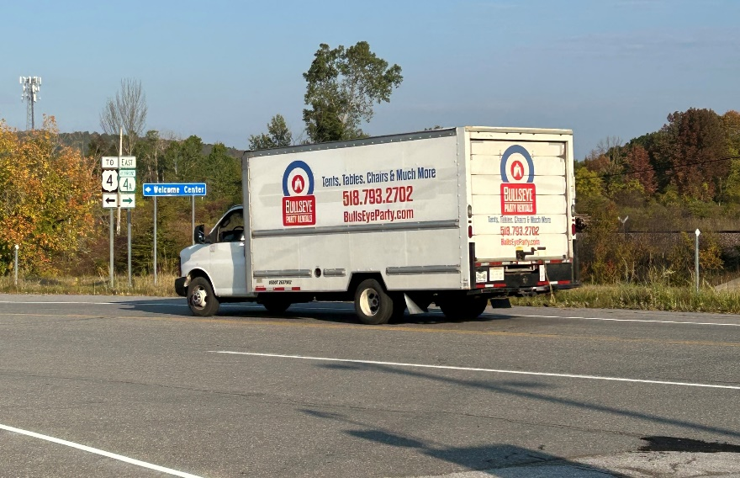
- 9/15, Inspector stopped a truck hauling a mini excavator on Route 103 in Clarendon. The driver was placed out of service for not having the required Class A CDL. The trailer was placed out of service for improper machine securement and no breakaway cable.
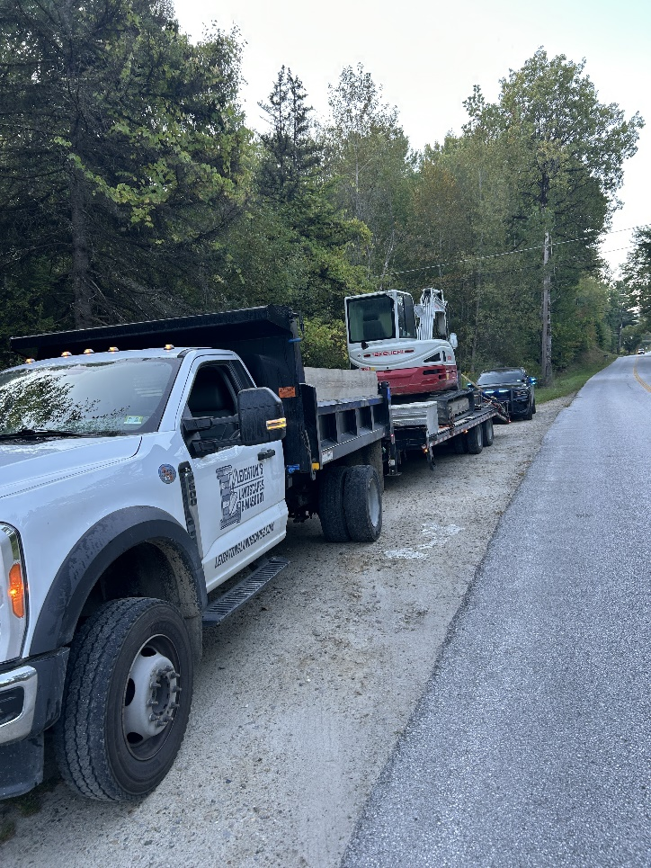
- 9/15, Inspector stopped an interstate truck on Route 100 in Ludlow. The carrier failed to register for a USDOT number prior to their interstate operations. The driver had no medical card and was placed out of service.
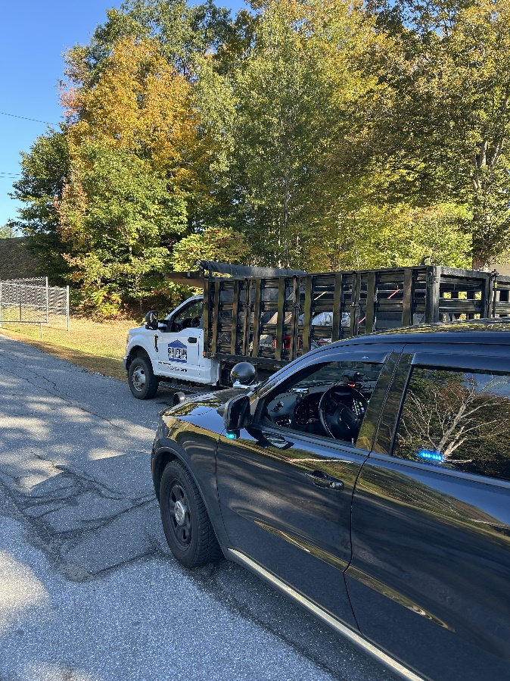
- 9/15, Inspector stopped a truck hauling a mini excavator on Route 103 in Ludlow. The driver did not have the required Class A CDL and was placed out of service. The trailer was placed out of service for improper machine securement, a flat tire and a breakaway cable that was not connected. The truck registration expired over a year ago and was not inspected. The carrier was issued several tickets.
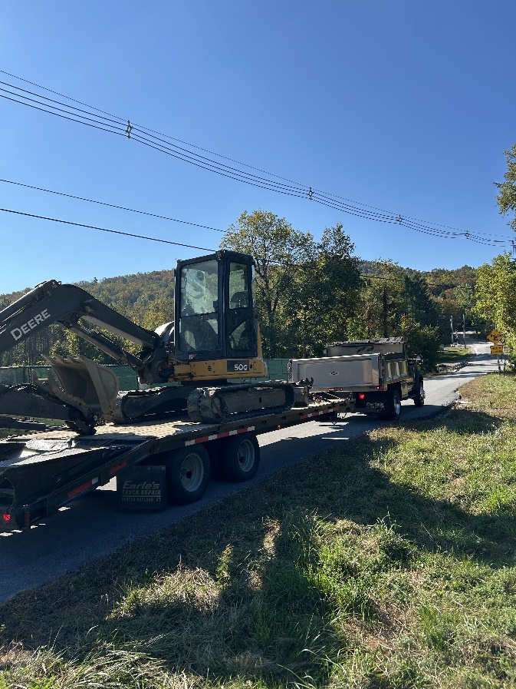
- 09/15, 09/19 Insp conducted TACT stops on I-89 in Randolph. Two drivers in passenger vehicles were issued tickets for driving 96 and 102 MPH while passing CMVs.
- 09/16, Sgt placed a commercial motor vehicle out of service for an air hose which was chaffed into the inner ply which was showing and damaged.
- 09/16, Sgt placed a commercial motor vehicle out of service for inoperable required brakes and a 20% brake violation.
- 09/16, Inspector stopped a tow truck hauling a mini excavator on Route 7 in Dorset. The driver was placed out of service for not having the required Class B license.
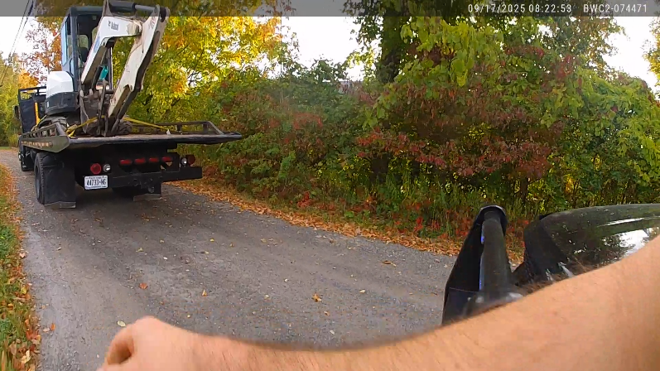
- 09/16, Inspector stopped a box truck on Route 7 in Dorset for speeding, 65 mph in a posted 50 mph zone. The driver was placed out of service for a discovered violation.
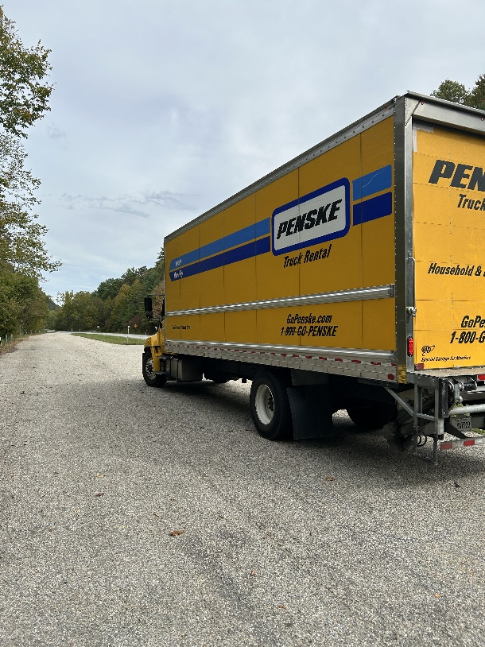
- 09/16, Inspector stopped a tow truck hauling an office trailer on Route 7 in Clarendon. The trailer was not registered, thus not compliant with the blanket permit. The coupling device was missing the safety pin, placing the trailer out of service. The company was educated about obtaining transporter plates to comply with permitting requirements.
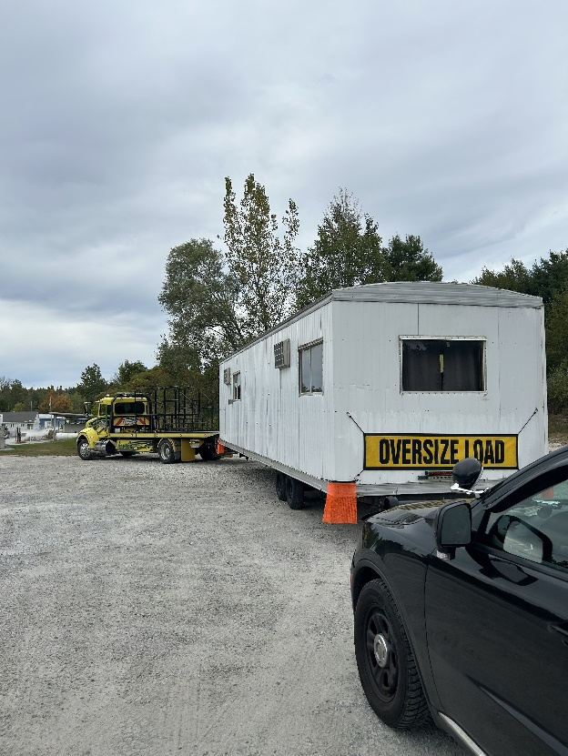
- 09/17- Insp stopped a CMV box truck on I-89 in Brookfield for a lighting violation. An inspection was conducted, and the truck was placed Out of Service for turn/brake signal violations. The driver was issued a warning.

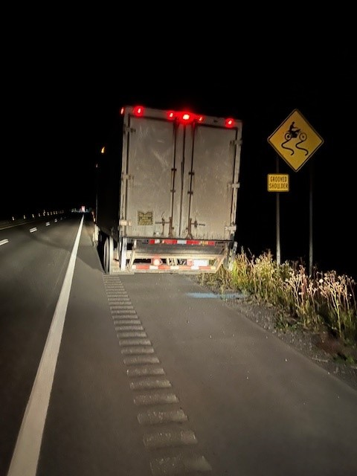
- 9/18, Fair Haven Scale House, Inspector placed a driver out of service for operating a commercial vehicle with air brakes while having an air brake restriction on his license.
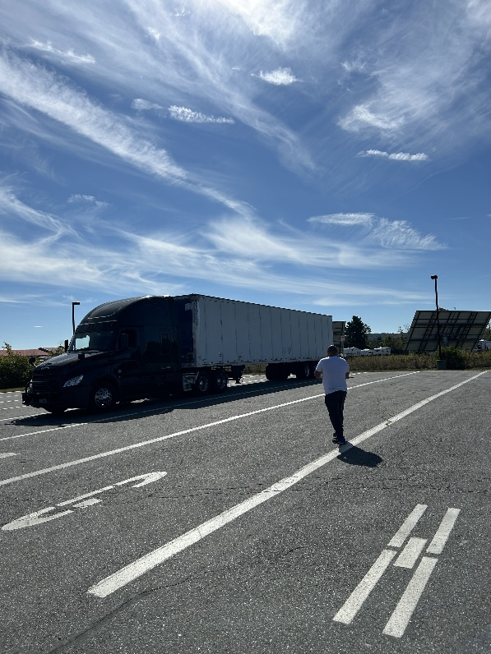
- 09/18, Inspectors were at the scene of a commercial vehicle crash in Plainfield when heavy smoke was seen in their area. The Inspectors immediately responded to the vicinity and found a structure fire. The Inspectors woke the resident who was sleeping and unaware that his house was on fire. The Inspectors were able to assist the residents out of the burning house as well as his animals. The Inspectors then assisted with fire suppression efforts.
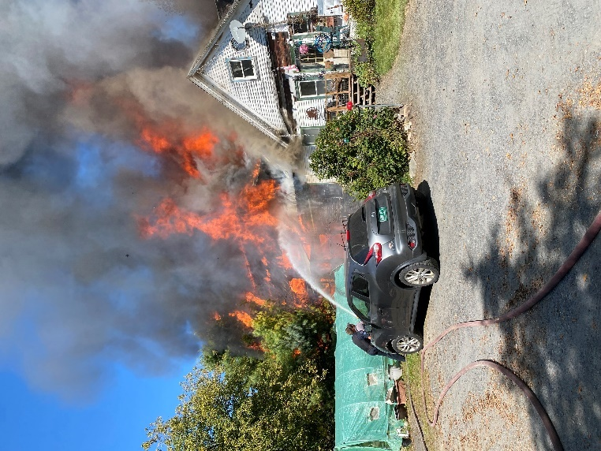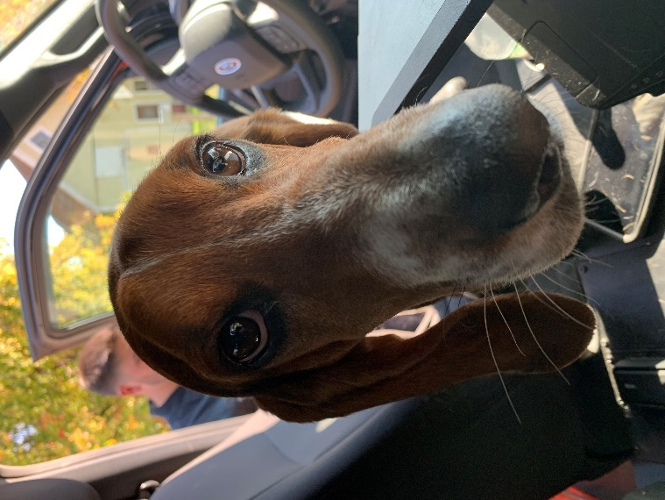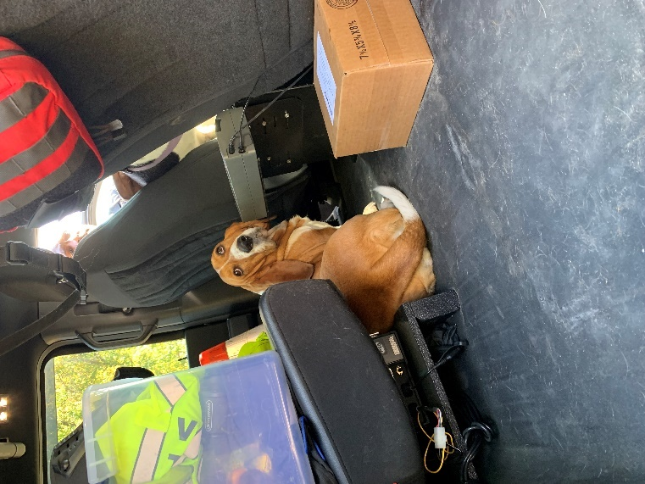
- 9/19, Bridgewater, Inspector placed a truck out of service for a loose fuel tank. The driver was placed out of service for a 60-hour violation.
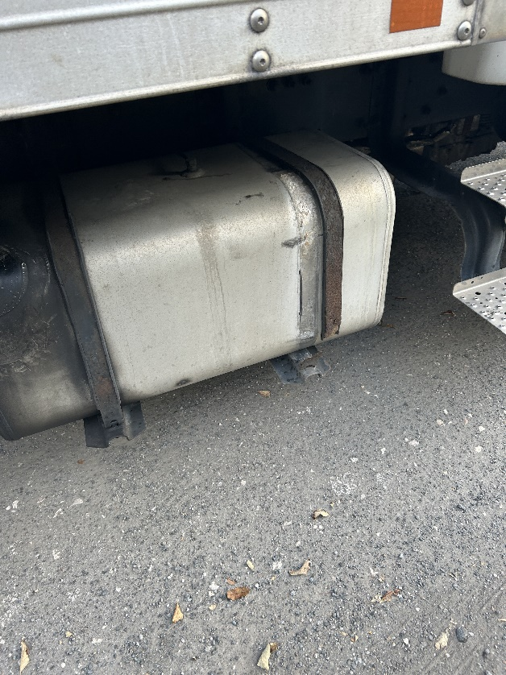
- 09/19, Sgt stopped a commercial motor vehicle for a projecting load violation, the cargo extended off of the rear of the vehicle more than 6 ft and did not have any warning flags. The cargo also required 2 straps due length and one 1 was present. The violations were corrected at the location of the stop.
- 09/19, Sgt stopped a commercial motor vehicle which was engaged in interstate commerce and was not displaying a USDOT number. The carrier was found to not have a USDOT number, and the driver did not posses a medical card.
- 09/19, Sgt stopped a vehicle for a registration violation, the combination was found to be displaying expired registration plates from another state. The driver was issued warnings for state inspection requirements, speeding and registration violations.

HQ Sergeant:

New Entrant:

