Commercial Vehicle Enforcement

NORTHEAST SECTOR:

Details:
- 08/27, Waterford 4 Inspectors screened 127 vehicles. 12 Inspections were completed which resulted in 39 violations (7 out of service) and 6 driver violations (4 out of service). 2 Portable weighs and 3 VCVC’s written, totaling $1598.
- 08/28, Coventry 2 Inspectors screened 103 vehicles. 7 Inspections were completed which resulted in 28 violations (5 out of service) and 2 driver violations.

Crashes: Nothing to report.

Notables:
- On 08/25, Lunenburg Inspector conducted an inspection on a commercial motor vehicle and located the sway bar bushings were worn and the sway bard could be moved by hand. The truck was placed out of service awaiting repair.
- On 08/25, Lunenburg Inspector conducted an inspection on a commercial motor vehicle and located (6) violations to include the trailers breakaway cable not attached to the towing vehicle, operating a commercial motor vehicle without a medical certificate and operating a class A required commercial motor vehicle with a class B license.
- 08/26, Bradford, Inspector conducted an inspection on a commercial motor vehicle and discovered (17) violations to include operating a commercial motor vehicle with de-activated DOT numbers, operating a commercial motor vehicle without a medical certificate, vehicle components not secured, missing bearing cap on a hub as well as the trailers breakaway cable missing.
- 08/26, Bradford, Inspector conducted an inspection on a commercial motor vehicle and discovered (13) violations to include operating a commercial motor vehicle without a medical certificate as well as both turn signals inoperative on the rearmost of the vehicle.
- On 08/26, Ryegate Inspector conducted an inspection on a commercial motor vehicle and located 24 violations. Among those violations was the driver being licensed intrastate only and having no medical card, a brake saturated with oil on the truck and a tire with a large portion of belt material showing. The driver and both vehicles in the combination were placed out of service awaiting repair and proper licensing.
- On 08/27, Waterford Inspector conducted an inspection on a commercial motor vehicle and discovered (5) violations to include the trailers breakaway cable not attached, a turn signal inoperative at the rearmost unit as well as operating a class A required commercial motor vehicle with a class D driver’s license.

- 08/27, Waterford Inspector attempted to conduct an inspection on a commercial motor vehicle, it was determined the driver could not speak English and was placed out of service.
- On 08/27, Waterford Inspector conducted an inspection of a commercial motor vehicle that failed to pull in for inspection. The company was not displaying USDOT numbers or a company name and was found to be suspended in Vermont in June and pending suspension in September. The exhaust was also discharged on the fuel saddle tank. The driver was issued a traffic ticket, and the truck was placed out of service pending repair and reinstatement of the company.
- On 08/28, Coventry Inspector conducted an inspection on a commercial motor vehicle and found an audible air leak from a brake chamber. The truck was unable to maintain air pressure and was placed out of service pending repairs.
- On 08/28, Derby Inspector assisted the Newport Police department with locating a suspect that made a bomb threat to the North Country Union High School.
- On 08/28, Coventry Inspector conducted an inspection on a commercial motor vehicle and found both the service and emergency glad hand hoses with damage into the reinforcement ply. The vehicle was placed out of service and repaired roadside.

New Entrant: Nothing to report

Compliance Review:

Passenger Vehicles: Nothing to report.

NORTHWEST SECTOR:

Details:
- 8/27, I89S Williston rest area; 5 Inspectors, 1 VSP Trooper, and 1 FMCSA Inv. screened 276 commercial vehicles and completed 22 inspections resulting in 2 driver and 21 vehicle violations; 2 drivers and 4 vehicles were placed out of service. Additionally, 3 portable weighs were completed, and 5 oversize/weight permits were checked. Two tickets were issued.

Crashes: Nothing to report

Notables:
- 8/26, Sgt. stopped a tractor trailer combination loaded with wood chips for a suspected overweight infraction on US Rte. 2 in Alburgh. A portable weigh revealed the 5-axle combination weighed 97,300 and the carrier did not have an overweight permit. A ticket was issued.
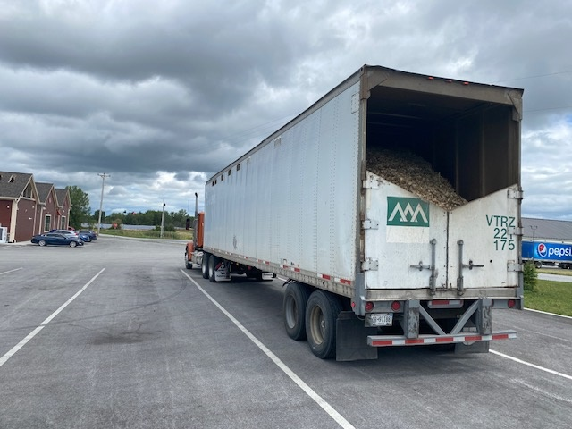

- 8/27, Sgt. inspected a tractor trailer combination at the I 89 Williston SB rest area detail. The inspection revealed a cement block not blocked/braced against forward movement and weighing over 1100 pounds was only secured with 1 chain. The trailer was placed out of service and the driver added a chain to continue his trip.
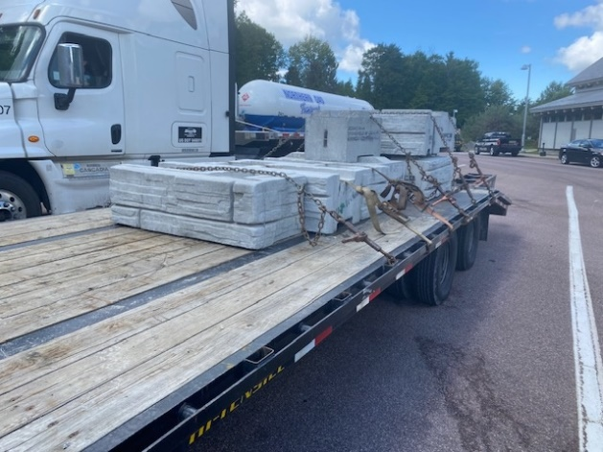

- 8/27, Inspector inspected a dump truck and trailer combination at the I 89 Williston SB rest area detail. The inspection revealed that both dual tires on axle 4 were measuring less than 1/32. The trailer was placed out of service.
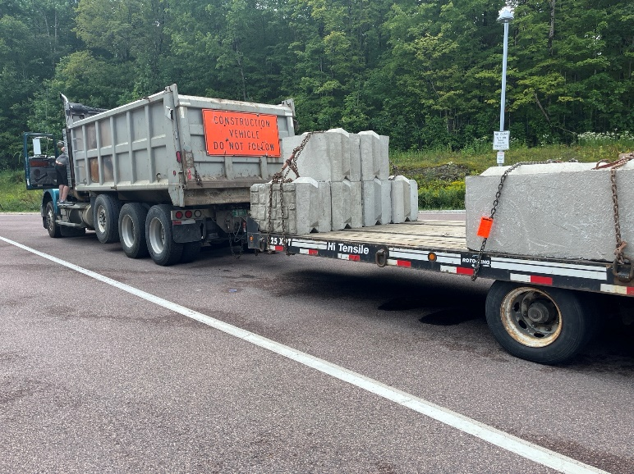
- 8/27, Inspector inspected a tractor trailer combination hauling logs at the I89 Williston SB rest area detail. A portable weigh revealed that the combination weighed more than 106,000 pounds on a valid 99k permit. A ticket was issued to the carrier.
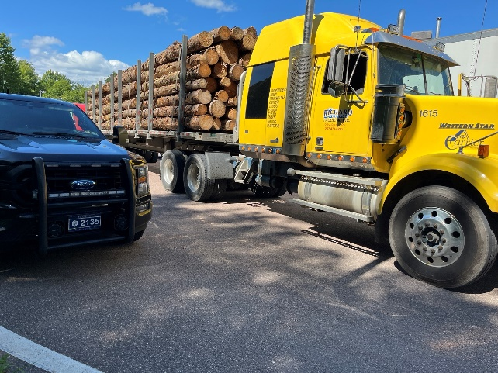
- 8/27, Sgt. inspected a tractor trailer combination hauling logs at the I 89 Williston SB rest area detail. A portable weigh revealed the combination weighed more than 109000 pounds on a valid 99K permit. A ticket was issued to the carrier.
- 8/27, Inspector attended the Champlain Valley Fair to assist at the Highway Safety & Child Passenger Safety Education booth; several hundred fair attendees passed through the booth, asking questions and raising awareness surrounding car seats and restraints.
- 8/28, Sgt. inspected a truck hauling a trailer at the US Rte. 7 Ferrisburgh HP detail. The inspection revealed the driver had an expired medical card, the breakaway device on the trailer was not hooked to the towing vehicle and two hub caps on the trailer wheels were missing actively leaking. The driver and trailer were placed out of service.
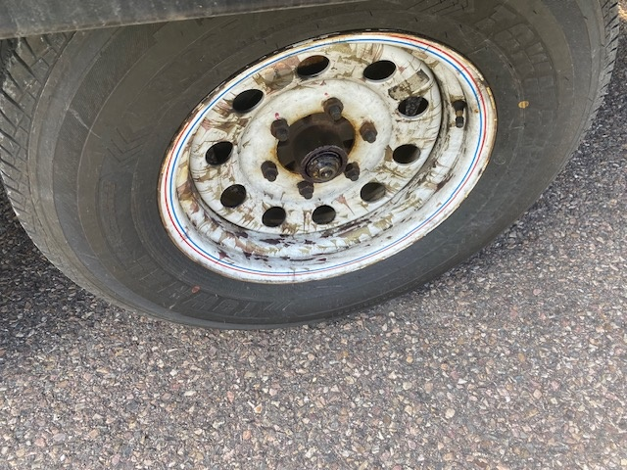
- 8/28, Sgt. stopped a truck hauling a trailer on US Rte. 7 in Charlotte for an inoperative rear most turn signal. An inspection was conducted, and the driver did not possess a CDL for the CDL required combination, the driver did not possess a medical card, the breakaway device was inoperable. Additionally, the trailer was not registered. Both the driver and trailer were placed out of service.
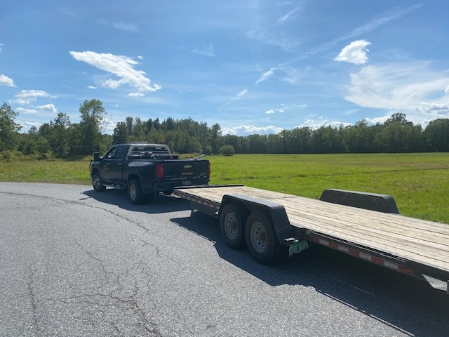
- 8/28, Inspector stopped a tractor trailer combination in Charlotte for traveling 64mph in a 50mph zone. An inspection was conducted, and a ticket was issued to the driver.
- 8/28, Lt. patrolled the Town of Poultney for Size & Weight enforcement on Route 31 (South Street) at the Poultney River bridge; the bridge has a temporary allowable weight of 16,000 lbs. and several complaints were received about overweight vehicles transiting the bridge.

New Entrant:

SOUTH SECTOR:
Details:
- 8/26, I 89 N Randolph Rest Area, CVSA Operation Brake Check, 5 Inspectors screened 247 commercial vehicles and completed 18 inspections resulting in 9 vehicle and 1 driver violation. Two vehicles and one driver were placed out of service. Seven CVSA decals were issued for a Level 1 inspection with no safety violations.
- 8/28, I91N Guilford, 5 Inspectors and 6 FMCSA Staff members screened 214 commercial vehicles and completed 23 inspections resulting in 4 driver and 11 vehicle violations; 3 vehicles were placed out of service. Two CVSA decals were issued and two VCVC’s were issued for $1349.

Notables:
- 8/26, I 89 N Randolph, Inspector conducted a Level 1 inspection on a box truck. During the inspection it was found that the right front brake was out of adjustment. The vehicle was placed OOS until repairs were made.
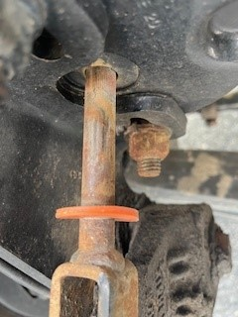
- 8/26, I 89 N Randolph, Inspector conducted an inspection on a 2025 3-axle flat bed and found that the axle 2 pinion seal was leaking.
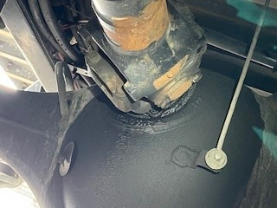
- 8/27, Vt Route 103 Rockingham, Inspector conducted a Level 2 inspection on a box truck and found a loose body bolt on the driver side of the vehicle.
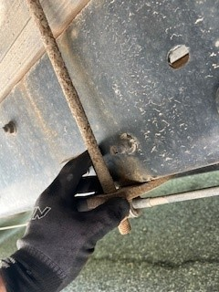
- 8/27, VT Route 9 East Marlboro, while on patrol, Inspector noticed a commercial motor vehicle with two flat tires traveling along the roadway. Inspector Hammond stopped the commercial motor vehicle and placed it out of service until the tires could be changed.
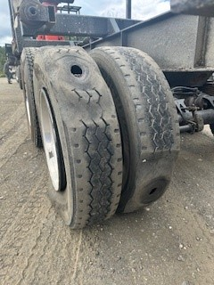
- 8/26, Inspector conducted a Level 1 inspection. The driver was found to not possess a valid medical card and was placed out of service.
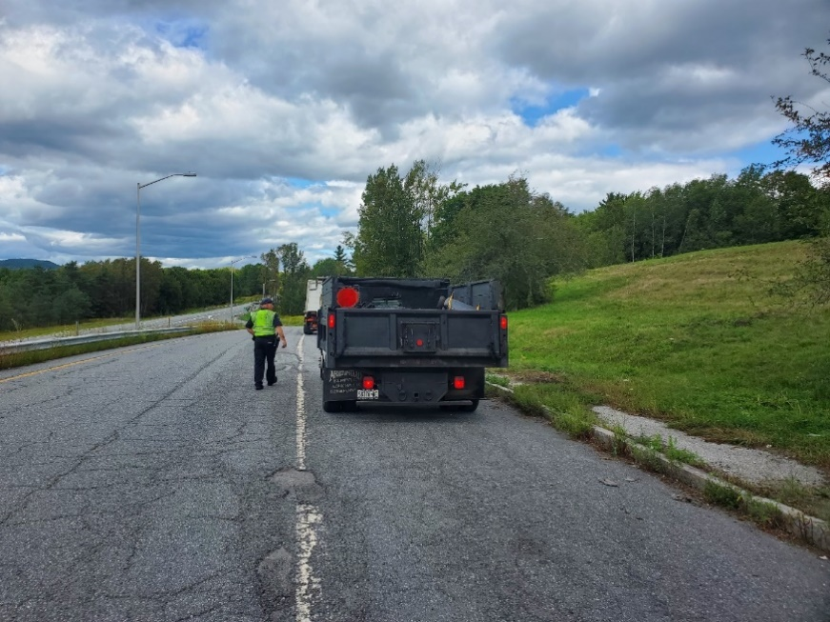
- 8/26, Inspector conducted a Level 2 Inspection in Randolph. The inspection revealed that the straight truck did not have commodity specific rear load securement. The vehicle was placed out of service.

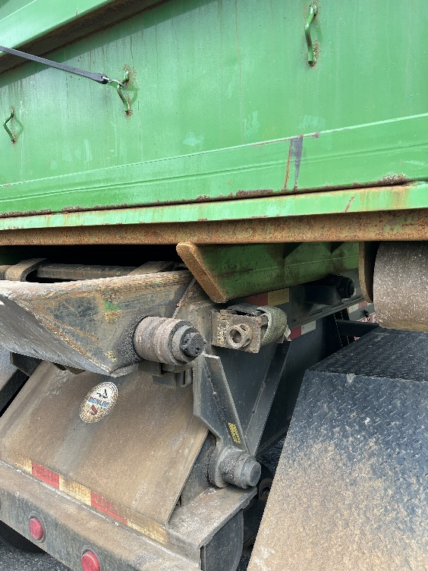
- 8/27, Inspector conducted a Level 2 inspection in Rockingham. The inspection revealed the carriers US DOT number had been de-activated. The truck was placed out of service for the violation.
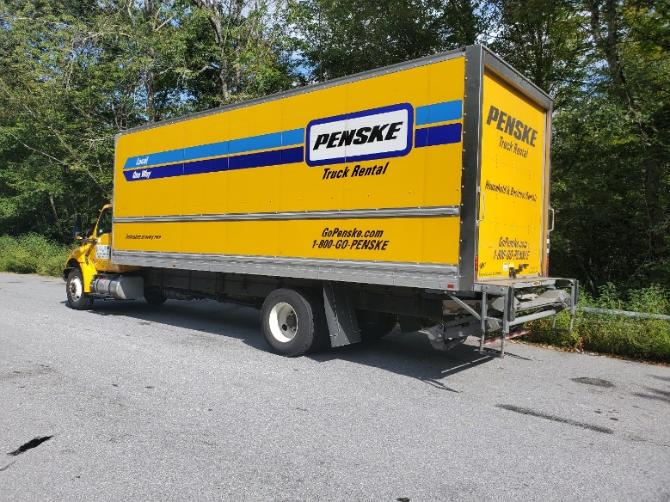
- 8/28, Inspector conducted a Level 1 on a truck/trailer combination. Among other violations, it was discovered the trailer had no working brake lights. The trailer was placed out of service for the violation.
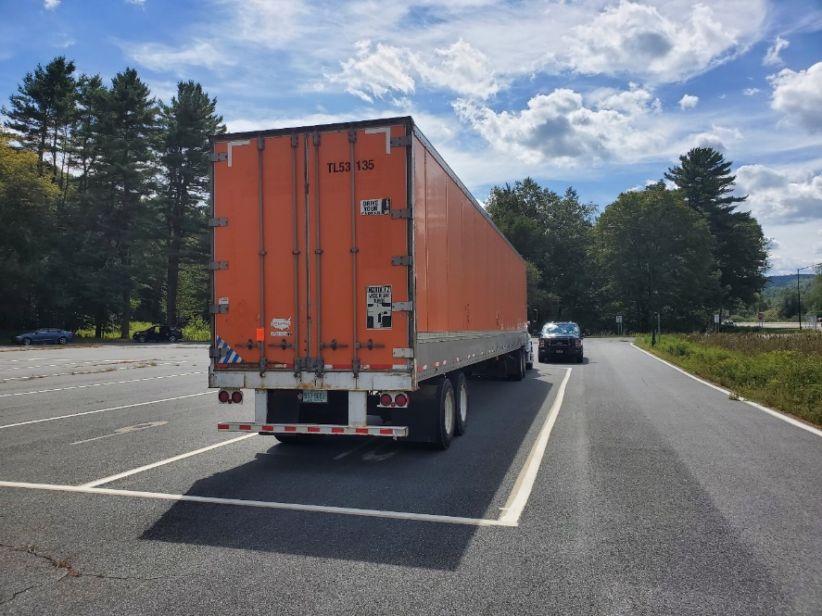

- 8/28, Sr. Cpl. conducted a Level 2 on a straight box truck that drove by the posted detail in Guilford. Among other violations, driver drove by detail because they did not have their lease agreement in the vehicle. Driver was issued a VCVC for not stopping for Traffic Control Devices.
- 8/28, Inspector conducted a Level 1 Inspection on a Tractor Trailer Unit. During the inspection it was discovered that a service air hose on the trailer had a sizable hole in it causing an air leak not at a proper connection. The trailer was placed out of service.

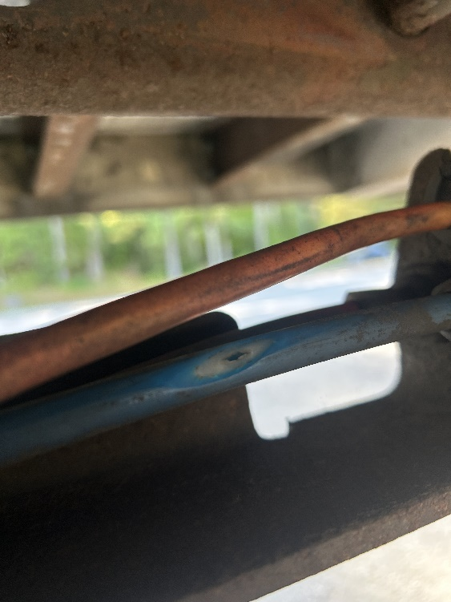
- 8/28, Inspector conducted a portable Weigh on a log truck at the Guilford detail. It was discovered that the log truck operator had a 99k permit but when weighed, the truck was over 120,000Lbs. The company was issued a VCVC for the ORL violation.
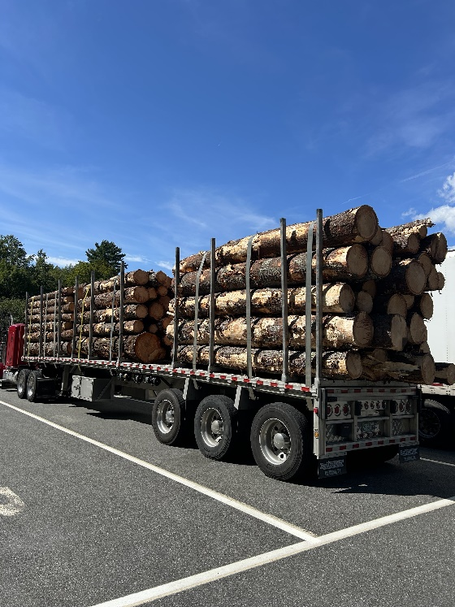

Passenger Vehicle: Nothing to report.

Traffic Enforcement:

During the week of 08/25 - 08/29 the Traffic Enforcement Unit conducted 65 inspections which resulted in 7 drivers and 13 vehicles being placed out of service.
Crashes: Nothing to report.
Notables:
- 8/25, Inspector stopped a truck on Route 4 in Woodstock. The driver was placed out of service for no medical card.
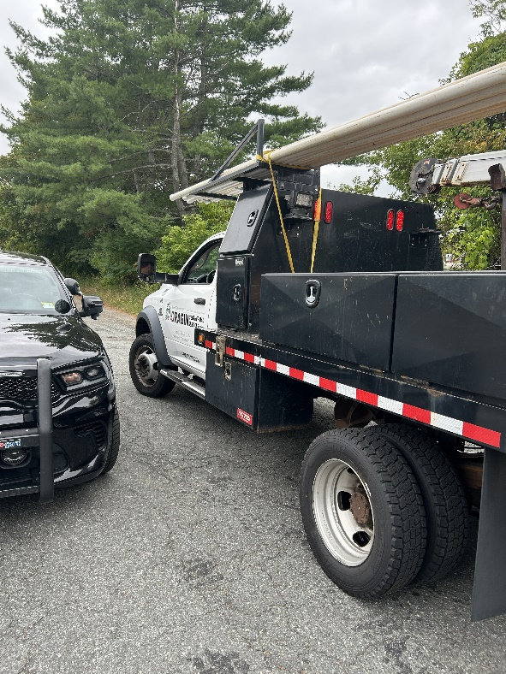
- 8/25, Inspector stopped a truck on Route 4 in Woodstock. The driver was placed out of service for no medical card.
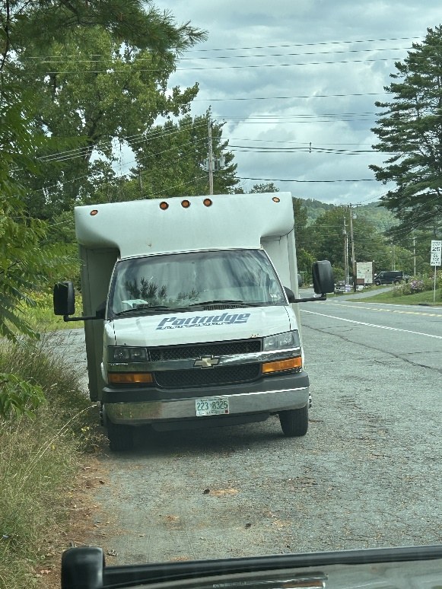
- 8/25, Insp stopped a CMV truck/trailer on Rte. 4 in Woodstock for a load securement violation. An inspection was conducted, and the trailer was placed Out of Service for heavy machinery not having the required number of tie-downs. The driver was issued a warning.
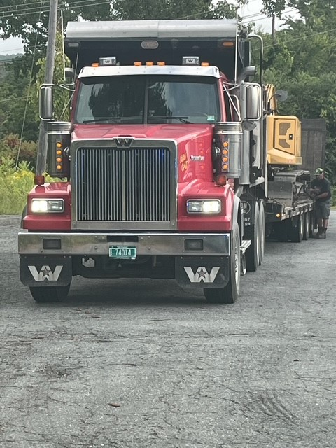
- 8/25, Insp stopped a CMV box truck on Rte. 4 in Woodstock an inspection was conducted, and the driver was placed Out of Service for no medical card. The truck was placed Out of Service for an inactive USDOT. The owner/operator was issued several warnings.

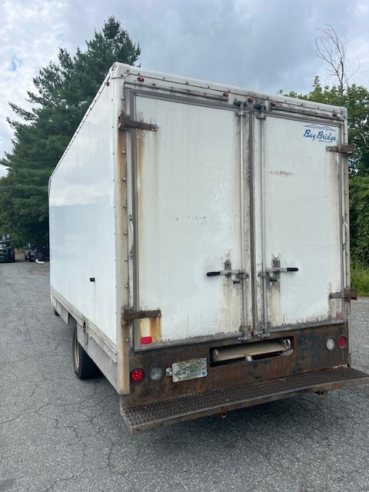
- 8/25, Insp stopped a CMV truck/trailer on Rte. 4 in Woodstock for a marking violation. An inspection was conducted, and the trailer was placed Out of Service for no working turn signals. The owner/operator was issued a warning.
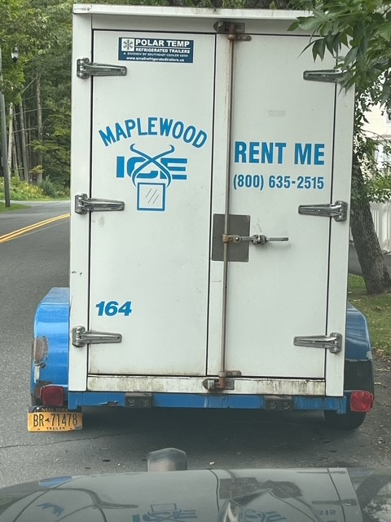
- 08/25, Bradford Sgt stopped a commercial motor vehicle for a load securement violation, the excavator which weighed over 10,000lbs was not properly secured. A portable weigh was also conducted, and the combination was found to weigh 14,000lbs it’s registered weight.
- 08/25, Ryegate Sgt stopped a commercial motor vehicle for a speeding violation (77/65).
- 08/25, Barton Sgt stopped a commercial motor vehicle for a speeding violation (76/65) the combination required a class A CDL to operate it. The driver did not have a CDL or a medical card, the vehicle was placed out of service for having an exposed hub assembly and for a defective trailer emergency breakaway cable.
- 8/26, Fair Haven Scale House, Inspector placed a NY based driver out of service for operating with an intrastate CDL and no medical card. The truck weighed 102,000 with no Vermont overweight permit. The carrier was issued several VCVC’s, and truck sent back to NY.
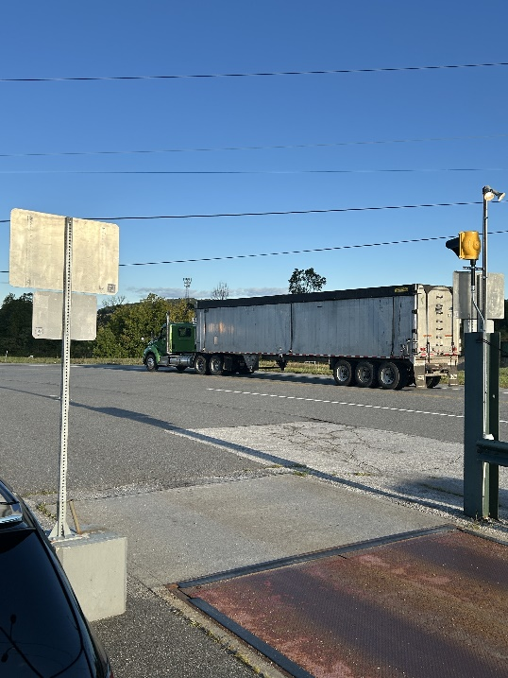
- 8/26, Insp stopped a CMV truck/trailer on I-89 in Randolph for not stopping at the Truck Safety inspection. An inspection was conducted, and the driver was placed Out of Service for no medical card. The driver was issued a warning.
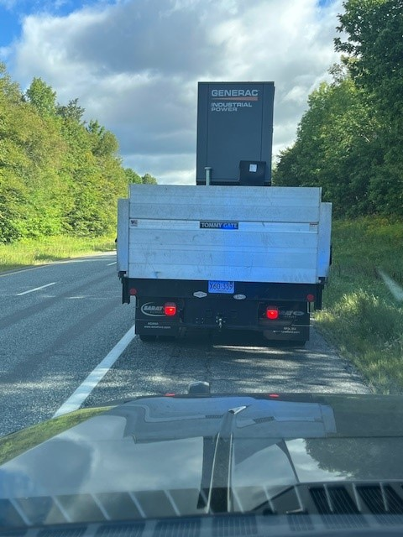
- 08/26, Randolph Sgt stopped a commercial motor vehicle which failed to stop at the safety checkpoint. The driver was found to have an expired medical card, the vehicle was placed out of service for inoperable brakes and for inoperable required brake lamps.
- 8/27, Insp stopped a CMV truck/trailer on I-93 in Waterford for not stopping at the Truck Safety inspection. An inspection was conducted, and the driver was placed Out of Service for no medical card. The carrier did not have a USDOT# as required. The driver was issued a warning. The carrier was issued a ticket for No Registration.
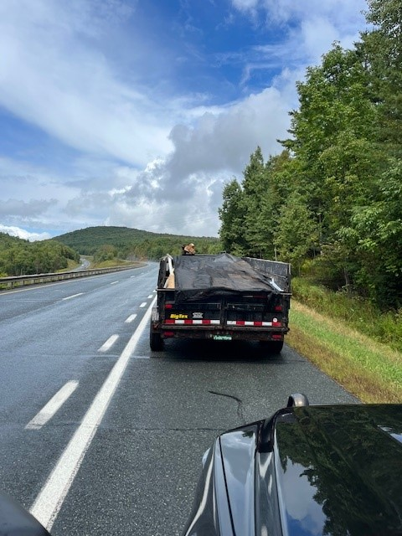
- 08/27, Williston Sgt stopped a commercial motor vehicle which failed to stop at the safety checkpoint. The oversized load weighed 136,000lbs and did not have the required permits to operate in Vermont. The combination was found to weigh 56,000lbs over its allowable weight. The carrier was issued a VCVC and was force permitted.
- 8/28, Insp responded to assist Norwich PD with a school bus that had gone off the road while transporting students. An inspection was conducted, and the driver was placed Out of Service for an unknown medical condition. The driver suffered a medical event while driving the bus.
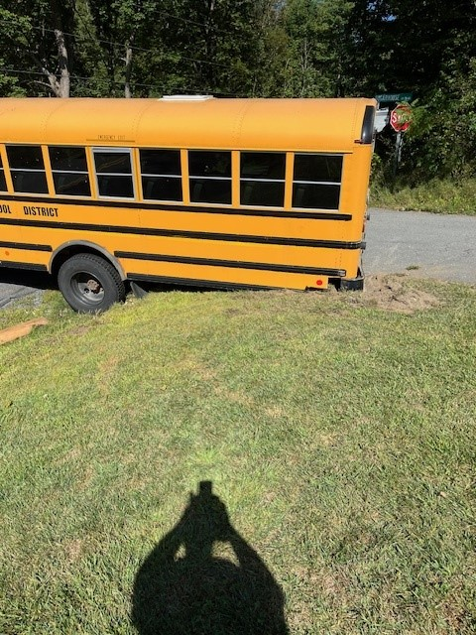
- 8/29, White River SB Weigh Station, Inspector placed a driver out of service for no medical card.
- 8/29, Inspector stopped a tractor trailer for performing a U-Turn on Route 4 in Killington, nearly causing multiple crashes. The driver was ticketed for the maneuver and placed out of service for a false log.
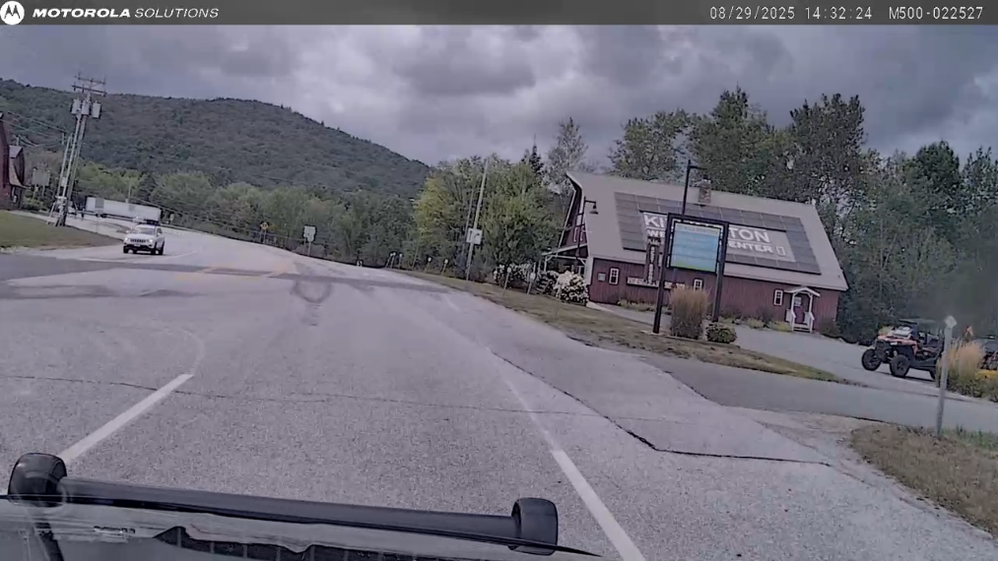
- 8/31, Inspector assisted VSP with coverage at the Green Mountain Stage Race in the Mad River Valley.

HQ Sergeant:

- 8/27, Williston detail, Sgt. inspected an interstate box truck. The driver was listed as prohibited in the drug and alcohol clearinghouse. He also had an active VT arrest warrant. The driver was placed out of service and arrested. VSP transported the driver to the courthouse. The co-driver was found to be in possession of marijuana. The company was able to send another driver for the truck.
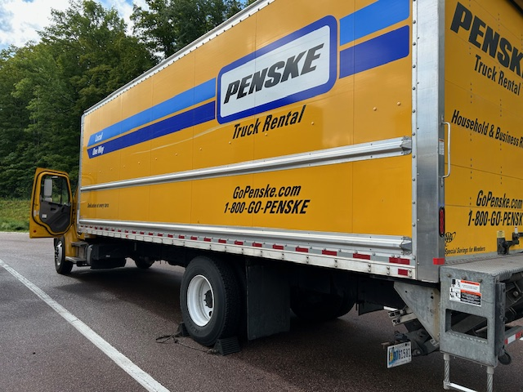

- 8/29, Sgt. attended firearms training.

New Entrant

