Commercial Vehicle Enforcement

NORTHEAST SECTOR:

Details:
- 09/02, I-91 Barton Rest Area, 5 Inspectors screened 148 vehicles. 20 inspections were completed which resulted in 32 vehicle violations (7 out of service) and 9 driver violations (2 out of service).
- 09/03, Inspectors from the Northeast sector attended the Northwest detail.

Crashes: Nothing to report.

Notables:
- 09/02 Barton, Inspector conducted a level 1 inspection on a commercial motor vehicle and found the sway bar bushings on axles 1 and 2 were worn and the sway bar could be moved with hand pressure. The truck was placed out of service pending repair.
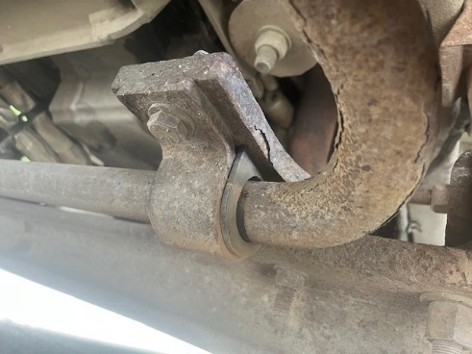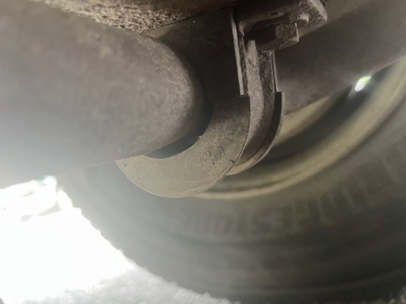
- 09/02, Barton detail, Inspector conducted an inspection on a commercial motor vehicle and discovered a green thermoplastic nylon supply air hose connected to the air reservoir had been actively chafing on a U-bolt causing exposure of the inner tube (secondary color). The vehicle was placed out of service.
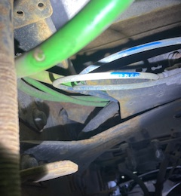
- 09/03 Williston, Inspector conducted a level 1 hazmat inspection on a commercial motor vehicle and found that it was laden with 1,025 lbs. of corrosive material but was only placarded for flammable. The combination was placed out of service pending proper placarding.
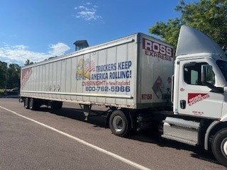
- 09/03 Williston, Inspector conducted an inspection on a commercial motor vehicle requiring a class A commercial driver’s license in which the driver did not possess. Several violations were located during the inspection of the combination. The driver was placed out of service until he was properly licensed.
- 09/03 Williston, Inspector conducted an inspection on a commercial motor vehicle and found that the exhaust was discharging onto a combustible part of the vehicle and was in fact melting an airline attached to the air dryer.

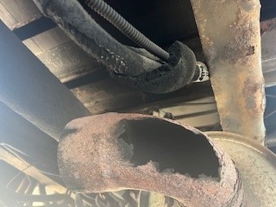
- 09/03 Williston, Inspector conducted an inspection on a commercial motor vehicle and found multiple violations to include a bent rim which resulted in a flat tire. The vehicle was placed out of service until repairs were made.
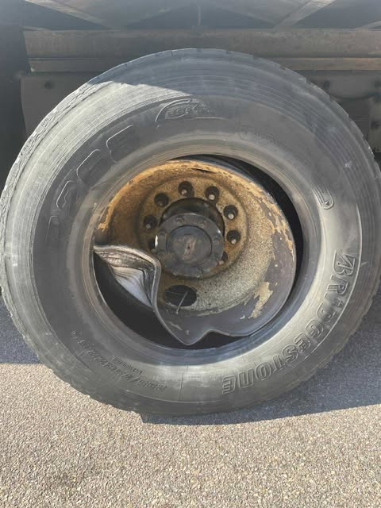

- 09/04 Lyndonville, Inspector conducted size and weight enforcement on an oversized commercial motor vehicle and discovered the heavy machinery had a bent chain link of the clevis variety causing the machinery to be unsecured. The vehicle was placed out of service until repaired.
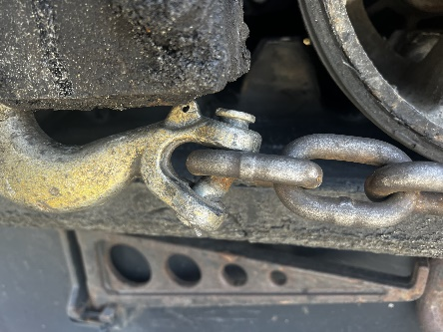

New Entrant:

Compliance Review:

Passenger Vehicles: Nothing to report.

NORTHWEST SECTOR:

Details:
- 09/02, US Rte. 4 Fair Haven Scale House; 3 Inspectors and 1 FMCSA Inv. screened 105 commercial vehicles and completed 11 inspections resulting in 13 vehicle violations; 3 vehicles were placed out of service.
- 09/03, I 89 N Williston rest area; 8 Inspectors and 1 FMCSA Inv. screened 270 commercial vehicles and completed 25 inspections resulting in 8 driver and 77 vehicle violations; 8 drivers and 7 vehicles were placed out of service.

Crashes:

Notables:
- 09/02, Inspector conducted a Level 2 inspection at the Fair Haven scale house detail on an empty logging truck. The inspection showed a turn signal on the rear of the trailer to be non-functional. The trailer was placed out of service until the defect was remedied.
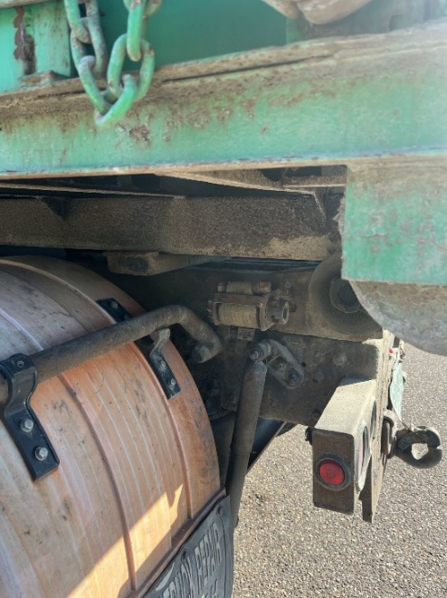
- 09/02, Insp. inspected a tractor trailer combination at the Fair Haven Detail. The inspection revealed that the combination failed the air-loss rate test. The combination was also found to have an air leak from axle 1 right air hose attached to the brake cannister. The leak was coming from a hole through the hose and reinforcement ply. The combination was placed out of service for repair.
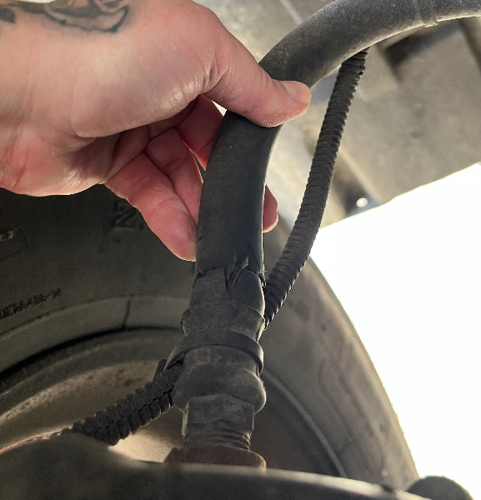

- 09/03, Sgt. inspected a tractor trailer combination at the I 89 Williston N rest area detail. The inspection revealed a plastic glad hand hose was not secured on the rear of the truck due to a loose clamp mechanism. The vehicle was placed out of service for repair.
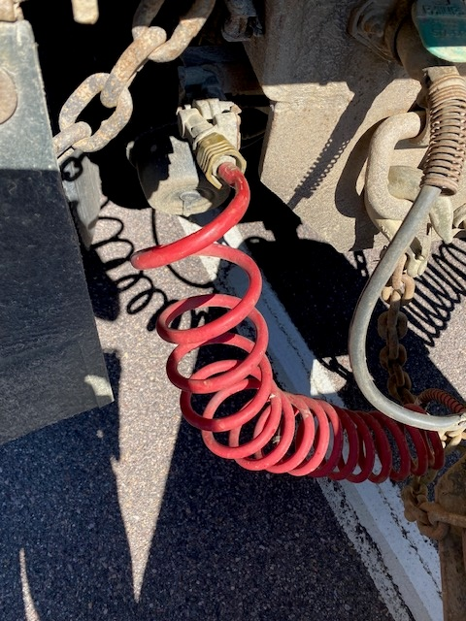
- 09/03, Inspector conducted a level 2 inspection at the Williston northbound detail on a TT-unit hauling a large forklift. The forklift was not sufficiently secured and the CMV was placed out of service until the proper amount of load securement was implemented.
- 09/04, Sgt. responded to a single vehicle box truck which drove off I 89 in Bolton. The interstate driver advised he fell asleep and drove off the road down an embankment. An inspection was conducted, and the driver was placed out of service for being fatigued. The recovery effort was several hours. The driver was ticketed.
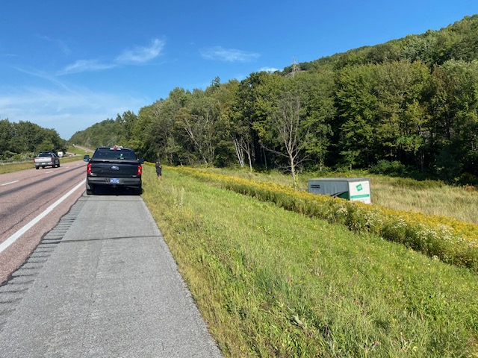
- 09/04, Inspector conducted a level 1 inspection on a TT-unit while patrolling Addison County. The inspection revealed a severely deflated tire on the power unit. The truck was placed out of service until its condition was repaired.
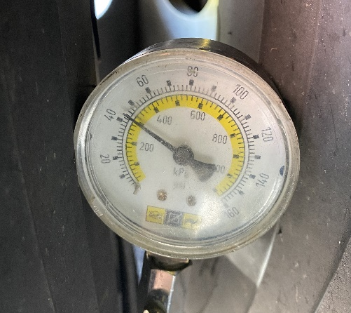

- 09/04, Insp conducted a level I inspection on a single unit truck which had a roll off container. It was found that the roll off container hooks were not secured appropriately, and the driver did not have a CDL when the unit required one. The driver was issued a fine and placed out of service for the lack of a valid CDL. The truck was placed out of service due to the roll off container not being secured appropriately.

New Entrant: Nothing to report.
SOUTH SECTOR:
Details:
- 09/02, I 91 S Bradford Rest Area, 3 Inspectors screened 111 commercial vehicles and completed 10 inspections resulting in 7 vehicle violations. Two vehicles were placed out of service. One CVSA decal was issued for a Level 1 inspection with no safety violations.
- 09/04, I91 S Putney Scale House, 4 Inspectors screened 172 commercial vehicles and completed 12 inspections resulting in 3 driver and 3 vehicle violations; 1 vehicle was placed out of service. One VCVC was issued for $394.

Notables:
- 09/02, Lt discovered the External Visual and Leakage test dates on a cargo tank were expired during a level 1 inspection at the Bradford detail.
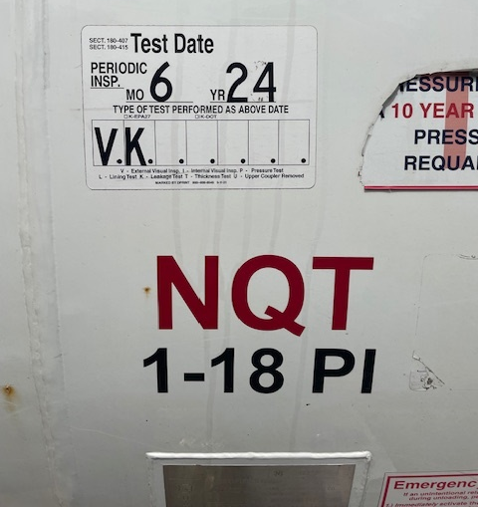
- 09/04, Lt discovered an overweight violation during the Putney Scale House detail. The 5-axle combination had a gross weight of 100,400 lbs. but was only permitted for 90,000 lbs. A ticket was issued to the carrier.
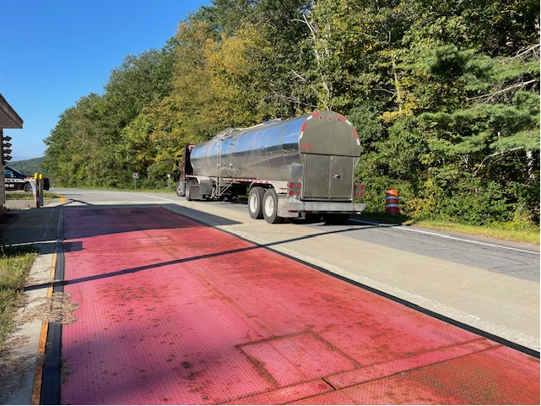
- 09/04, Inspector conducted a Level 2 inspection on a truck/trailer combination. It was discovered the emergency breakaway on the trailer was not properly connected. The trailer was placed out of service until repaired.
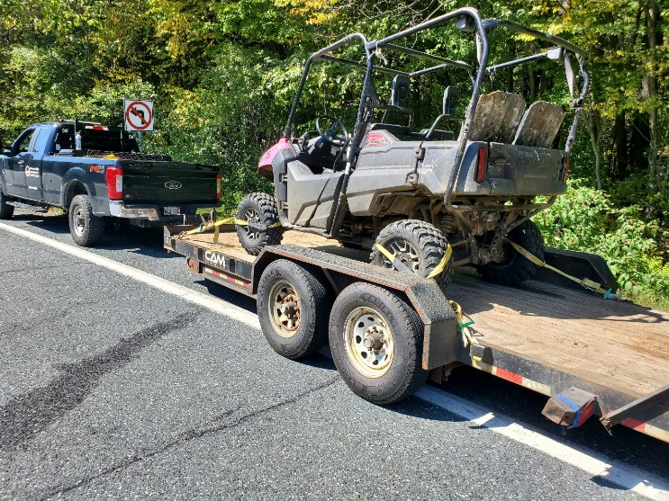
Passenger Vehicle: Nothing to report.
Traffic Enforcement:

During the week of 09/02 - 09/05 the Traffic Enforcement Unit conducted 48 inspections which resulted in 10 drivers and 16 vehicles being placed out of service.
Crashes: Nothing to report.
Notables:
- 09/02, Fair Haven Scale House, Inspector placed a trailer out of service for a flat tire.
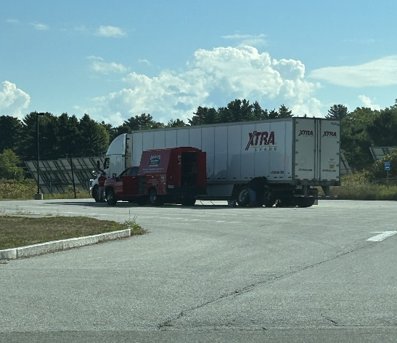

- 09/02, Fair Haven Scale House, Inspector force permitted an oversize load. The load was 9’5 wide with no flagging nor permit.
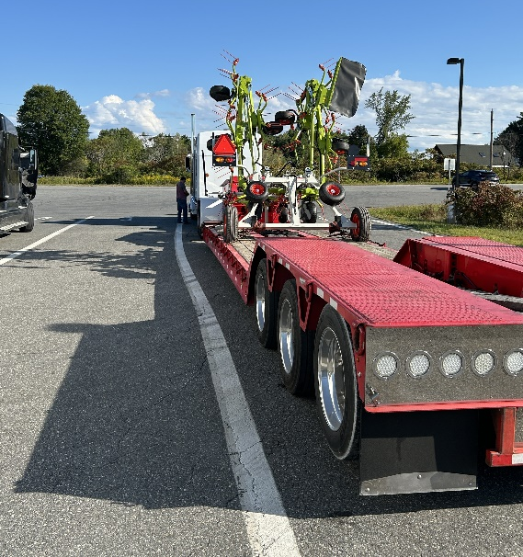
- 09/02, Inspector stopped a vehicle that failed to stop at the Fair Haven Scale House. The carrier failed to register for a USDOT number prior to interstate operations. The driver had no medical card and was placed out of service.
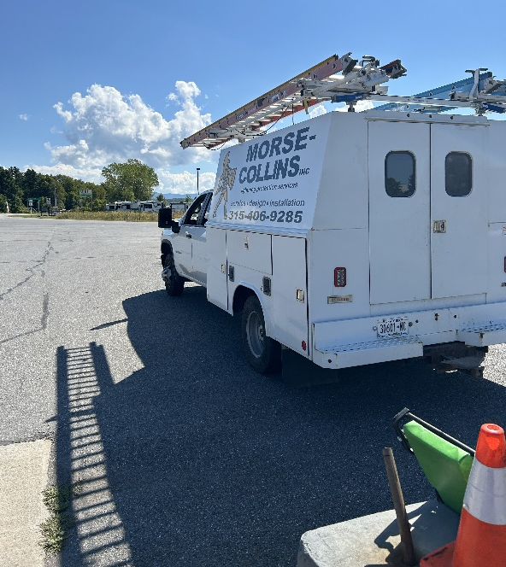
- 09/02, Sgt stopped a commercial motor vehicle for a marking violation, the driver was placed out of service for not having a medical card, the combination was placed out of service for a defective emergency breakaway cable. A portable weigh was completed, and the combination was found to weigh 12,600lbs over its registered weight.
- 09/02, Sgt stopped a commercial motor vehicle for not displaying a front or rear registration plate on the truck and for not displaying a registration plate on the trailer. An inspection was completed, and the driver was placed out of service for not having a CDL when it was required and no medical card. The combination was placed out of service for a defective emergency breakaway cable and for a load securement violation. The carrier was issued a VCVC.
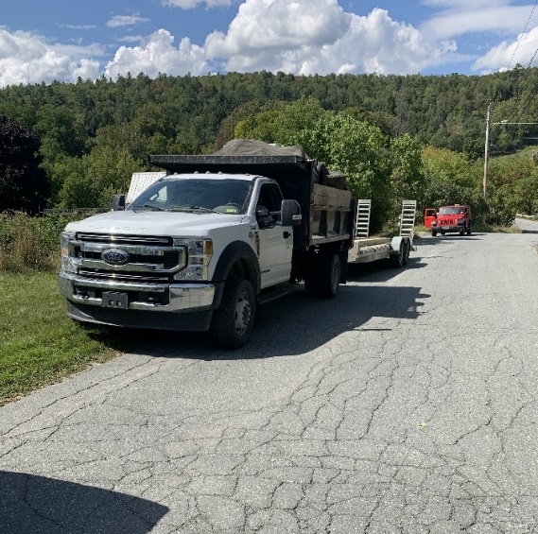
- 09/02, Insp stopped a CMV tractor/trailer at the Bradford detail on I-91. An inspection was conducted, and the driver was placed Out of Service for an hour-of-service violation. The driver was issued a warning.
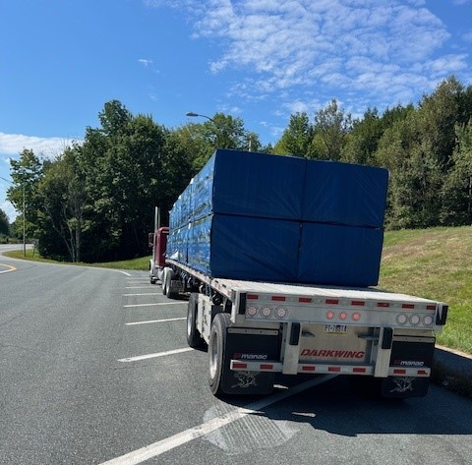
- 09/03, Inspector stopped a bucket truck on Route 103 in Mount Holly for no inspection. The truck required a Class B CDL, which the driver did not have. The driver had no medical card either and was placed out of service.
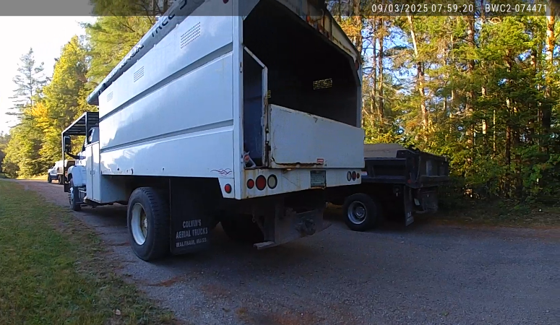
- 09/03, Mount Holly, Inspector placed a driver out of service for no medical card.
- 09/03, Insp Ross stopped a CMV dump truck on VT Rte. 63 in Berlin for a lighting violation. An inspection was conducted, and the truck was placed Out of Service for no operable stop lamps. The owner/operator was issued a warning.
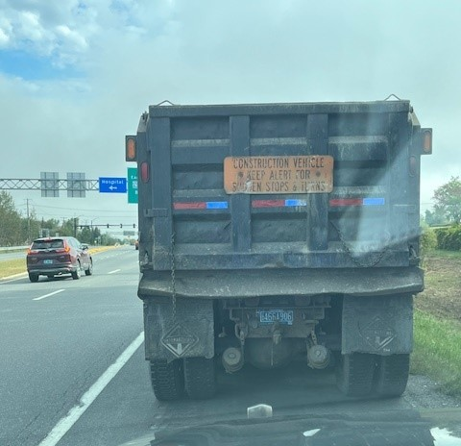
- 09/03, Insp stopped an Oversize Load on I-89 in Brookfield for operation during hours of darkness. An inspection was conducted, and the vehicles were found to be in violation of their permit. No pilot vehicle was present and there was no nighttime operation permitted. The vehicle was grounded, and the Carrier was issued a ticket.
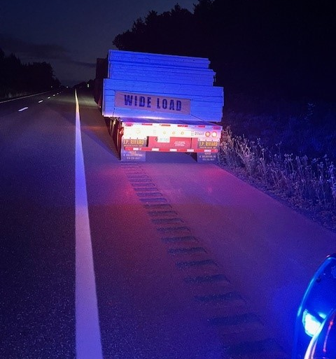
- 09/03, Sgt stopped a commercial motor vehicle which failed to stop at the safety checkpoint. The driver did not possess a CDL, and the combination required a Class A CDL to operate it. The driver was placed out of service for the license violation and for not having a medical card. The combination was placed out of service for a defective breakaway cable, inoperable required lamps, a flat tire and for having an exposed hub assembly.
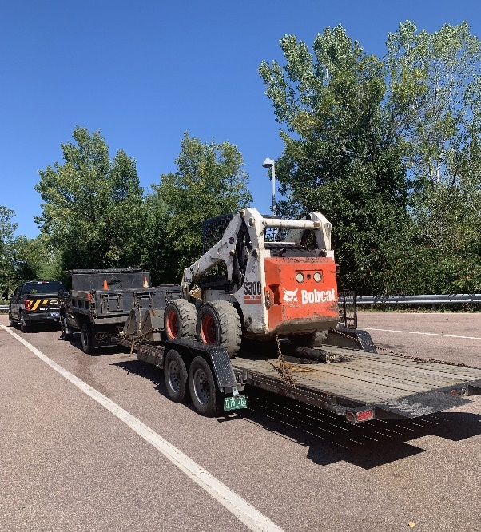
- 09/03, Sgt stopped a commercial motor vehicle which failed to stop at the safety checkpoint in Williston. The driver was found to have falsified his hours of service on multiple dates.
- 09/04, Sgt stopped a commercial motor vehicle for a speeding violation within a work zone (73/55).
- 09/04, Sgt stopped multiple passenger cars for speeding violations within the I91 Fairlee work zone.
- 09/04, I91 TACT stop, Sgt stopped a passenger car for a speeding, unsafe passing and lane violation. The operator of the passenger car said that they were running late for work and were unaware that they were traveling over 90MPH. The driver was issued a VCVC for speeding.
- 09/04, Insp stopped a CMV truck/trailer for a marking violation on I-89 in Royalton. An inspection was conducted, and the driver was placed Out of Service for no medical card, and the driver failed the English language proficiency test. The owner was present as a co-driver, and his license was suspended. The carrier was issued a ticket for permitting an unqualified driver to operate.
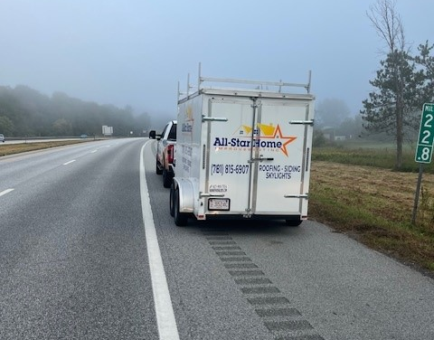
- 09/04, Inspector stopped and escorted a truck hauling wood chips to the Fair Haven Scale House. A platform weigh showed the truck weighing 103,160 while only allowed 80,000. A ticket was issued to the carrier.

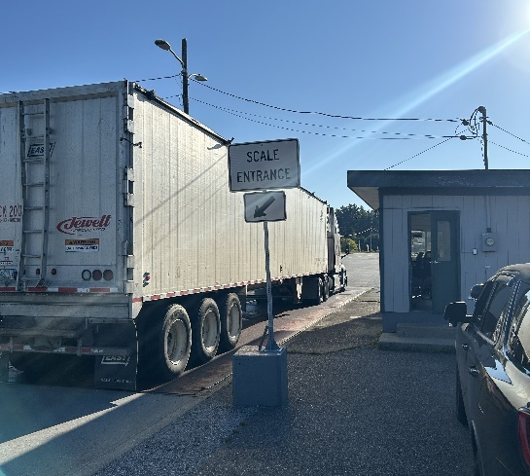
- 09/05, Insp stopped a CMV truck/trailer for speeding on I-89 in Williamstown. An inspection was conducted, and the owner/operator was placed Out of Service. The vehicle combination had a combined GVWR of 37,000 lbs., and a Class A CDL was required. The driver had no CDL and was issued a ticket and several warnings.
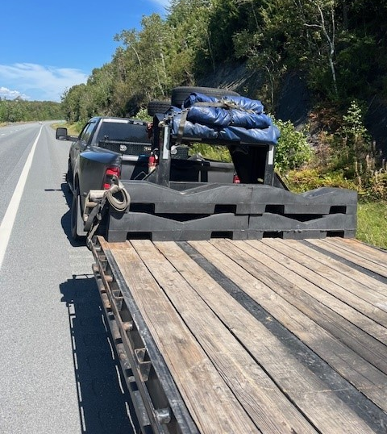
- 09/05, Insp conducted 2 TACT stops on passenger vehicles on I-89 in Berlin for speeding while passing CMVs. The operators were issued tickets for speeds of 96 and 99 MPH.
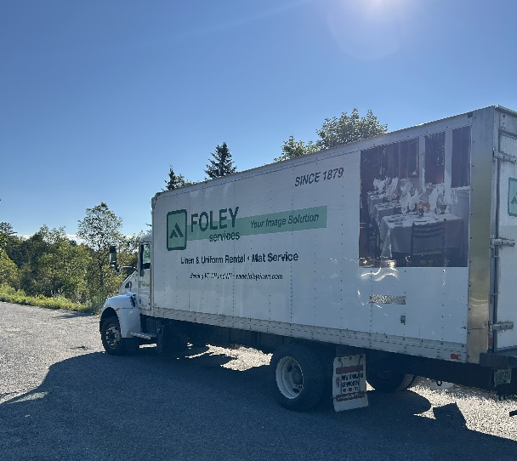
- 09/05, Sgt stopped a commercial motor vehicle for failing to display required registration plates. The driver’s medical card indicated that they needed to wear corrective lenses, and the driver was not wearing any. The driver was placed out of service for the violation.
- 09/05, Sgt stopped a vehicle for a load securement violation, the trailer was loaded with pallets which weighed over 3,000lbs and were only secured with 1 strap, two straps were required. The trailer’s registration had also expired in 2024, and the truck was found to weigh 10,000lbs over its registered weight.
- 09/05, Sgt stopped a passenger car for a speeding and unsafe passing violation on I91 in Lyndon. The driver of the vehicle was traveling over 100MPH, a traffic stop was conducted, and the driver was found to have a criminally suspended driver’s license in the State of Vermont. A 10-month-old child was in the backseat of the vehicle as well. The driver was issued a citation to court for driving with a suspended license and negligent operation. The driver was issued a VCVC.

HQ Sergeant:
New Entrant:

