Commercial Vehicle Enforcement

NORTHWEST SECTOR:

Details:
- 9/30 – VT Rte. 104 Cambridge; 4 Inspectors screened 54 vehicles. 11 inspections were completed, and 13 violations were detected. 2 drivers were placed OOS.
- 10/01 – I 89 N Colchester weigh station; 5 Inspectors screened 331 vehicles. 17 inspections were completed, and 33 violations were detected. 12 vehicles and 1 driver were placed OOS.

Crashes: Nothing to report.

Notables:
- 9/30, Cambridge detail; Sgt. inspected a truck hauling a trailer in commerce. The combination required a CDL license, and the driver did not possess one. The driver was placed OOS for the licensing infraction.
- 9/30, Cambridge; Lt. inspected an interstate vehicle and found the driver had no medical certificate in his possession. The driver was placed out of service for the violation.
- 10/01, Colchester WS detail; Insp. inspected a tractor trailer combination. A flat tire was detected on the trailer. The trailer was placed out of service for repair. 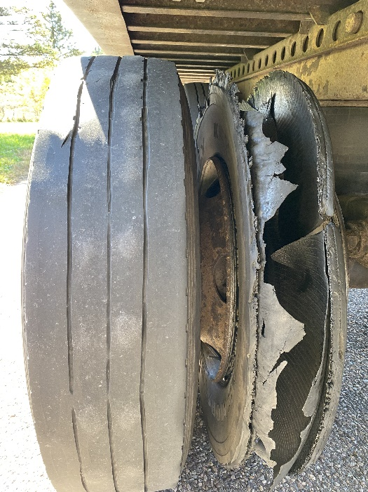
- 10/01, Colchester WS detail; Insp. inspected a 3-axle delivery truck. The rear-most axle had a tie-down strap wrapped around the axle and dragging on the ground. The truck was placed out of service until the strap was removed.
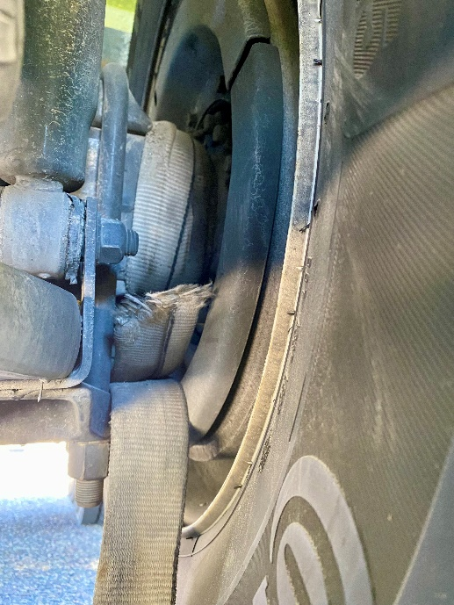
- 10/01, Colchester WS detail; Insp. inspected a tractor trailer combination. The air hose between the truck and the trailer responsible for the trailer brakes was damaged through its reinforcement plies. The combination was placed out of service until repaired.
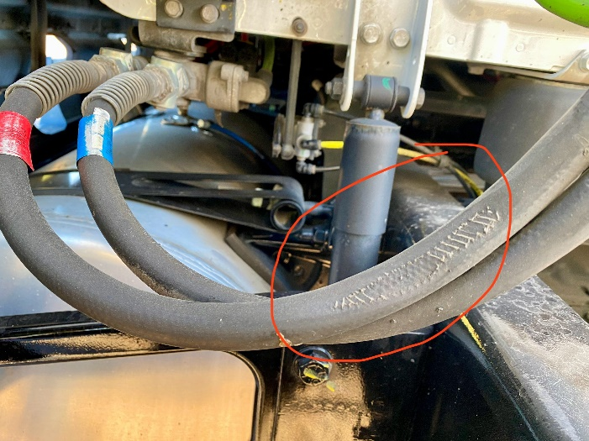
- 10/01, Colchester WS detail; Insp. inspected a tractor trailer combination. A wheel hub on the trailer that required lubrication showed no lubrication in the hub. The trailer was placed out of service for repair.
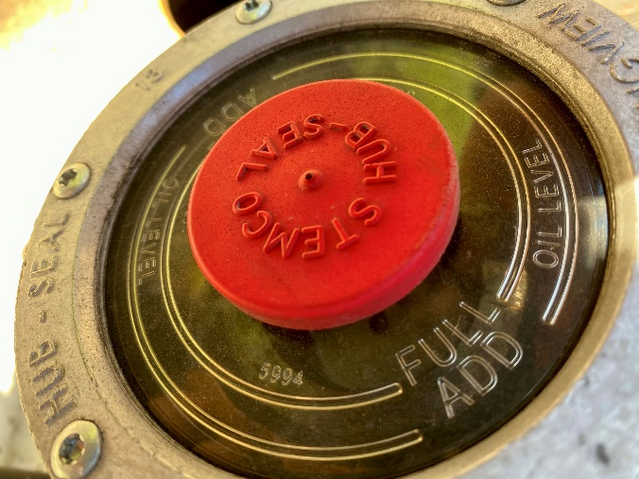
- 10/01, Colchester WS detail; Sgt. inspected a tractor trailer combination. A flat tire was detected on the truck. The truck tractor was placed out of service for repair.
- 10/01, Colchester WS detail; Sgt. inspected a tractor trailer combination. An air leak was detected, and the source of the leak was determined to be a chafed air hose. The leak was not at a proper connection, and the truck tractor was placed out of service.

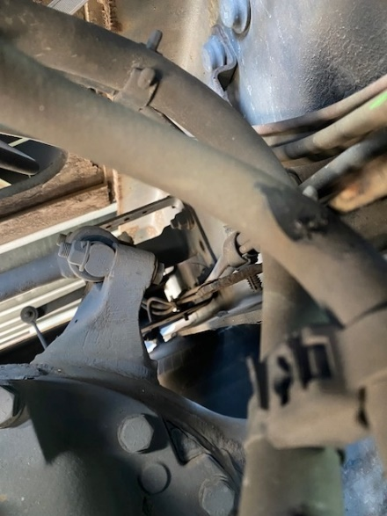
- 10/02, US Rte. 7 Ferrisburgh; Insp. inspected a tractor trailer combination. The air hose between the truck and the trailer responsible for the trailer brakes was damaged through its reinforcement plies. The combination was placed out of service until repaired.
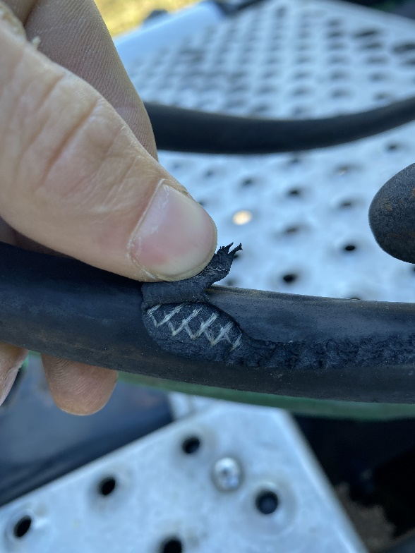
- 10/02, US Rte. 7 Ferrisburgh; Insp. inspected a dump truck hauling a flatbed trailer. The air hose between the truck and the trailer responsible for the trailer brakes was damaged through its reinforcement plies. The trailer was placed out of service until repaired.
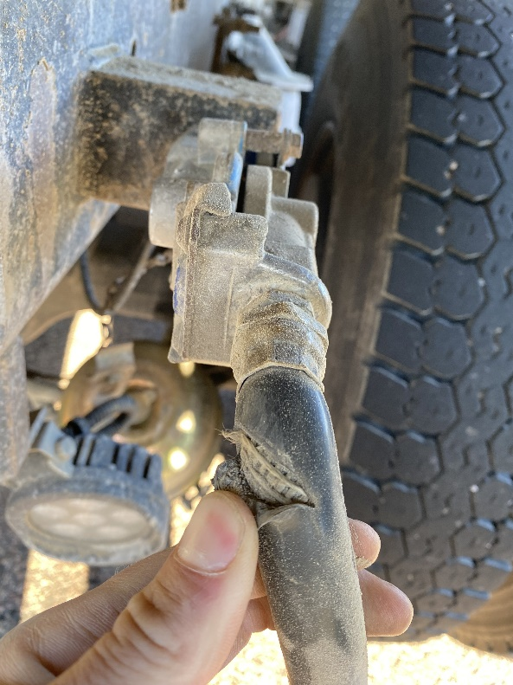
- 10/02, US Rte. 7 Ferrisburgh; Insp. inspected a tractor trailer combination. The carrier’s ability to operate in the State of VT was under suspension. The truck was grounded until the issue was resolved with the DMV.
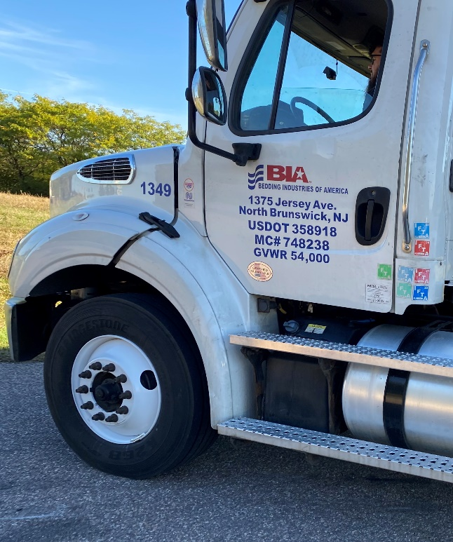
- 10/02, US Rte. 7 Ferrisburgh; Sgt. inspected an oversized load hauling an excavator. The inspection revealed the carrier did not have an over width permit, was not flagged properly and the pneumatic arm overhang was over 4 feet off the rear of the trailer. The combination was grounded until a proper permit was obtained and the trailer was placed out of service. The carrier was ticketed.
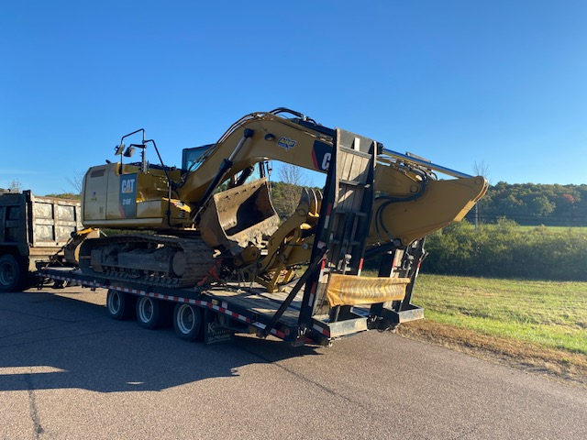
- 10/02, US Rte. 7 Ferrisburgh; Sgt. inspected a 3-axle box truck registered in Ontario. The truck did not have an IRP registration or IFTA. The carrier was force permitted for both infractions.
- 10/02, US Rte. 7 Ferrisburgh; Sgt. inspected a truck hauling concrete forms. The inspection revealed a tire was flat and metal bar was loose on the deck of the truck. The truck was placed out of service for the infractions.
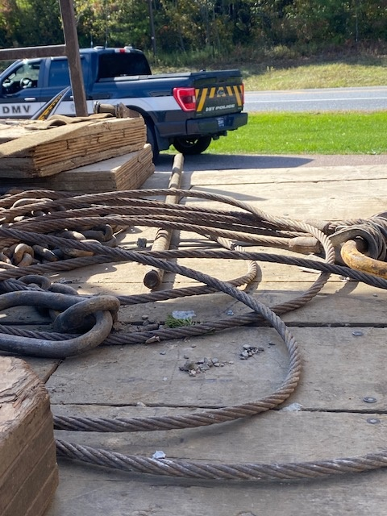

New Entrant: Nothing to report.

Passenger Vehicles: Nothing to report.

NORTHEAST SECTOR:

Details:
- 09/30 I-93 Waterford Welcome Center, 6 Inspectors screened 181 vehicles. 20 inspections were completed which resulted in 19 vehicle violations (7 out of service), 10 driver violations (1 out of service), and 3 tickets issued ($1,618).
- 10/02 I-91 Ryegate Nb Rest Area, 4 Inspectors screened 122 vehicles. 16 inspections were completed which resulted in 32 vehicle violations (2 out of service) and 10 driver violations (2 out of service).

Crashes: Nothing to report.

Notables:
- 09/29, Bradford, Inspector observed a commercial motor vehicle transporting an excavator with an unsecured boom. An inspection was conducted and revealed 7 violations to include Improper securement of heavy vehicles, the trailers breakaway cable not attached, operating without active USDOT numbers when required as well as operating a class A required combination without a medical card or a commercial driver’s license.
- 09/29, Bradford, Inspector observed a commercial motor vehicle engaged in interstate commerce with no USDOT numbers displayed. An inspection revealed the carrier did not have active USDOT numbers and was placed out of service.
- 09/29, Bradford, Inspector observed a commercial motor vehicle engaged in interstate commerce with no USDOT numbers displayed. An inspection revealed the company did not have active US DOT numbers, and the operator did not have a medical certificate. The vehicle and driver were placed out of service.
- 09/29, Bradford, Inspector observed a commercial motor vehicle engaged in interstate commerce with no USDOT numbers displayed, an inspection revealed 12 violations to include a turn signal at the rearmost of the vehicle to be inoperative, the company to have no USDOT numbers, a broken main leaf spring, operating a class B required vehicle with no commercial driver’s license as well as operating a commercial vehicle with no medical certificate.
- 09/29, Bradford, Inspector conducted an inspection on a commercial motor vehicle and discovered the driver operating a class A required commercial motor vehicle with a class D driver’s license as well as the trailers breakaway cable not attached to the towing vehicle.
- 09/29, Lyndonville, Inspector conducted a traffic stop on a dump truck that was losing its load on the roadway. An inspection was completed, and it was discovered the vehicle was unable to keep its load secure due to damage to the rear gate. The vehicle was placed out of service.
- 09/29, Saint Johnsbury, Inspector completed an inspection on a commercial motor vehicle hauling heavy machinery that was only secured at three points. The operator was temporarily out of service while he secured a fourth point and the articulating bucket.
- 09/30, Waterford, Inspector conducted an inspection on a commercial motor vehicle and observed 5 violations to include the operator not having a medical certificate when required.
- 09/30, Waterford detail, Inspector conducted an inspection on a commercial motor vehicle and observed 5 violations to include vehicle components not secured as well as operating a commercial motor vehicle engaged in interstate commerce without valid US DOT numbers.
- 09/30, Waterford detail, Inspector conducted an inspection on a commercial motor vehicle and observed the emergency glad hose to have damage exceeding into the hose's reinforcement ply.
- 09/30, Waterford detail, Cpl and Inspector conducted an inspection on a commercial motor vehicle and found the company had an IFTA permit that was expired since December 2024. A ticket was issued for the violation.
- 09/30, Waterford detail, Inspector conducted a portable weight on a 4-axle truck loaded with railroad mats with no permit. The vehicle was found to be 8,900 lbs. overweight. The carrier was issued a ticket.
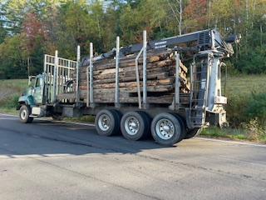
- 09/30, Waterford detail, Inspector conducted an inspection on a commercial motor vehicle with inadequate number of tie-downs to secure 12-14 ft lumber not blocked or braced. The lumber was only secured with two tie-downs when required three. The driver was able to add additional tie-downs and continue their route.
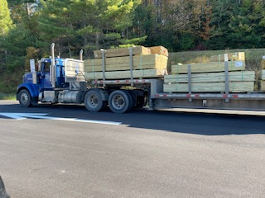
- 09/30, Waterford detail, Inspector conducted an inspection on a commercial motor vehicle and discovered a damaged glad hose with damaged/severed reinforcement ply.
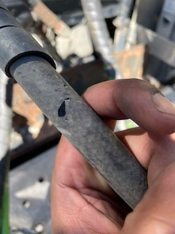
- 10/01, Bloomfield, Inspector conducted an inspection and portable weigh on a commercial motor vehicle, found to be 7,600 lbs. overweight and a brake hose that was actively chafing causing the reinforcement to be frayed. The carrier was issued a ticket, and the vehicle was placed out of service.
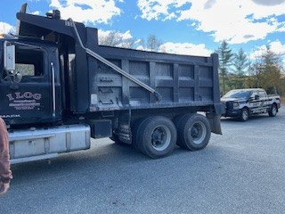
- 10/01, Colchester detail, Inspector conducted multiple inspections on commercial motor vehicles for being flagged with a concern of having flat tires. 4 out of 5 vehicles were discovered to have flat tires and were placed out of service until repairs were made.
- 10/02, Ryegate detail, Inspector conducted an inspection on a commercial motor vehicle with unsecured 14 ft tension bars. The driver was able to secure their load and continue their route.
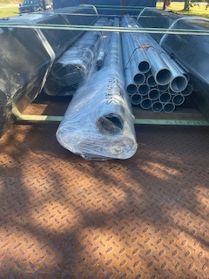
- 10/02, Ryegate detail, Inspector conducted an inspection on a commercial motor vehicle and observed 5 violations to include trailers breakaway cable not attached to the towing vehicle, one tire with an inflation of 0 PSI as well as the operator not having a medical certificate when required.
- 10/02, Ryegate detail, Inspector conducted an inspection on a commercial motor vehicle and observed 7 violations which included the operator driving without corrective lenses as required on his medical certificate.

New Entrant:

Compliance Review:

Passenger Vehicles:
- 09/29, White River Junction, Cpl conducted 9 bus inspections at Butler’s Bus Service with the South and Northwest teams.

SOUTH SECTOR:
Details:
- 9/30, I 91 Springfield NB,5 Inspectors and 2 FMCSA Investigators screened 147 commercial vehicles and completed 21 inspections resulting in 1 driver and 5 vehicle violations; 1 driver was placed out of service.
- 10/2, I 91 Hartford SB,4 Inspectors and 2 FMCSA Investigators screened 172 commercial vehicles and completed 12 inspections resulting in 3 driver and 3 vehicle violations; 1 vehicle was placed out of service. One VCVC was issued for $394.
Crashes: Nothing to report.

Notables:
- 9/29, Inspectors assisted Westminster VSP with an active dispute in Whitingham involving shots being fired by one party involved. The incident ended without further issue and VSP took one person into custody.
- 9/29, Inspectors assisted Westminster VSP along with other local units in attempting to locate and apprehend a vehicle and suspect wanted in connection with a homicide.
- 9/30, Inspector conducted a Level 1 inspection on a box truck. During the inspection it was found that 3 of the body mounts for the box were loose.
- 9/30, Inspector conducted a Level 3 inspection and found that the operator’s medical card had expired 1/25. The driver was placed OOS until he obtains a valid medical card.
- 10/2, Inspector conducted a Level 1 inspection on a truck and trailer combination. During the inspection it was found that the air brake hose was rubbing on an electrical line that caused a reduction in surface area.
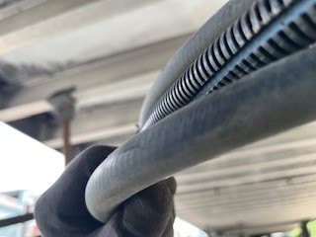
- 10/2, Inspectors conducted a Level 1 inspection on a tractor trailer combination. A local repair company called to report that the TT Unit refused to get necessary repairs on the units brakes due to the cost. During the inspection of the combination, it was found that 6 of the 10 brakes were out of adjustment and one of the brakes had pieces hanging out of the backing plate. The combination was placed OOS until repairs are made.
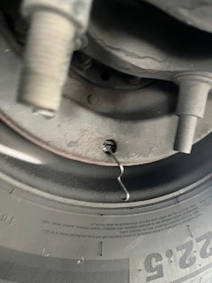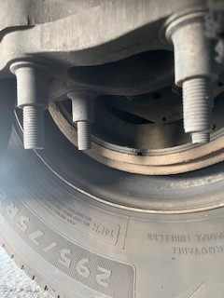

Passenger Vehicle:
- 9/29, White River Junction, 4 Inspectors conducted passenger vehicle inspections at Butlers bus terminal.
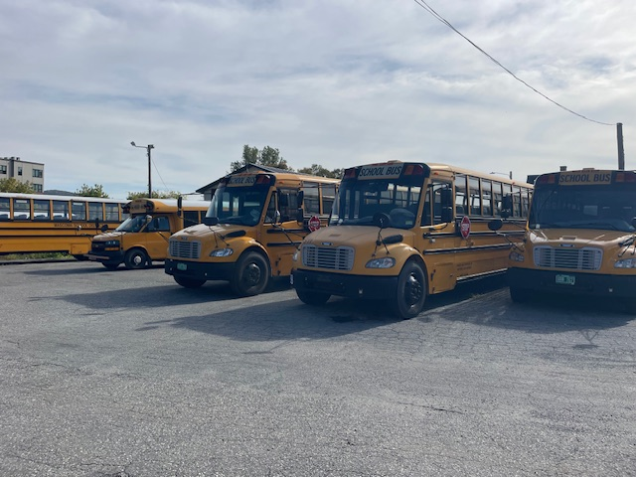

Traffic Enforcement:

- During the week of the Traffic Enforcement Unit conducted 71 inspections which resulted in 12 drivers and 15 vehicles being placed out of service.

Crashes: Nothing to report.
Notables:
- 9/29, Inspector stopped truck on Route 103 in Ludlow for a marking violation. The carrier failed to register for a USDOT number (third offense). The driver had no medical card. Both truck and driver placed out of service and carrier issued a VCVC.

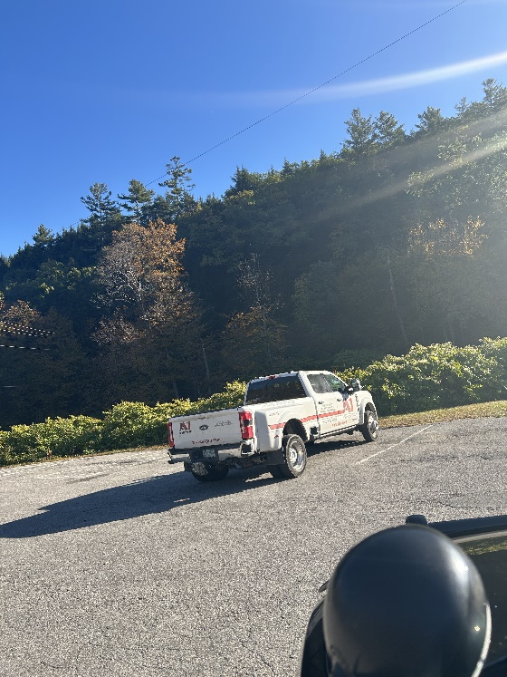
- 9/29, Inspector stopped a fully loaded dump truck with its tag axle up on Route 4 in Mendon. The driver was placed out of service as he self-certified as Excepted Interstate but was not operating in that capacity and had no medical card.

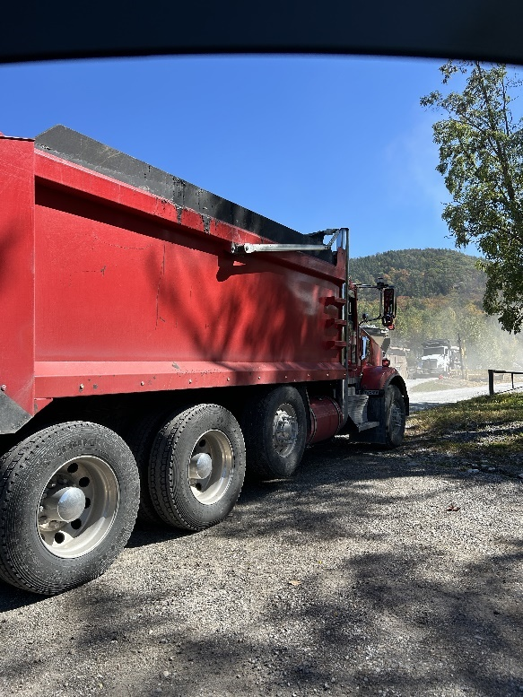
- 9/29, Inspector stopped a truck and trailer on Route 4 in Mendon. The trailer was placed out of service for no operable brakes.
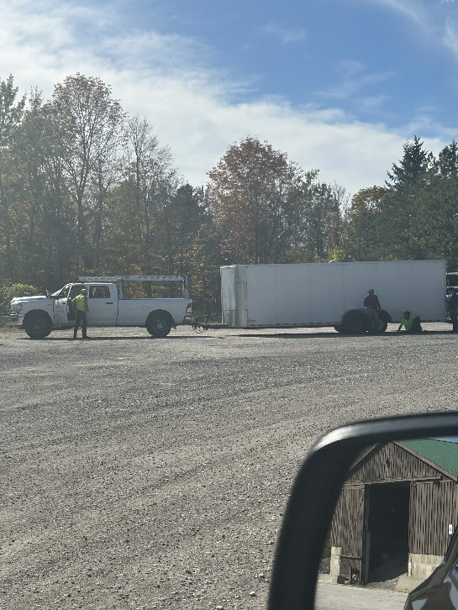
- 9/30, Inspector stopped a truck and trailer on Route 103 in Ludlow. The carrier failed to register for a USDOT number prior to interstate operations. The driver had no medical card, and the trailer latch was not secured. Driver and trailer placed out of service.

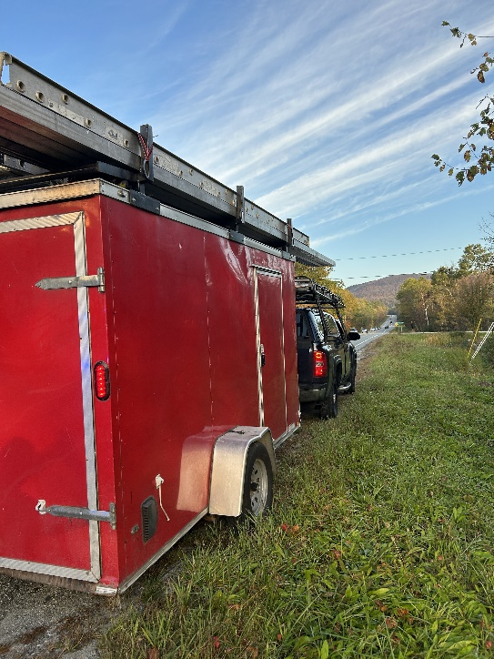
- 9/30, Inspector stopped a truck and trailer on Route 11 in Springfield. The driver was placed out of service as he was under 21 years of age and had no medical card while operating in interstate commerce. The trailer breakaway cable was connected improperly, placing the trailer out of service.
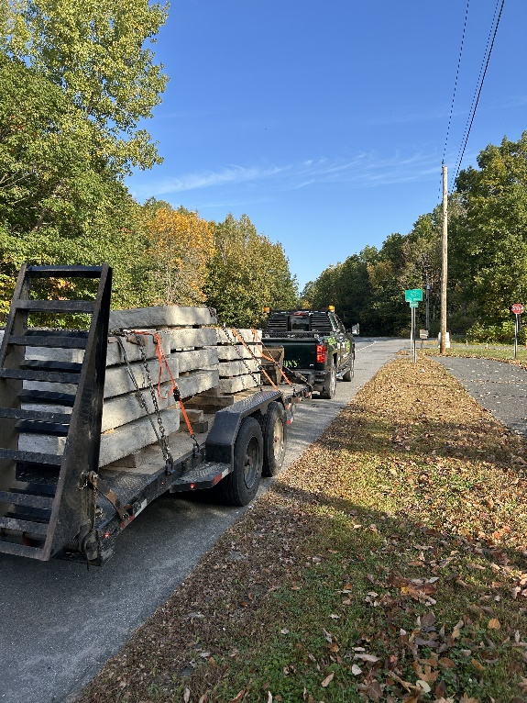
- 9/30, Inspector stopped a truck on Route 5 in Springfield. The registration was expired, truck not inspected, and the carrier failed to register for a USDOT number. The driver had no medical card and one of the truck’s rear turn signals were inoperable. Both driver and truck were placed out of service.
- 9/30, Inspector stopped a truck on Route 11 in Springfield. The driver had no medical card and was placed out of service.

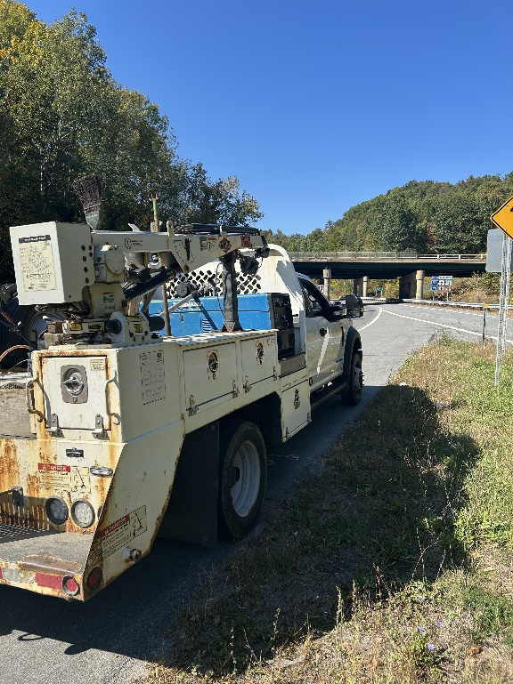
- 09/30, Sgt stopped a commercial motor vehicle which failed to stop at the Waterford safety checkpoint, the carrier was found to not have operating authority, and the driver did not have hours of service.
- 09/30, Sgt stopped a commercial motor vehicle which failed to stop at the Waterford safety checkpoint, driver did not have a medical card and was placed out of service for the violation.
- 09/30, Sgt stopped a commercial motor vehicle which failed to stop at the Waterford safety checkpoint. The vehicle was carrying a placard able amount of hazardous materials, and the driver was found to have an improper medical card self-certification. The driver and co-driver switched seats and continued on their trip.
- 10/1, Inspector stopped a vehicle on Route 4 in Woodstock. The carrier failed to register for a USDOT number prior to interstate operations. The driver had no medical card. The truck had an inoperable rear turn signal. Both driver and truck placed out of service.
- 10/1, Insp stopped a passenger vehicle for speeding in the I-89 work zone in Royalton. A check of the driver’s operator’s license showed that he is currently under criminal suspension. The driver was issued a warning for speed and a citation to appear in Windsor Superior Court for DLS.
- 10/02, Sgt stopped a commercial motor vehicle for a load securement violation, the combination was found to require a class A CDL to operate it. The driver had a class D operator’s license. The driver was placed out of service for the violation. The vehicle combination was placed out of service for the load securement violation, for not having an emergency breakaway cable and for a flat tire. The carrier was issued a VCVC for having an unregistered trailer.
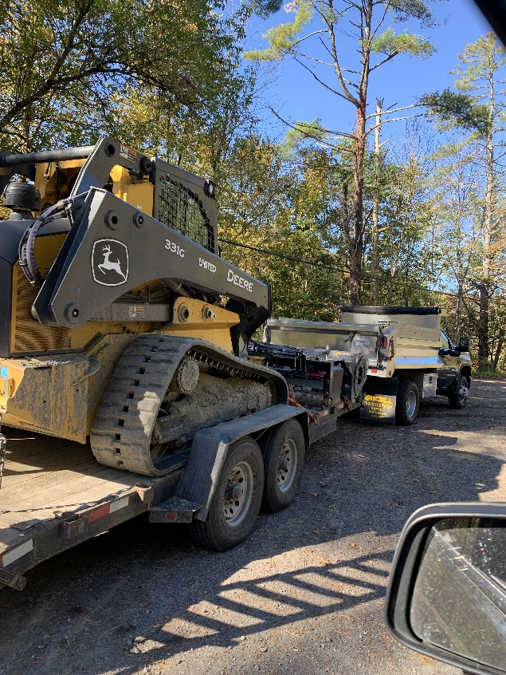
- 10/02, Sgt stopped a commercial motor vehicle for a speeding violation. The vehicle was found to be operating at 7,000 lbs. over its allowed permitted weight.
- 10/02, Sgt stopped an oversized load for a size and weight inspection. The combination was not displaying the proper signage or flags for the width of the load. The load was 10ft 6in wide and the carrier had failed to obtain a permit for the trip. The carrier was issued a VCVC for not having the required permit and the load was grounded until the permit was obtained.
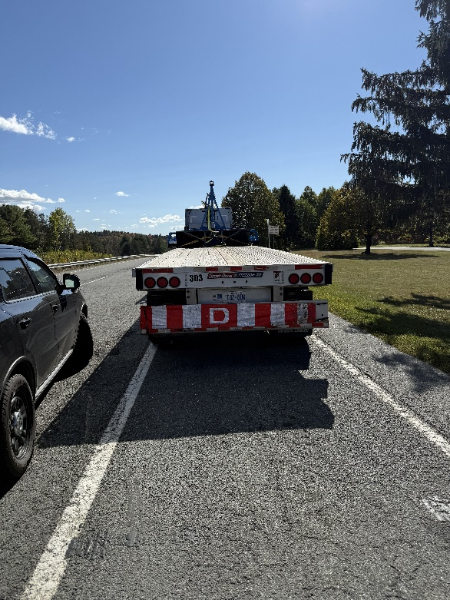
- 10/02, Sgt stopped a truck / trailer combination for a load securement violation. The driver of the combination had not secured the excavator to the trailer prior to transporting it. The driver was issued a VCVC.
- 10/02, Inspector stopped an intrastate carrier on Route 4 in Mendon. The carrier had prefabricated wall panels measuring 11’ with no oversize permit. The carrier was issued a VCVC.
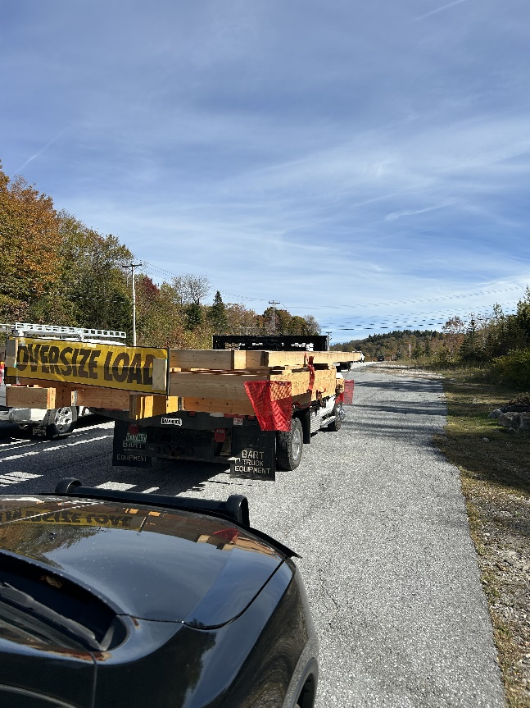
- 10/04, Inspector stopped a FedEx truck on Route 4 in Woodstock. The driver was placed out of service for no medical card.
- 10/04, Inspector stopped a truck hauling a telehandler on Route 4 in Mendon. The hydraulic accessory (boom arm) was not secured to the deck, placing the trailer out of service.
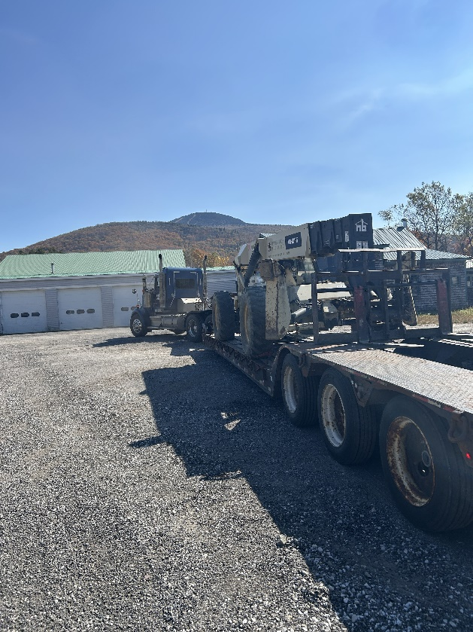
- 10/04, Inspector conducted motor coach inspections in Woodstock.
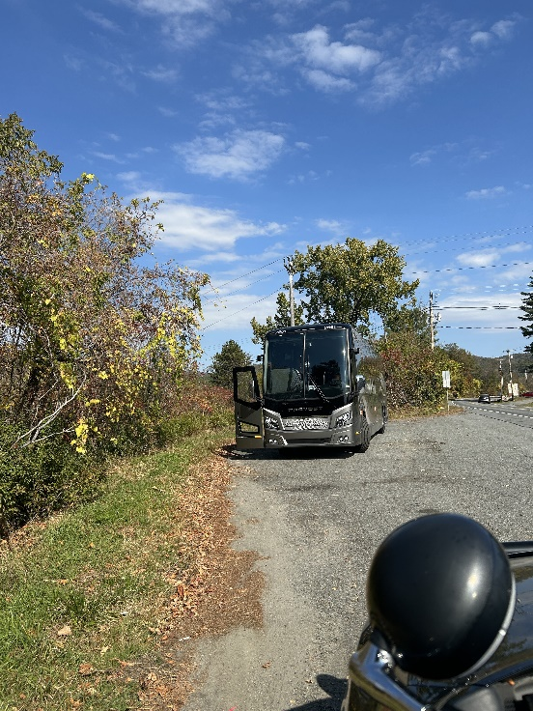

HQ Sergeant:

- 10/1, At the Colchester detail: Sgt. inspected an interstate tractor trailer. The tractor was placed out of service for a flat tire.
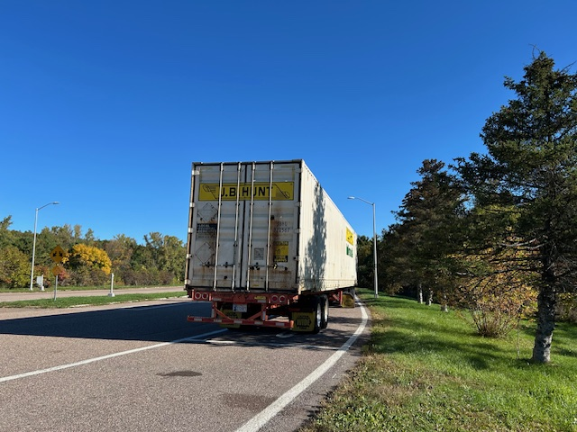
- Sgt. inspected an interstate box truck. The driver was placed out of service for 24 hrs. for being in possession of marijuana. The vehicle was placed out of service for more than 20% of the brakes out of adjustment.
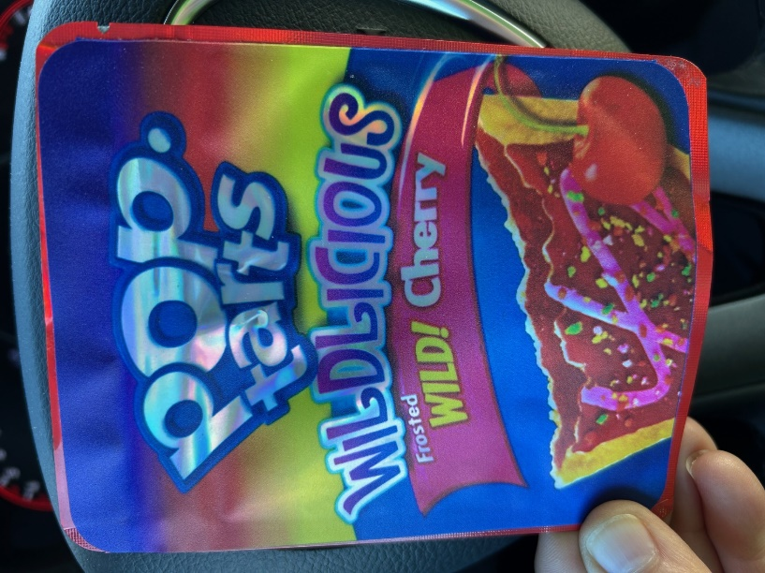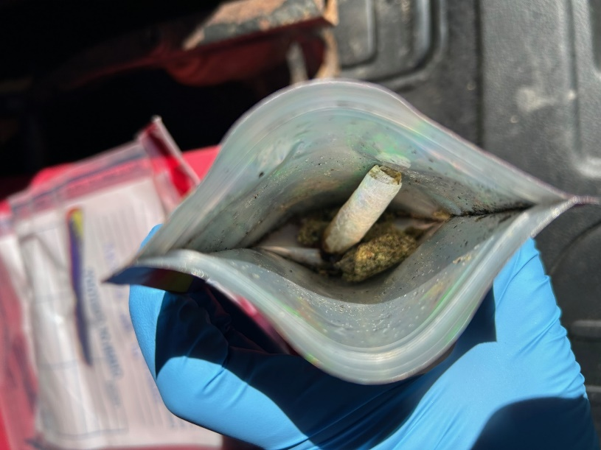
- Sgt. inspected an interstate tractor trailer hauling hazardous materials. The carrier was cited for having hazardous materials residue on the vehicle.
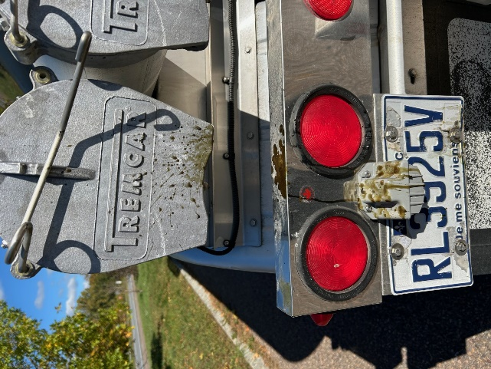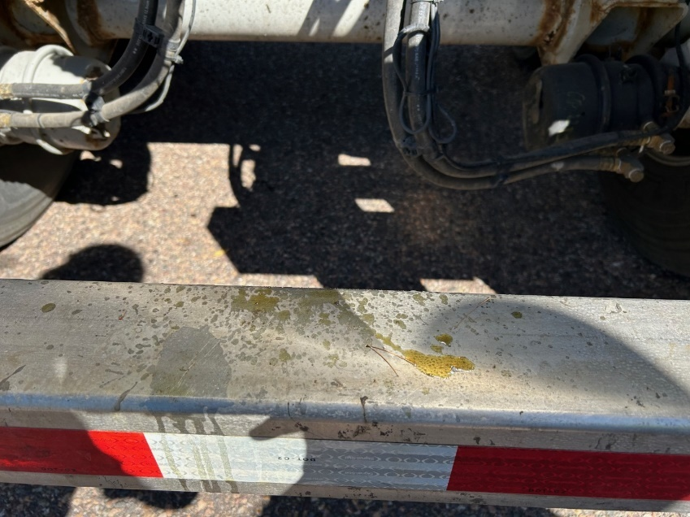
- Sgt. inspected an intrastate hazardous materials hauler. The vehicle was placed out of service as there were no HM shipping papers. Other violations included missing required tank testing, expired HM registration, improper emergency shutoff label, and no emergency response information.

New Entrant:

